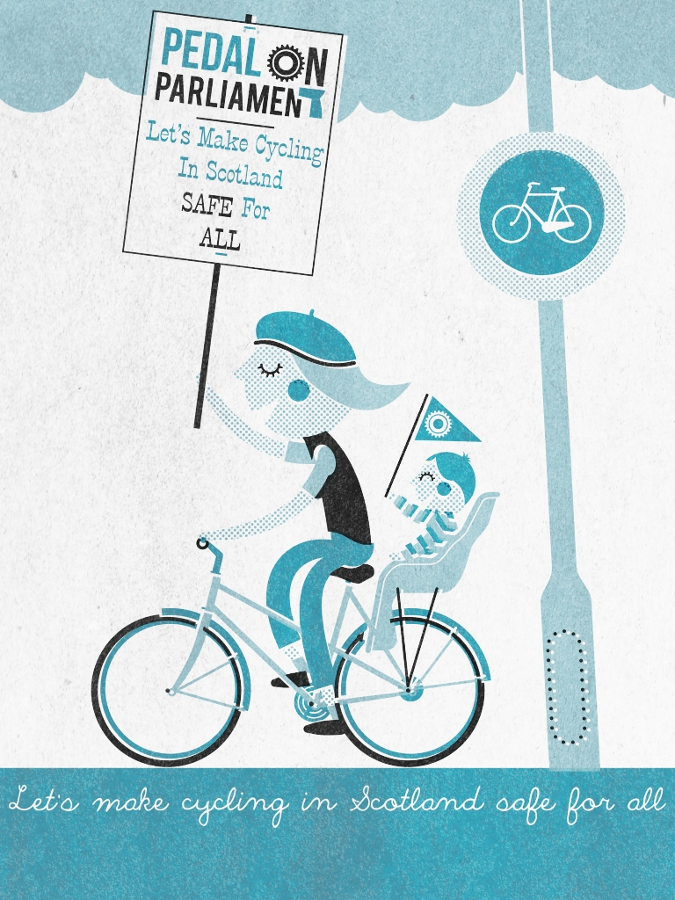
Pedal on Parliament
E-mail: hello@pedalonparliament.org
Website: http://www.pedalonparliament.org

Finance Committee Draft Budget Call for Evidence

Pedal on Parliament welcomes the Scottish government’s commitment to promoting sustainable economic growth.

Active travel can and must play a key role in any sustainable growth strategy, as it captures and enhances synergies between prosperity, job creation, the environment and the health of the Scottish population – it can go from its unenvied role as the sick man of Europe, to being a more active, healthy and sustainable country, reaping the considerable economic benefits that popular cycling as transport provide.

Question 1: Aligning Scottish Government spending decisions with increased sustainable economic growth and reflecting this in the draft budget 2013-14.

- Challenge from Emissions.
In the Climate Change Scotland Act of 2009 the government set some tough yet achievable targets to reduce green house gas emissions, with 2010 being the first year with a defined target, yet in 2010 no reduction was reported. In fact there was an increase in emissions, about a 2% increase. Looking further at the figures, specifically at sources of the emissions and the change in emissions from 1990 until 2010, we find that only two emission sources have increased during that time, residential (3%) and transport (2%). The increase in residential emissions may have been impacted by extremes of cold weather, but that would have no or little effect on transport.

Transport (which excludes aviation and shipping) itself is one the biggest contributors to greenhouse gas emissions providing 19% of the total output. If we were to increase cycling from 1% to 10% by 2020 (in keeping with government targets) there would be a significant impact on transport CO2 emissions.

Costs of driving impacting the citizen
Further, while the real costs of driving have decreased in the past 10 years, the costs of public transport have increased (IIPPR 2012) [1]. Improving public transport – and integrated cycle-bus-train use - as apart of a multi-modal travel strategy would further encourage more Scots to take up cycling as part of the daily transport strategy. It is important to remember that cycling is a cheap, efficient and democratic mode of transport. Integrated travel strategies must make it perceived convenient too.

If the modal share of cycling is to reach the governments own target (CAPS) of10% or higher by 2020 investment will be required. If 5% of the transport budget (£20 per head per year) were to be spent on cycling and cycling infrastructure this target would be achievable. However, any delays in the provision of the funding will severely impact the likelihood of the target being reached. Cycling infrastructure, ‘bang for buck’, compared to more provision for vehicles, is relatively cheap. World-class cycling infrastructure will give back more than is taken in tax pounds.

Economic benefits of cycling outweigh amount spent by 5:1
Investment in cycling and walking networks returns to the economy up to four to five times the amount spent, a better rate of return than any other transport investment. (Sælensminde 2004) [2] As the numbers of cyclists increase, road congestion decreases, less time is spent finding parking spaces, and the population becomes more efficient and effective.

Finally, supporting active travel and multi-modal travel does not just contribute to meeting environmental targets, it also supports local businesses and job creation.

Recent evidence from France [3] confirms data from elsewhere in Europe and the United States that cycle tourists spend a third more than other tourists, boosting rural communities, through the creation of 16 500 jobs.

Question 2: Harnessing the public sector to support sustainable economic growth and reflecting this in the draft budget 2013-14

- Scottish government can harness links between health, transport, environment
The Scottish government is in an ideal position to drive change on active travel. Not only can it provide leadership and investment, but it can harness the obvious synergies between health, transport, sport and the environment. In particular, with very real concerns about obesity, rising levels of diabetes, and other preventable illnesses in the population, the public sector is ideally positioned to make key infrastructural and financial shifts to encourage active travel, which will have direct, albeit long-term, benefits for the health of the population, and the financial health of our health service.

- Direct threats to our health from fumes.
Further, the threat to health from the increase of traffic in our cities is not only indirect. Recent work by the World Health Organisation [4] states that exhaust fumes from Diesel engines are definitely a cause of lung cancer. And that everyone should try and reduce their exposure to diesel fumes. Thus by focusing policy and investment on cycling and walking strategies more vehicles will be removed from our road reducing the pollution burden faced by the population as a whole.

Question 6: Making a decisive shift to preventative spend across all areas of service delivery and reflecting this shift in the draft budget 2013-14

Cycling decreasing preventable disease
It is evident that government expenditure on healthcare is increasing and will continue to increase. Yet, many of the ills that beset the Scottish public are preventable. Spending on cycling not only decreases congestion on roads, and aids in meeting environmental targets, but it also brings significant and well documented health benefits. Studies (Anderson et al 2000, Hu 2004, and Matthews 2007) have shown that the relative risk of mortality of those who cycle or walk to work is significantly less than those who drive (55% to 79% of drivers), but at present many Scottish people perceive cycling as more of a risk to their health. By building infrastructure that allays peoples fears about the risks of cycling will increase the percentage of the population actively travelling to work and will reduce the future burden on the health service.

- Perceptions of safety and infrastructure
However, this perception is unlikely to be changed by soft measures alone. There have been many campaigns over the years that have aimed to educate road users (drivers and cyclists alike) and yet there has been no significant increase in cycling. Public education campaigns rarely stimulate behaviour change. Instead, we need to make people feel safer on their bikes, and this will only be done through changes in the road infrastructure. As infrastructure is introduced, the number of cyclists will increase, and cycling will become ‘mainstreamed’. It is only at this point that roads will become less of a battlefield – as benefits are realised for all – and the health benefits will be realized in all communities, including those which currently have the worst rates of preventable disease.

Conclusion:

Government investment in Active Travel can have real, financial implications for future budgets, sustainable economic growth and the health and well-being of our population.

To realise these complex and interlinked benefits, government investment in cycling must go beyond public education and engage seriously with changes in infrastructure.

In this way, not only will systematic economic benefits be realised, but also the health and well-being of a more active Scottish population residing in a cleaner environment will reap rewards.

References:

Andersen LB, Schnohr P, Schroll M, Hein HO. 2000. All-cause mortality associated with physical activity during leisure time, work, sports, and cycling to work. Arch Intern Med 160:1621–1628

Hu G, Eriksson J, Barengo NC, Lakka TA, Valle TT, Nissinen A, et al. 2004. Occupational, commuting, and leisure-time physical activity in relation to total and cardiovascular mortality among Finnish subjects with hypertension. Am J Hypertens 20:1242-1250

Matthews CE, Jurj AL, Shu XO, Li HL, Yang G, Li Q, et al. 2007. Influence of exercise, walking, cycling, and overall nonexercise physical activity on mortality in Chinese women. Am J Epidemiol 165:1343–1350

Sælensminde K. 2004 Cost–benefit analyses of walking and cycling track networks taking into account insecurity, health effects and external costs of motorized traffic. Trans Res Part A 38:593-606

