
The Lothian Cycle Campaign
St. Martins Church, 232 Dalry Road, Edinburgh EH11 2JG 0131.313.2114 [answerphone] spokes@spokes.org.uk www.spokes.org.uk Twitter-SpokesLothian Facebook-Spokes
This competition info/entry form is on the Spokes website in downloads – odds and ends
My Favourite Place by Bike
SPOKES SUMMER 2012 COMPETITION – OPEN TO ALL
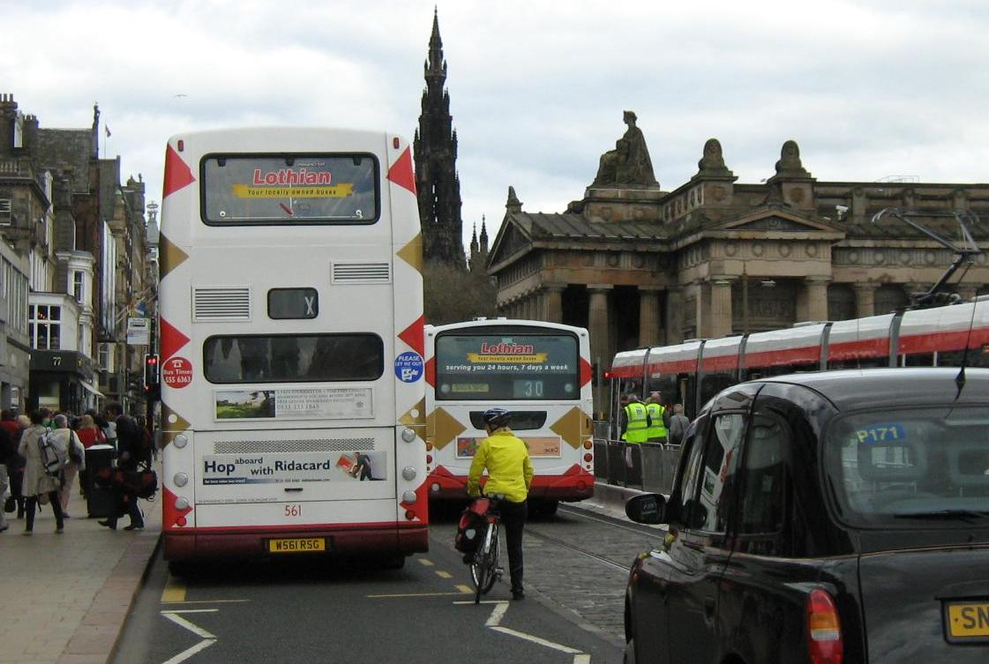Not my favourite place by bike (until it's bike-friendly!)
Our picture probably shows one of the places you'd rather not be with your bike (at least, until we get a better Princes St!) but for our 2012 competition we'd like to know where you really do love to go, or be at, or pass through, with your bike.

We hope to hear about a whole range of delightful experiences and/or places where your bike enjoyment is at its peak!! It must be somewhere or something you can do, visit or experience in Edinburgh or the Lothians.

Closing date: 9 September 2012

EXAMPLE PLACES...
It could be a view, a downhill swoop, a picnic spot, somewhere with a lovely smell, a cafe, something unusual, maybe something more abstract, or doubtless loads of other things. Note that we want a favourite place, not a ride [although your favourite place might be on your favourite ride].

HOW ENTRIES WILL BE USED...
Spokes may put some or all entries on our website, in our Bulletin, possibly in a special publication, or use them in other ways. We would of course normally credit your name, unless you ask us not to.

PRIZES..Top prizewinner gets first choice of prizes, and so on till all prizes allocated

www.edinburghbicycle.com Revolution Tune-up advanced toolkit
ScotRail www.scotrail.co.uk Return 1st class ticket for 2 between any 2 Scottish stations
Kalpna Indian Veg Restaurant www.kalpnarestaurant.com lunch for 2
Sustrans www.sustrans.org.uk Set of Sustrans Scotland maps
Camera Obscura/World of Illusions www.camera-obscura.co.uk Family ticket
Scottish Seabird Centre www.seabird.org Family day ticket [2a+2c]
Peter's Yard www.petersyard.com Small food hamper including bread book & £10 vouchers
Bridge Inn, Ratho www.bridgeinn.com [exact prize to be confirmed]
Velo Ecosse www.veloecosse.com Bike service worth £30
Reiss hairsalon 27 Hamilton Place Hair cut and blow dry
My Favourite Place by Bike – Entry form
SPOKES Summer 2012 Competition

- The competition is open to everyone. Each person can submit a maximum of 2 entries.
- You gain marks for excellent or interesting places and great descriptions of why it's a favourite.
- Each entry must fit one side of A4, or be on this form. Pictures are welcome if they fit on the sheet.
- If you enter on a separate sheet put your name, address, phone and email on the very top or the back. Do not put your name, address etc inside or under your entry, as the judges must not see names.
- The competition closes on 9 September - entries will be judged soon after.
- Email your entry to spokes@spokes.org.uk; or hand in at a SPOKES stall; or post to Spokes.

Your Name

Address Postcode

Email Phone number
_______________________________________________________________

My Favourite Place by Bike: say where or what it is [it must be accessible in Edinburgh or the Lothians. It does not have to be a geographical location, but if it is please say where it is, ideally giving postcode or grid ref].

Why it's my favourite place by bike...

Thanks for entering – Encourage your friends to enter too! Details also at: www.spokes.org.uk

