
The Lothian Cycle Campaign
St. Martins Church, 232 Dalry Road, Edinburgh EH11 2JG 0131.313.2114 [answerphone] competition@spokes.org.uk www.spokes.org.uk Twitter @SpokesLothian Facebook Spokes
This competition info/entry form is on the Spokes website in downloads > odds and ends
Cycling with a Purpose: Photo & Caption
SPOKES SUMMER 2013 COMPETITION – OPEN TO ALL
Shopping is the purpose in this picture of Edinburgh's Princes Street, and people are doing it in all sorts of ways, including by bike [spot the cyclist!]
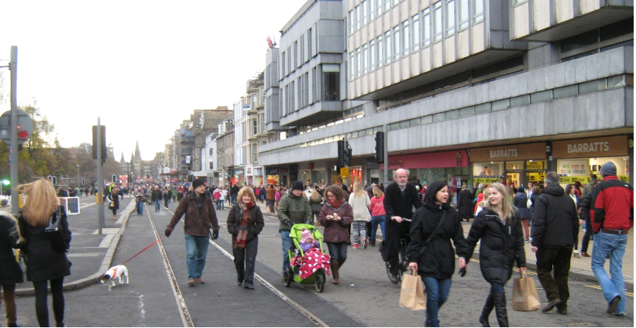Traffic-free Princes Street shopping, with bags, buggy or bike
For our summer competition please send us a photo and a caption to illustrate Cycling with a Purpose. It could be getting to school, work or the cinema; or for a family outing or to stay healthy. We are looking for ordinary people using a bike, not super-sportspeople.
Your picture and caption should make clear the purpose – why the bike is being used. Picture/caption combinations which might entice other people to cycle, or to cycle for more kinds of journey and purpose, or which give some other useful message, will be especially welcome. Our picture is an example – the cyclist(s) may be far more prominent in yours.
We hope to hear about a whole range of reasons for getting about by bike; with persuasive pictures and captivating captions. Your picture need not include an identifiable location, but if it does it must be in Edinburgh or the Lothians [see entry form overleaf].
Closing date: 6 September 2013. Maximum 2 entries per person.

HOW ENTRIES WILL BE USED...
Spokes may use some or all entries on our website, in our Bulletin, in other publications or in other ways. We would of course normally credit your name, unless you ask us not to. By entering the competition you give Spokes permission to use your images and captions in our ongoing campaigning and promotional work.

PRIZES.. Top prizewinner gets first choice of prizes, and so on till all prizes allocated

www.edinburghbicycle.com Revolution Tune-up advanced toolkit
ScotRail www.scotrail.co.uk Return 1st class ticket for 2 between any 2 Scottish stations
Camera Obscura/World of Illusions www.camera-obscura.co.uk Family ticket
Kalpna Indian Veg Restaurant www.kalpnarestaurant.com Lunch for 2
Cameo Cinema www.picturehouses.co.uk/cinema/Cameo_Picturehouse Offpeak tickets for 2
Filmhouse www.filmhousecinema.com Tickets for 2
Sustrans www.sustrans.org.uk Set of Sustrans Scotland maps
Peter's Yard www.petersyard.com Food hamper, voucher, keep-cup, baking book
Velo Ecosse www.veloecosse.com Bike service
Reiss hairsalon 27 Hamilton Place Hair cut and finish
Bike Smith 36 Haymarket Terrace Bike service, value £20
Cycling with a Purpose – Entry form
SPOKES Summer 2013 Competition

- The competition is open to everyone.
- Each person can submit a maximum of 2 entries.
- You gain marks for your combination of photo and caption. We'd like them to be imaginative and positive, to give a useful message and to inspire people to use a bike or to use it for new purposes, anything from the everyday to the unusual or quirky.
- Your caption should be no longer than 140 characters, including spaces and punctuation.
- Your photo should be sent as a jpg file, not exceeding 1MB size. If you are unable to use jpg and/or if you cannot reduce the size of your file, please let us know and we may be able to accept your entry. We can also accept printed photos, but we will not return the original.
- The competition closes on 6 September - entries will be judged soon after.
- Email the completed entry form and your photo(s) as attachments to competition@spokes.org.uk. For printed photos, post the form and your photo(s) to our office address.

------------------------------------------------------------------------------------------------------------------
Your Name

Address Postcode

Email Phone number
------------------------------------------------------------------------------------------------------------------
ENTRY 1

Caption for your photo [maximum 140 characters including spaces and punctuation]...

If your photo includes an identifiable location, please say where [must be Edinburgh or Lothians]

------------------------------------------------------------------------------------------------------------------
ENTRY 2 [if you are sending 2 entries]

Caption for your photo [maximum 140 characters including spaces and punctuation]...

If your photo includes an identifiable location, please say where [must be Edinburgh or Lothians]

------------------------------------------------------------------------------------------------------------------
Any other relevant information [this will not count towards the judging]

Thanks for entering – Encourage your friends to enter too! This form is at www.spokes.org.uk.

