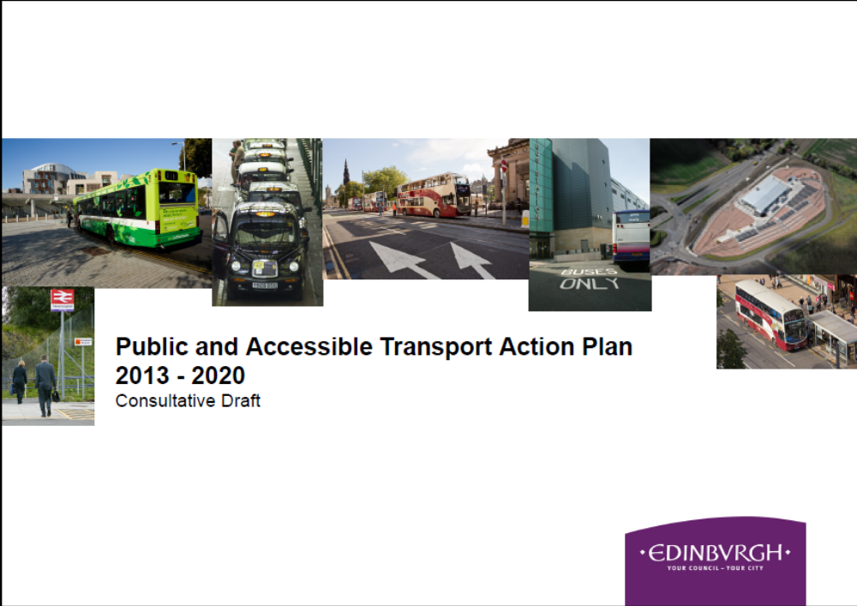

Contents
Foreword 3
Section 1: Introduction, Background and Objectives 4
- Introduction
- The Council’s 2030 Vision
- Background trends
- Future trends
- Public transport’s potential
- The Council’s role, and joint action
- Monitoring and review
Section 2: Bus Operations 9
- Edinburgh Bus Station
- Issues
Section 3: Bus Infrastructure 11
- priorityconnect Corridor
Section 4: Community and Accessible Transport 13
Section 5: Taxis and Private Hire 14
- Issues
Section 6: Rail 16
Section 7: Tram 18
Section 8: Information 19
Section 9: Targets and Monitoring 21
Appendix: PATAP Actions 27
Further Information 36

Foreword


Edinburgh is a city that in many ways is ideally suited to public transport. With a dense urban environment, relatively low fares, and jobs and services concentrated in the city centre, bus use is among the highest in Britain. But we must not be complacent; we want to see continual improvement.

Public transport plays an essential role in the lives of many of the city’s residents, workers and visitors. It enables access to employment, health care, education and leisure opportunities. It uses the road network efficiently, and so mitigates congestion. A good public transport system has fewer environment impacts than a car-based transport system. This Public and Accessible Transport Action Plan (PATAP) sets out to deliver these benefits by enabling and encouraging people in Edinburgh to use public transport more often.

We are establishing this Plan to:
- build on existing successes, and develop a clear plan up to 2020
- prioritise activity whilst improving customer service
- ensure public and accessible transport contribute to our objectives for Edinburgh
- complement the existing Road Safety and Active Travel Action Plans

I believe that implementing this plan will make a positive difference to Edinburgh. It will reduce pollution and congestion. Streets that are easy and friendly to walk and cycle in are more civilised and safer for everyone.

Councillor Lesley Hinds
Convener of Transport

Section 1: Introduction, Background and Objectives

Introduction
For a city of its size, Edinburgh has a well-regarded public and accessible transport network. Nevertheless, the Council, and many others in the city, do not consider this sufficient for the future. In particular, to meet aspirations for Edinburgh to compete on a European, if not world stage, we must develop a public transport system that is at least equal to the best in Europe.

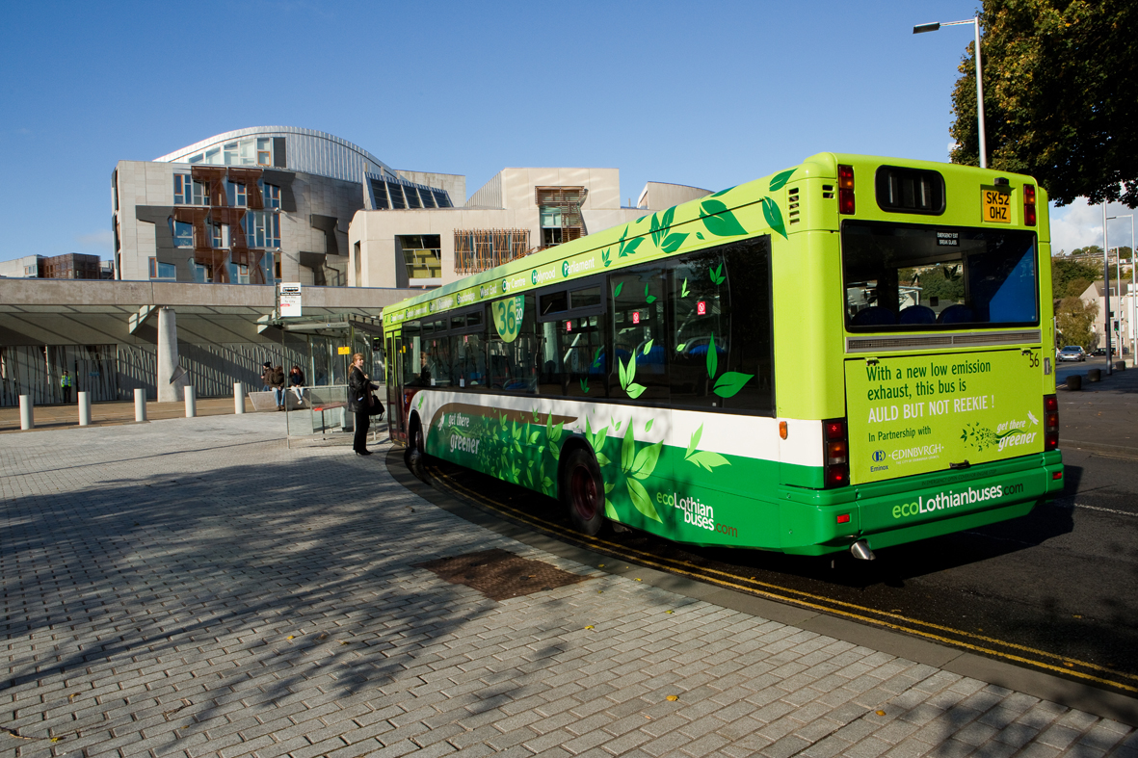

The Edinburgh Partnership 2012-15 Single Outcome Agreement sets strategic priorities and associated local outcomes. It notes: ‘Transport underpins many of the city’s activities and SOA outcomes…a key element of …Edinburgh’s attractiveness as a place to do business…An effective public transport system is essential...Accessible transport is crucial for…social inclusion, and…independent living.’

Outcome 4 is ‘Edinburgh’s communities are safer and have improved physical and social fabric’. A required action is ‘Implement the Local Transport Strategy’.

The Council’s 2030 Vision
By 2030, Edinburgh’s transport system will be one of the greenest, healthiest and most accessible in northern Europe:
- environmentally friendly
- healthy
- accessible and connected, supporting the economy and providing access to work, amenities and services
- smart and efficient providing reliable journey times
- part of a well planned, physically accessible, sustainable city that reduces car dependency, with public transport, walking and cycling conditions to be proud of
- safe, secure and comfortable
- inclusive and integrated
- customer focussed and innovative
- responsibly and effectively maintained

2030 Vision
Local Transport Strategy
Road Safety Plan
Public and Accessible Transport Action Plan
Active Travel Action Plan
Other Plans
Other Plans

From its first Local Transport Strategy in 1999, through to the 2030 Vision approved in 2010, the Council has given high priority to public transport. This continues in the Council’s new LTS (2014-19). The overall aim is to achieve:
‘an integrated, safe, modern, sustainable, top quality public transport system, providing for all major medium and longer distance movement to, from and around Edinburgh; accessible to all’.

The objectives to meet this aim are:
- implement the Tram as an integral part of the public transport system
- ensure the bus network is reliable, convenient, and economical across the city at all times
- consolidate recent, and secure further improvements to passenger railways
- well designed Park and Ride available at the edge of, or outside the city
- ensure taxis and PHCs are convenient and accessible, particularly where other public transport is inconvenient
- maximise information provision
- support a strong city centre economy
- promote and facilitate local, national and international connectivity
- mitigate the local and global environmental and transport impacts of long distance travel

The Actions which follow from these objectives are listed in the Appendix.

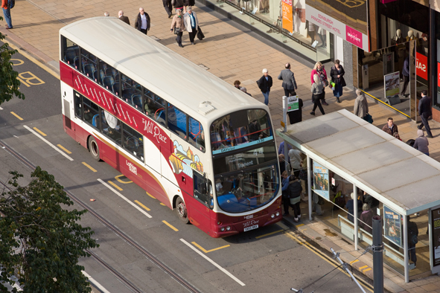

Background trends
Quantifying public transport’s role in Edinburgh is not straightforward; all the main data sources have some limitations. Nevertheless, it appears that public transport accounted for around 3% more of Edinburgh residents’ journeys over the last decade; mainly due to more commuting by public transport.
Travel in Edinburgh has grown since the 1990s, while traffic volumes have declined (i.e. more people, but fewer vehicles). Public transport trips increased.
68.5% of its workforce lives in the city; around 6% each in Midlothian, in West Lothian and in East Lothian, and 4.7% in Fife. It has hardly changed since 2001, when 64,500 (24%) of the city’s workforce commuted by bus, 11,200 (4%) by train.

Edinburgh residents; public transport share of trips
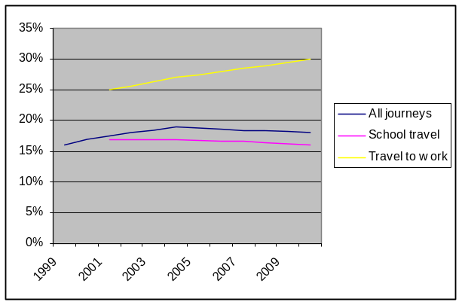

Future trends
The introduction of Trams in 2014 will be a major milestone during the PATAP period. For forecasting and target setting purposes, PATAP combines Tram and bus patronage figures. Modelling predicts that in year 1, 27% of Tram passengers will be new to public transport, mainly having previously travelled by car, with a smaller number of new generated trips.
The modelling suggests that in 2015, 128 million trips will be made on bus and Tram, a 17% increase; by 2020, 145 million.

Million trips |  |  | * predicted
 | 2006 | 2008 | 2010 | 2012 | 2015 | 2020
Bus | 108 | 113 | 109 | 115* | 123* | 138*
Tram |  |  |  |  | 5.1* | 7.5*

Between 2009 - 2024, rail trips in the ‘Edinburgh conurbation market’ are projected to increase 90 – 118%, a 25 - 31% increase by 2015.

To be consistent with the Council’s 2030 Vision, Local Transport Strategy and Active Travel Action Plan (ATAP), public transport mode share should not grow by shifting pedestrians and cyclists onto buses and trains; it must gain market share from car travel.

Some background themes
- little evidence of communications technology substantially reducing travel; rather, it’s increasing public transport use
- research suggests personal interaction is still important for work and leisure
- growth in car travel, whilst comprising the great majority of trips nationally and locally, has apparently levelled off
- continuing relocation of work, leisure and education; which is partly planned, partly unplanned and unpredictable
- projected doubling of rail passenger numbers; impact on connecting transport

Public transport’s potential
Car/van users recognise that they could use Edinburgh’s public transport. Its quality is widely recognised. Scottish Household Survey (SHS) data suggests there is no single simple answer for improving bus services. Nationally, car/van commuters who could use public transport do not mainly because it ‘takes too long’ or there is ‘no direct route’ (there is no local data).

SHS opinion data; compared to other Scottish ‘large urban areas’, Edinburgh residents:
- rate public transport ‘good’ (41%; average 31.5%). In Edinburgh only 3.7% rate it ‘poor’)
- rate local public transport ‘very convenient’ (69.1%; average 62.6%)
- bus use is higher. (In Edinburgh, 23.6% used no buses in the past month; average 41.6%)
- Edinburgh residents’ rail use was lower
- Distances to bus stops (and stops with frequent services) are shorter

Compared to other large urban areas, Edinburgh residents consider buses more:
- on time, frequent, well timed, clean, comfortable, safe, secure, with few timetable changes,
- fares and information easy to find and understand; better value
- except for transfer between modes, Edinburgh’s buses scored higher on every parameter than Glasgow, Aberdeen and Dundee
- the only below average score was for easy transfer to other transport

The Council’s role, and joint action
The Council works within a legal framework. In the case of buses, since the 1980s this has aimed to improve efficiency and quality through competition and market forces rather than public sector intervention, other than in exceptional cases. This makes integration and co-ordination challenging.

The Council seeks to meet this challenge through partnership with bus operators, and managing the local road network to support bus operation. To date this strategy has been very successful, and the long-term decline in bus use has reversed. The Council’s inputs can include, for example, bus priority measures (lanes and/or signalling) supported services, Park and Ride, bus stop and other improvements.

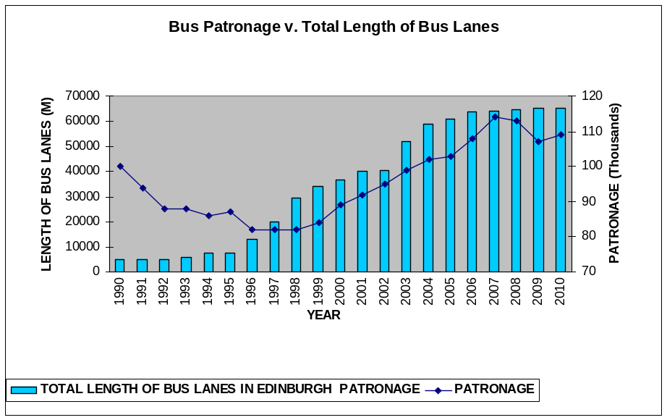

The Council has no statutory role in rail services, but it actively promotes improvements. Since the Scottish Government introduced the Single Outcome Agreement approach to Council funding, the Council has been unable to fund projects on the scale of the Edinburgh Crossrail project (2001). Therefore the Council will

continue to focus on promotion, or other ‘soft’ interventions.

Many other organisations share the Council’s role in public transport. They include bus and rail operators; local and central government agencies; the taxi and private hire trades. Each is responsible for part of the overall system. Some parts of the service may not be included in the service plan in great detail, for example if some parts of the service are delivered by partners.

Monitoring and review
This PATAP runs until 2020. The targets will be monitored biannually, with a review in 2015. The targets are set out on pages 19 to 24.

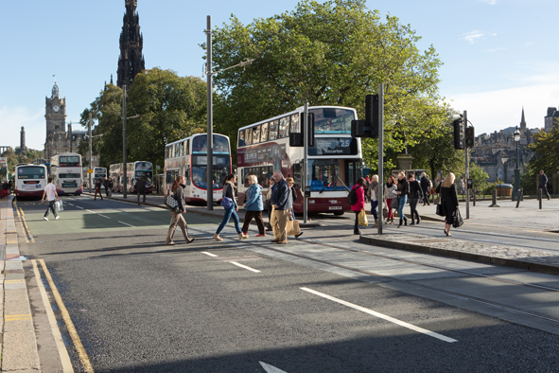

Section 2: Bus Operations

Relevant objectives
Ensure the bus network is reliable, convenient, and economical across the city at all times | Make well designed Park and Ride available at the edge of, or outside the city
Promote and facilitate local, national and international connectivity | Mitigate the local and global environmental and transport impacts of long distance travel
Support a strong city centre economy

The main areas for action
Bus and Tram integration | Updating the Bus Information Strategy
Integrated ticketing across the bus network | Minimising impact of roadworks and special events
Maintaining supported services | Improving bus reliability
Opportunities for new/improved services | Reducing costs, increasing revenue at Edinburgh Bus Station

Most bus services in Edinburgh are operated by Lothian Buses, others (primarily beyond the city boundaries) by Firstbus, Stagecoach and Scottish Citylink. Other operators provide in particular the non-commercial services which are financially supported by the Council.

As set out in Section 1, bus patronage in Edinburgh has grown in ten of the past twelve years. Public transport has catered for a greater share of Edinburgh residents’ journeys to work, but not off-peak travel. Much of the bus patronage growth must consist of trips by non-residents.

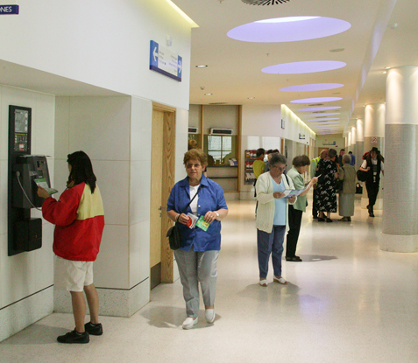

Edinburgh Bus Station
Edinburgh Bus Station is operated directly by the Council, and used by some four million people per year. On weekdays, typically
around 800 buses arrive or depart. Income is generated by charging bus operators for using the site, and other sources such as use of luggage lockers and toilets. Nevertheless, operating the Bus Station has been a loss-making activity since 1994.

More than 97% of bus services in Edinburgh are provided commercially by bus operators. The Council financially supports a few non-commercial bus services, in whole or part, and some cross-boundary services jointly with neighbouring Councils. The annual cost of this support is around £1.1 million.

Issues
There are a number of challenges to future bus operations. They include:
- The rising cost of fuel, both directly and as a result of reductions in Bus Service Operators’ Grant (BSOG) by government
- City centre management; improving pedestrian access and emissions
- Integration with the Tram (opening in 2014)
- General ongoing roadworks
- By 2024, a substantial increase in passengers embarking/disembarking at three main rail stations, and the opening of Edinburgh Gateway station. This means more passengers travelling to stations by bus
- Edinburgh Bus Station’s financial deficit
- Reliability and faster journeys arising from new and improved bus lanes accounted for much of the patronage growth over the past decade. No equivalent expansion is planned for future years
- The need to improve reliability by traffic management initiatives

Some of these could offer new opportunities. Other social trends also present clear opportunities:
- An apparent shift towards public rather than private transport use
- The apparent decline in ‘car culture’; e.g. the number of under-25s taking the driving test has fallen by over 20% in five years
Edinburgh’s buses are newer than most other UK urban centres’, and many meet a high emissions standard. Most services pass through the Central AQMA. Lothian Buses has fitted all vehicles with idling cut-off devices. It also retrofitted exhaust technology to upgrade 34 buses to better than Euro 5 emissions standard (September 2011). With Scottish Government support, it has or is acquiring a total of 25 hybrid diesel-electrics

Reducing buses’ direct emissions is a continuing process, with the goal of achieving at least Euro 5 standard in all buses serving Edinburgh by 2020. To encourage further improvements by all operators, the Council will consider Low Emission Zones, and other means of emission control.

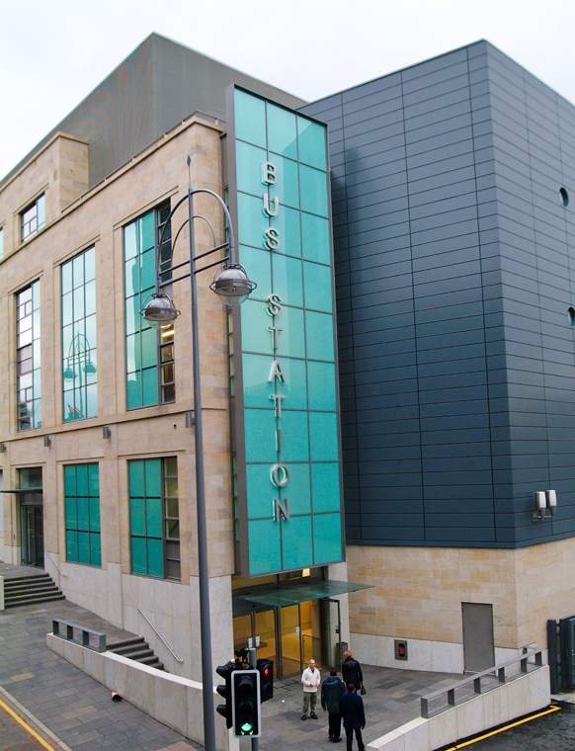

Section 3: Bus Infrastructure

Relevant objectives
Ensure the bus network is reliable, convenient, and economical across the city at all times | Make well designed Park and Ride available at the edge of, or outside the city
Support a strong city centre economy | Promote and facilitate local, national and international connectivity

The main areas for action
Bus and Tram integration (the physical components) | Further bus priority including priorityconnect Corridor
Improving bus reliability | Reviewing Interchange principles
A renewed focus on maintaining bus infrastructure

The Council is directly responsible for Edinburgh’s roads, and therefore most of the infrastructure that buses use. This includes, for example, bus priority measures, Bustracker, bus shelters, and Park and Ride.

As shown in Section 1, there was a clear correlation between the expanding bus lane network and bus patronage in Edinburgh from 1997 to 2007. There are currently 65.25 km of bus lanes in Edinburgh; a figure essentially unchanged since 2006.

There are about 2,400 bus stops in the city, of which about 1,450 have shelters. 900 shelters are Council owned, the others belonging Clear Channel Ltd (under an advertising contract), and about 10 privately owned. Currently 360 bus stops have Bustracker real time information displays.

CEC-built P & R sites | Spaces
Ingliston | 1085
Hermiston | 450
Straiton | 600
Newcraighall | 565
Built by other Councils | Spaces
Ferrytoll | 1040
Sheriffhall | 545
Wallyford | 300

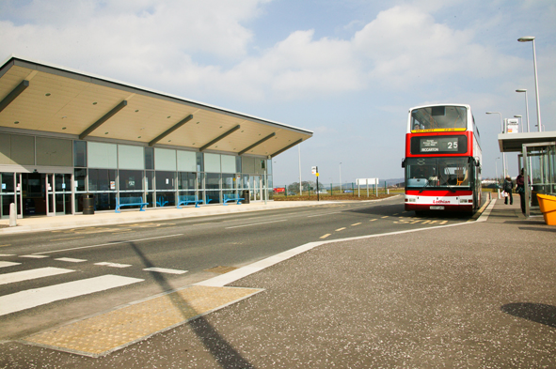

Future Park and Ride plans include extending Hermiston by 600 spaces, progressing a new site at Lothianburn (by Midlothian Council) and the potential development of a new site at Gilmerton (land for which is safeguarded).

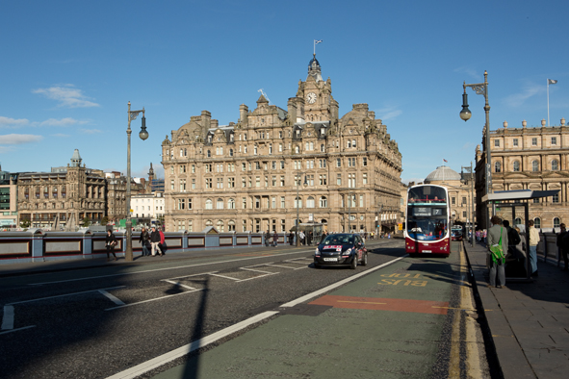

Enforcing bus lanes by camera and installing equipment on traffic signals to prioritise late running buses, are the most innovative measures planned to improve bus infrastructure in the immediate future. They will improve reliability.

The current Council’s pledges include to ‘encourage the improvement of routes and times’.

priorityconnect Corridor
We will consider significantly enhancing an existing main bus corridor (to be selected), to improve service quality, especially journey times and reliability.

Parts of this route would need to be already in place; a core of existing bus lanes, but with important gaps.

The corridor would:
- improve links on the existing route to and through the city centre
- upgrade links to key recreational and business destinations
- fill short but important gaps in existing routes

The first stage of development will involve selecting a corridor and identifying options to improve services on it.

traffic signals

Section 4: Community and Accessible Transport

Relevant objectives
Ensure the bus network is reliable, convenient, and economical across the city at all times | Ensure taxis and PHCs are convenient and accessible, particularly where other public transport is inconvenient

The main areas for action
Developing, consulting on, and implementing value for money improvements

Community and Accessible Transport (C&AT) supplements other transport. It is generally available only to those who meet various eligibility criteria. In Edinburgh, the key components are:
- The concessionary bus zero-fare scheme (eligibility based on age and disability). Funded by Transport Scotland; card holders have free bus travel throughout Scotland.
- The Council’s Taxicard scheme; holders pay discounted fares in participating taxis, up to 104 trips annually.
- HcL, formerly Handicabs, a charitable company, operates Dial-a-Bus (scheduled routes to local shopping centres, diverting for passengers en route) and Dial-a-Ride (a door-to-door service). Both charge fares.
- Shopmobility loans mobility equipment in the City Centre, Gyle, Cameron Toll and Fort Kinnaird
- Eligible persons can use Patient Transport Services for health appointments.
- For eligible community groups, daycare centres, community groups and organisations, a range of group travel is available

SLA contracts annual value 2011-12
HcL Dial a Ride | £341,435
HcL Dial a Bus | £106,555
Group travel (LCTS, SEAG, PEP, Dove Transport) | £309,038
Lothians Shopmobility | £78,207
Taxicard (2010/11) | £522,000 (spend)

During 2011, consultants reviewed the Council-funded services. This revealed two significant challenges to maintaining the high-quality range of services in future: the need to maintain and improve service levels with a constrained resource, and continuously increasing demand. Current arrangements are not viable in the medium to long term. During 2012-13, the Council will develop proposals for the future and consult on what and how change should be introduced.
b

Section 5: Taxis and Private Hire

Relevant objectives
Ensure taxis and PHCs are convenient and accessible, particularly where other public transport is inconvenient | Mitigate the local and global environmental and transport impacts of long distance travel
Support a strong city centre economy

The main areas for action
Taxi ranks | Improving passenger service
Improving the Licensing service

A taxi is a vehicle that is licensed by the Council to ply for hire on the street (hailed or hired at a taxi rank); it may also be prebooked. Private Hire Cars must be prebooked (though in a place where the public has restricted access, they do not need pre-booking).

Taxis and PHCs enhance travel choice and offer a viable alternative to car ownership and use. They are important for accessible transport, providing safe door-to-door transport for people with disabilities.
As licensing authority, the Council applies certain requirements beyond those that are statutory. These have included wheelchair accessibility, specified vehicle types, fares meters, disability training and knowledge of the city. The requirements for PHCs are much less strict. The Council limits the number of taxi, but not PHC, licences issued.

There were 1,306 taxi licences in early 2012 (up from 1,260 in 2001); one for every 370 Edinburgh residents. This compares favourably with other UK cities. There are 80 taxi stances with 267 spaces (and additional temporary spaces during the Festival); one space per 4.85 taxis.

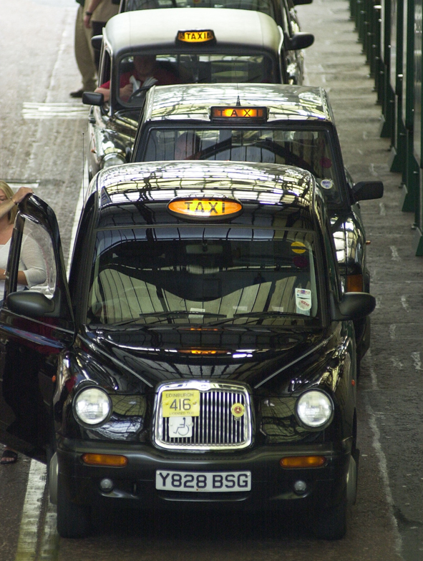

The annual turnover of the Edinburgh taxi and PHC trade is estimated to be in the region of £100 million.

Vehicle occupancy (excluding driver) appears similar to car use; whether they create extra vehicle kilometres is contentious. Less than 1% of journeys to work in 2001 were by taxi.

Issues
- PHC trade members have long sought access to bus lanes and other priorities
- The number of taxi ranks

- Encouraging use of ‘green’ vehicles
- Access to transport hubs
- Technological advances, and the opportunities they offer
- Integrating taxi/PHC licensing policy with the Council's transport strategies
- Reviewing the taxi limitation policy
- Various options for improving the licensing service
- Options for improving passenger service

Section 6: Rail

Relevant objectives
Consolidate recent, and secure further improvements to passenger railways | Make well designed Park and Ride available at the edge of, or outside the city
Support a strong city centre economy | Promote and facilitate local, national and international connectivity

The main areas for action
Continue to press for, and support, High Speed Rail network including Edinburgh | Continue to press for improved and extended rail network

The 11 railway stations in the Council area range from basic halts with around 20,000 passengers/yr, to a national hub at Waverley, used by 20 million. Scottish services are operated by Scotrail; cross-border services by East Coast, CrossCountry Trains, Virgin West Coast, and First Transpennine Express.

Between 2004 and 2010, journeys to or from the rest of Scotland grew from 15.3million to 19.8m. Trips to or from the rest of the UK grew from 2.2 m to 3.1m. Most trips to Edinburgh stations are from Glasgow, Fife, West Lothian, then within Edinburgh.
Since the Airdrie-Bathgate route was reopened in December 2010, and Bathgate-Edinburgh frequencies doubled, travel has grown between Edinburgh, Bathgate (4%), Uphall (21%) Livingston North (12%), and by 14% along the whole route from Helensburgh. Similar effects are expected from reopening the Borders railway (2014).

An improved Edinburgh-Glasgow Queen St route with faster journey times will affect Edinburgh Park, Haymarket and Waverley.

The impact of the planned Edinburgh Gateway station will be more complex. The Tram will link it, Edinburgh Park and the Airport. The new station may abstract some passengers from existing stations, but most are likely to be new to rail.
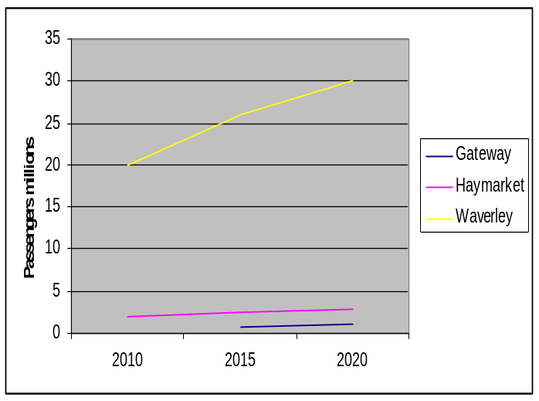
Haymarket estimated from ORR factored by NR/Transport Scotland projection
Growth at Waverley and Haymarket will significantly affect connecting transport networks.

At Waverley the station fabric is being renewed; escalators and lifts at Waverley Steps and improved entrances are being installed. Network Rail is redeveloping Haymarket station into a major transport interchange.

During this PATAP, physical integration issues will focus on Waverley, Haymarket, Edinburgh Park and Edinburgh Gateway. The Tram will add significant capacity at Haymarket; bus connections are critical at Haymarket and Waverley. Network Rail is developing a station Travel Plan for Waverley.

There are over 6,500 car park spaces at stations in the Edinburgh Travel to Work Area, mostly owned by local authorities. Some car parks have been expanded but are still over-subscribed. Transport Scotland’s future rail Park and Ride plans are awaited.

All the rail franchises serving Edinburgh will be renewed during this Plan. The Council’s approach to the next Scotrail franchise will reflect its response to Transport Scotland’s ‘Rail 2014’ consultation.

The case for a new high-speed rail route between Scotland and the south of England is clear. The target should be a journey time well under three hours between Edinburgh and London. The Council will continue to lobby for bringing forward high speed services, and the construction of high speed infrastructure, serving Edinburgh and Scotland. It will continue working with other agencies to plan for high speed rail, including an Edinburgh station, connecting wider Scotland to the wider high speed network.
Nevertheless, existing long-distance services to other parts of the UK are still important. The Council will continue to press for improvements by engaging with operators and those who let rail franchises as opportunities arise.

The Council notes that options considered for reintroducing passenger trains on the Edinburgh South Suburban Railway are insufficiently strong to warrant requesting further Scottish Government consideration in the current economic climate.

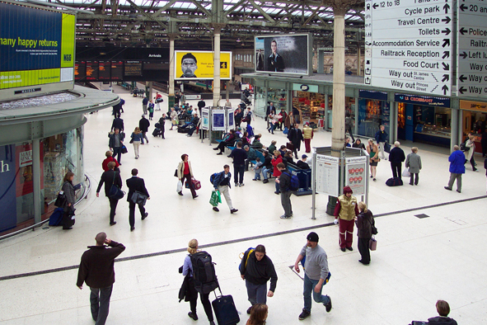

Section 7: Tram

Relevant objectives
Implement the Tram as an integral part of the public transport system | Make well designed Park and Ride available at the edge of, or outside the city
Support a strong city centre economy | Promote and facilitate local, national and international connectivity
Mitigate the local and global environmental and transport impacts of long distance travel

The main areas for action
Ensuring Tram integrates fully in city’s public transport network

Edinburgh’s Tram scheme is now based on a route between the Airport and York Place. It is predicted to carry 5.1 million passengers in year 1 (starting 2014), rising to 7.5 million in year 5. One of the Council’s pledges (2012-2017) is to ‘complete the Tram project in accordance with current plans’.

The route includes many interchange points with bus and rail. Tram stops at Edinburgh Gateway, Edinburgh Park, Haymarket, Princes St and St Andrew Square will be particularly important. The integration plan for bus and Tram seeks to achieve optimal alignment of service patterns at interchanges, making interchanging as simple and easy as possible. The facilities needed for interchange will be defined and installed during this Plan.
Lothian Buses will operate the Trams, and is responsible for integrating bus and Tram. As far as the passenger is concerned, Trams will have the same ticketing and information arrangements as buses. The short term priority is to implement what is needed to ensure seamless interchange between bus and Tram.

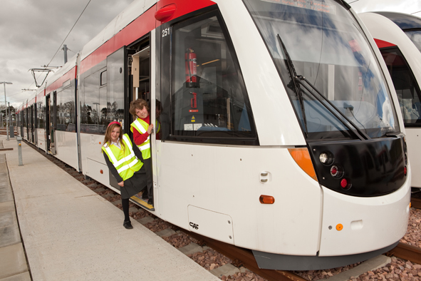

Section 8: Information
Relevant objectives
To maximise the provision of information to potential travellers

The main areas for action
Updating the Bus Information Strategy

The Transport (Scotland) Act 2001 requires the Council to produce a strategy for providing information at bus stops. The Edinburgh Bus Information Strategy (2007) sets out minimum standards for bus stop information, on buses, in print and on web-sites. The actual information is provided largely by the operators, and at bus stops is generally good.

The Strategy also sets out aspirations for information in the future. The current minimum standards include, for all operators:
- websites with current timetables and fare information, concessions and maps
- comprehensive timetable leaflets showing start dates, route maps, Traveline Scotland information, wheelchair accessible routes, public holiday services
- a commitment to subscribe to and promote Traveline Scotland
- service changes advertised on buses 21 days in advance

Future goals set out in the Bus Information Strategy are now included in this Action Plan:
- accessible information for those with disabilities
- comprehensive information at the bus, Waverley and Haymarket stations, tourist information centres, Council offices, libraries,

- hospitals, the airport, major out-of-town shopping centres, park and rides, universities and colleges
- an all-operator map of the city on the Council web-site
- all bus company web-site links to Traveline Scotland
- different bus companies to integrate information to reduce clutter and help comprehension
- illuminated information displays
- more interchange points
- ‘next stop’ electronic signs on buses
- internal route diagrams on buses showing interchanges
- continued roll-out of Bustracker signs at stops and other key locations
- audible RTI at bus stops

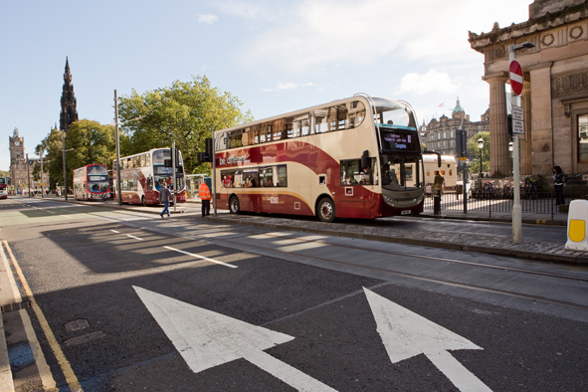

Currently over 360 stops have Bustracker real time information displays. Displays were initially concentrated along main arterial bus routes, subsequently at key bus stops on less well used and less frequent bus routes.

In recent years new installations have depended on developer funding, with a new emphasis on providing Bustracker information via the internet and to mobile phones. The information is available on most of Lothian Buses routes. The system architecture is available for other operators to use.

The most significant change has been the introduction of Bustracker information on the web, by text, and by apps. Information on service disruption is posted on the Edinburgh Travel Disruptions Twitter feed.

The variety and capability of communications technologies grows at a remarkable pace. A substantial commitment is therefore required to monitoring, and exploiting, new media channels to provide passenger information.

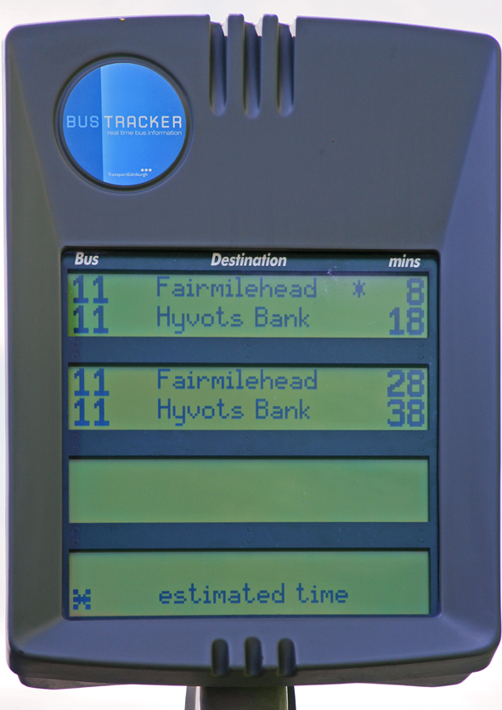

Section 9: Targets and Monitoring

Transport 2030 Vision Outcomes impacting on public transport (includes data from 2011 annual report)
Indicator |  | Baseline |  | Previous annual report | Most recent |  | Trend
Greenhouse gas emissions for road transport in Edinburgh |  | CO₂: 786 thousand tonnes per year Decrease year on year |  | CO₂: 743 thousand tonnes per year  2008 | CO₂: 723 thousand tonnes per year  2009 |  | 
Local nitrogen dioxide concentrations |  | 27 micrograms per cubic metre  Decrease year on year |  | 24 micrograms per cubic metre  2009 | 31 micrograms per cubic metre  2010 |  | _
Working age population, resident in SEStran area, within 30 minutes public transport travel time from centres of employment |  | City Centre: 322,822  South Gyle Business Park: 145,653  Victoria Quay, Leith: 184,693  Ferry Road / Crewe Toll: 210,466  Increase year on year |  | City Centre: 330,186  South Gyle Business Park: 156,182  Victoria Quay, Leith: 210,686  Ferry Road / Crewe Toll: 222,675 | City Centre: 341,083  South Gyle Business Park: 162,032  Victoria Quay, Leith: 221,295  Ferry Road / Crewe Toll: 233,419 |  | 
Accessibility of hospitals by public transport (population within 30 mins public transport travel time), 8am-9am weekdays |  | Western General Hospital: 225,122  Royal Infirmary: 97,086  Increase year on year |  | WGH: 2006 212,810  2008 218,460  RIE: 2006 130,172  2008 130,772 | WGH: 2010 228,199  RIE: 2010 134,144 |  | 
Indicator |  | Baseline |  | Previous annual report | Most recent |  | Trend
Satisfaction with access by public transport |  | Households walking time < 6 mins to bus stop and frequency.  2005 -2006  5+ buses/hr 46%  3-4 buses/hr 29%  1-2 buses/hr 6%  Increase bus frequency |  | Households walking time < 6 mins to bus stop and frequency.  2007 – 2008  5+ buses/hr 50%  3-4 buses/hr 28%  1-2 buses/hr 6% | Households walking time < 6 mins to bus stop and frequency.  2009 – 2010  5+ buses/hr 55%  3-4 buses/hr 24%  1-2 buses/hr 6% |  | 
Views on convenience of public transport |  | 91% very or fairly convenient  Maintain or improve year on year |  | Not available | 93% very or fairly convenient. |  | 
Feeling safe when travelling by bus in the evenings |  | 70% very/fairly safe, 18% do not know. Increase year on year |  | 71.8% very/fairly. 14% don’t know | 73.9% feel safe and secure |  | 
Feeling safe when travelling by train in the evenings |  | 42% very/fairly safe 48% don’t know Increase year on year |  | 49% very/fairly. 37% don’t know | 80.8% strongly agree or tend to agree (NB in 2009-10 only those who used a train in past month were asked, & question changed (previously specific to crime) |  | 
Integrated ticket sales |  | 2007-8 Oneticket sales (bus with bus); 22,929  Increase |  | 2008-9; 24,298  2009-10; 24,575 | 2010–11: 27,211 |  | 
Accessible public transport infrastructure |  | 100% Lothian Buses/70% First buses low floor  58% of bus stops with 24hr Clearway markings  Increase year on year |  | 100% Lothian Buses/71% First buses low floor  60% of bus stops with 24hr Clearway markings | 100% Lothian Buses/71.4% First Bus low floor  63% of bus stops with 24hr Clearway markings |  | 
Indicator |  | Baseline |  | Previous annual report | Most recent |  | Trend
Accessibility for those with no car access |  | 39% very/fairly difficult (access to GP)  65% very/fairly difficult (Visiting friends and relatives)  67% very/fairly difficult (access to supermarket shopping)  Decrease year on year |  | 40% very/fairly difficult (access to GP)  62% very/fairly difficult (Visiting friends and relatives)  64% very/fairly difficult (access to supermarket shopping) | 44% very/fairly difficult (access to GP)  73% very/fairly difficult (Visiting friends and relatives)  68% very/fairly difficult (access to supermarket shopping) |  |  SHS reduced sample size 2007, new weighting 2008. Figures here re-weighted. Results subject to sampling variability. Care needed re year-year changes
Demand not met for door to door transport |  | Handicabs Dial a Bus refusals: 1.6%  Handicabs Dial a Ride refusals: 19.3%  Decrease year on year |  | Handicabs Dial a Bus refusals: 1%  Handicabs Dial a Ride refusals: 16.1% | Handicabs Dial a Bus refusals: 0.26%  Handicabs Dial a Ride refusals: 15.4% |  | 
Journey time variability by general traffic (public transport to follow in future years) |  | General traffic - greatest average travel time variability 12 minutes AM, 13 minutes PM  Decrease variability for public transport Stabilise or reduce variability for cars |  | Not available | Proportion of journeys by general traffic on main roads within 3 minutes of average journey time: 88%  Proportion of journeys by general traffic on city centre roads within 3 minutes of average journey time: 95%
Indicator |  |  | Baseline | Previous annual report | Most recent | Trend | Indicator
Peak person trips to the City Centre |  | Increase walk, cycle, public transport; reduce private cars
2007  A90  A8  A70  A702  A7  B1350  A900  Total | Bicycles Cars & taxis Pedestrians Bus pax  30 1279 58 1725  61 1366 236 3032  61 639 917 2428  30 665 131 1540  27 1016 397 4164  44 1073 215 4391  36 1318 725 3939  289 7356 2679 21219 |  |  | Bi C/T Ped BP  35 1241 71 1760  88 574 233 3210  36 321 1270 2538  32 563 315 2026  56 553 500 5100  46 490 407 4379  42 956 936 4392  335 4698 3732 23402 | Bi C/T Ped BP  39 1448 68 1597  70 1486 236 3446  54 675 1159 2686  81 978 320 2122  78 1139 524 5246  50 1279 321 4154  60 135 540 2947  432 8140 3168 22198
Satisfaction with bus services |  |  | Increase year on year | satisfied with:  Driver behaviour, attitude 97%  Driving style, journey smoothness 94%  Frequency 84%  Punctuality 79%  Reliability 92%  81% rate LBs overall service excellent/very good | satisfied with:  Driver behaviour, attitude 85%  Driving style, journey smoothness 97%  Frequency 86%  Punctuality 86%  Reliability 94%  85% rate LBs overall service excellent/very good

Other targets
The targets are a 17% increase in trips on Lothian Buses and Tram between 2010 and 2015, 33% increase between 2010 and 2020; i.e. on bus and Tram in 2015, 128 million trips, in 2020 145 million trips. NB for consistency, these figures exclude the additional routes adopted by Lothian Buses in 2012 to replace those previously operated by First Bus in East and Midlothian.
By rail, Haymarket growing from 4.1m users in 2010, to 5.5m in 2015, 6.5m in 2020; Waverley from 20m in 2010 to 26m in 2015, 30m in 2020
The targets below are for Edinburgh residents only; the aim is to increase public transport’s share of all their trips by 2015 by 1.3%, and by 2020 by 2.3% compared to the (SHS) average of 2007-8 and 2009-10 (19.1%)

 | Trend data |  |  |  |  |  |  |  |  |  | PATAP and ATAP targets for 2015 (and 2020)
Modal split; All journeys by CEC residents |  | 1999 |  | 2000 | 2004 |  | 2007-8 |  | 2009-10
Modal split; All journeys by CEC residents | Walk | 24% |  | 24% | 23% |  | 34.3% |  | 35% |  | Walk | 34.5% (35%)
Modal split; All journeys by CEC residents | Cycle | 2% |  | 1% | 2% |  | 1.6% |  | 2% |  | Cycle | 5% (10%)
Modal split; All journeys by CEC residents | PT | 16% |  | 17% | 19% |  | 20.3% |  | 18% |  | PT | 20.5% (21.5%)
Modal split; All journeys by CEC residents | Car | 57% |  | 56% | 54% |  | 42.9% |  | 43% |  | Car | 38% (31.5%)
Modal split; All journeys by CEC residents | Other | 1% |  | 2% | 2% |  | 1.1% |  | 1% |  | Other | 2% (2%)
Modal split; All journeys by CEC residents | SHS changed methodology in 2007-8, significantly increasing walking mode share at expense of others |  |  |  |  |  |  |  |  |  | PATAP and ATAP targets based on current methodology
Modal split; School travel |  |  | 2001 |  | 2003-4 |  |  |  | 2009-10 |  | Increase
Modal split; School travel | Walk |  | 52% |  | 56% |  |  |  | 62%
Modal split; School travel | Cycle |  | <1% |  | 1% |  |  |  | 1%
Modal split; School travel | PT |  | 17% |  | 17% |  |  |  | 16%
Modal split; School travel | Car |  | 31% |  | 26% |  |  |  | 20%
 | Trend data |  |  |  |  |  |  |  |  |  | PATAP and ATAP targets for 2015 (and 2020)
Modal split; Travel to work |  |  | 2001 |  |  | 2004 |  |  |  | 2009-10
Modal split; Travel to work | Walk |  | 15% |  |  | 22% |  |  |  | - 19%
Modal split; Travel to work | Cycle |  | 4% |  |  | 4% |  |  |  | - 7%
Modal split; Travel to work | PT |  | 25% |  |  | 27% |  |  |  | - 30%
Modal split; Travel to work | Car |  | 54% |  |  | 46% |  |  |  | 42%

Appendix: PATAP Actions

S = short term, 2013-15. M = medium term, 2015-18. L = long term, 2018-20
Column 3 shows completion dates assuming current funding levels. Column 4 shows timescales with additional funding

 | Action | Time (with current funds | Time (with additional funds) | Lead | Partners
 | Joint Actions/variations on ATAP and Road Safety Plan
J10v | Increase enforcement of Planning Conditions with regard to Public Transport | nil | S-M | Planning
J13v | By enforcing compliance with Streetworks Acts, ensure that utilities reinstate lines, symbols and coloured surfacing where they are removed as part of street works | S | S | Street Inspectors | Utilities
J16v | Continue developing School Travel Plans, including encouraging Public Transport use | Ongoing | Ongoing | Tran (Road Safety) | Education
J23v | Promote public transport in workplaces/travel plans/etc e.g. hospitals by establishing Travel Planning Officer | nil | M | Trans | Workplaces/ hospitals etc
W5 | Based on the audits of routes to Saughton and Broomhouse Tram stops, carry out improvements to the pedestrian routes to these stops in time for the opening of the Tram | S | S | Trans
W6 | Audit other Tram stops and improve pedestrian routes to/from these | M | S | Trans | SfC
W7v | Review and upgrade pedestrian and cycle routes to Haymarket Station and, if feasible, increase the number of access points | nil | S-M | Trans | TS, Network Rail, Scotrail
W7v2 | Review and upgrade bus stops at Haymarket Station | S-M | S-M | Tran (PT& Accessibility)
W8 | Review and upgrade pedestrian and cycle routes to Waverley and upgrade the access points, particularly underused routes | nil | S-M | Trans | Planning, TS, Network Rail
W8v | Review and upgrade bus stops at Waverley | S-M | S-M | Tran (PT& Accessibility)
 | Action | Time (with current funds | Time (with additional funds) | Lead | Partners
W9 | By April 2012 produce a priority list of bus stops for improved access (i.e. routes to and from the stops) and implement a programme of improvements, with an initial target of 20 bus stops per year from 2012-2013 onwards | S-L | S-L | Tran (PT& Accessibility)
E1 | Complete a wayfinding audit (Tram, bus, walk, cycle) on access routes to/from Edinburgh Gateway, Edinburgh Park, Haymarket and Waverley stations, and implement recommended actions | M-L | S-M | Tran (Strat Planning) | Tran (PT& Accessibility)
E2 | Identify interventions needed at Edinburgh Gateway, Edinburgh Park, Haymarket and Waverley stations to accommodate predicted long term growth | S | S | Trans | TS, Network Rail, Scotrail
E3 | Ensure the Planning process permits developments at locations and in a sequence that supports development of commercial bus services; by Development Control involvement in bus liaison meetings | S-L | S-L | Planning
C6 | Improve cycle links to Tram stops/transport interchanges, starting with routes to Balgreen and Saughton Tram halts | S-M | S-M | Trans
C59 | Work with rail industry to provide/improve bike parking at stations/bike hubs | Ongoing | Ongoing | Trans, ScotRail | TS, Network Rail
C60v | Introduce ‘Station Travel Plans’/‘Safe Routes to Stations’ | M | M | Network Rail | TS
C61 | Consider a pilot bus bike carriage scheme for an appropriate urban - rural route | S | S | Tran (Strat Planning) | Operators
S1 | Investigate the cause of incidents involving elderly people using buses in Edinburgh | Ongoing | Ongoing | Tran (Road Safety) | Children & Families, Police, ACFAA Advisory Grp, Equals Network, LB, Firstbus
S2 | Consider developing with partners a Safer Travel Partnership to improve the personal security of bus users, pedestrians and cyclists | M | S | Tran | Police, Operators, etc
 | Action | Time (with current funds | Time (with additional funds) | Lead | Partners
T3 | Provide education to identified target user groups regarding future integration with the completed Tram project and required safety practices to be adopted | S | S | Road Safety | Tram, Children & Families, Fire Brigade etc
 | Bus Operations
B1 | Work with bus operators on Tram and bus integration arrangements in terms of fares, ticketing and service patterns | S-M | S-M | Tram Team, Lothian Buses | LB, Firstbus
B2 | Identify opportunities for operators to improve frequencies evening and Sunday bus services | L | S-M | Tran (PT& Accessibility) | LB, Firstbus
B3 | Assess implications of Competition Commission report and report further actions required | S | S | Tran (PT& Accessibility)
B4 | Establish operator/local government dialogue on services | S | S | Tran (PT& Accessibility) | Bus operators
B5 | Examine opportunities for financial resources to ‘kick start’ new bus services to new developments that that may have demand close to commercial levels | L | S-M | Tran (PT& Accessibility)
B6 | Ensure events planning preserves PT routes as long as possible; through liaison with Events Unit | S | S | Tran (PT& Accessibility) | Corporate Services
B7 | Improve roadworks co-ordination; more consideration to impact on PT in city-wide traffic management | M | M | SfC | Utilities
B8 | Encourage more Lothian Buses onstreet ticket sellers/giving information |  |  | Lothian Buses
B9 | Subject to LTS approval, ringfence a proportion of new parking charge revenue for supported services | S | S | Tran
B10 | Develop options for reducing costs and increasing revenue at the Bus Station | S | S | Tran (PT& Accessibility)
B11 | Review methodology for prioritising supported services, and identify improvements in procurement processes | S-M | S-M | Tran (PT& Accessibility)
B12 | Identify weaknesses in reliability/access to jobs/access to hospitals/ frequency | S | M-L | Tran | Bus operators
 | Action | Time (with current funds | Time (with additional funds) | Lead | Partners
B13 | Review winter gritting routes to ensure reflect updated bus routes | Ongoing | Ongoing | SfC
B14 | Encourage operators to develop the range of, and the access to, multi-modal, multi-operator, multi-journey tickets | Ongoing | Ongoing | Tran (PT& Accessibility) | Bus operators
B15 | Work with operators to expand ticket products to suit City visitors | Ongoing | Ongoing | Tran (PT& Accessibility) | Bus operators
B16 | Provide information to the Traveline Scotland service | Ongoing | Ongoing | Tran (PT& Accessibility)
B17 | Major events; action to promote public transport information | nil | Ongoing | Tran (PT& Accessibility) | Events
B18 | Review and implement Bus Information Strategy  - accessible information for those with disabilities  - comprehensive information at bus, Waverley and Haymarket stations, tourist information centres, Council offices, libraries, hospitals, airport, main out-of-town shopping centres, park & rides, universities, colleges  - an all-operator map of the city on the Council web-site  - all bus company web-site links to Traveline Scotland  - different bus companies to integrate information to reduce clutter and help comprehension  - illuminated information displays  - ‘next stop’ electronic signs on buses  - internal route diagrams on buses showing interchanges | S | S | Tran (PT& Accessibility)
 | Bus Infrastructure
H1 | Review all existing bus gates to ensure they are converted to bus lanes where required, using powers of traffic regulation variation so that they can be used by taxis | M | S | Tran Projects Dev | Tran Traffic Reg. & Enforcement
H2 | Review Interchange principles; to enhance services to meet passenger needs better, enhance bus operations efficiency and be practical in traffic engineering terms | nil | S | Tran (PT& Accessibility)
H3 | Identify key Interchange sites and actions (at key Tram stops, Bus Station, Waverley, Haymarket, Edinburgh Park and Edinburgh Gateway). Implement improvements, subject to funding. | S-M | S-M | Tran (PT& Accessibility)
 | Action | Time (with current funds | Time (with additional funds) | Lead | Partners
H4 | Parking controls on major corridors | L | S | Tran
H5 | Review and improve effectiveness of existing priority measures outwith priorityconnect Corridor: 1) general approach, 2) corridor by corridor | nil | M-L | Tran Projects Dev
H6 | Work with operators to identify where bus lanes most often transgressed; introduce remedial programme; determine extended programme | L | S | Tran Projects Dev | LB
H7 | Speed up selected bus corridors by traffic signal phasing | S | M | Tran
H8 | Work with operators to take up improvements in Smart ticket recognition technology | Ongoing | Ongoing | Tran (PT & Accessibility), Lothian Buses
H9 | Ensure all bus boxes correct length (covered by audit) | M | S | Tran (PT& Accessibility)
H10 | Identify funding for orbital bus services on the city bypass | nil | M | Tran | SESTRAN
H11 | Preserve and enhance good bus access across the city centre | Ongoing | Ongoing | Tran | Bus operators
H12 | Install signs at Waverley Station to buses and vice versa | S-M | S-M | Network Rail, Tran (PT & Accessibility)
H13 | Install 15 Talking Bustracker signs; review, consider more | S | S | Tran (PT& Accessibility)
H14 | Consider adding street names to stops and shelters | nil | S-L | Tran (PT& Accessibility)
H15 | Provide/improve bike parking at bus and Tram stops where high demand | S-M | S-M | Tran
H16 | Sunday Parking; yellow line restrictions on main public transport corridors; charges in core retail areas, and residents’ permits in zones to be decided, subject to LTS | S | S | Tran (Strat Planning)
H17 | Work with Transport Scotland to ensure delivery of the Forth Replacement Crossing Public Transport Strategy | S-M | S-M | Transport Scotland
 | Action | Time (with current funds | Time (with additional funds) | Lead | Partners
H18 | Monitor usage and review the potential for further bus-based park and ride sites, and for expanding those sites already delivered | Ongoing | Ongoing | Tran Projects Devlopment
H19 | Continue to implement further sites for Bustracker at key stops, and seek developer contributions | Ongoing | Ongoing | Tran (PT& Accessibility)
H20 | Develop and implement programme for further bus priority measures | L | M | Tran Projects Dev
H21 | Develop decriminalised bus lane camera enforcement | S | Ongoing | Tran Projects Dev
H22 | Develop a scoring matrix that can be applied to all bus stops to determine their accessibility and DDA compliance. Develop and implement further bus stop upgrading programme. | Ongoing | Ongoing | Tran (PT& Accessibility)
H23 | Complete input of bus stop data into ‘Freeway’ database. Log shelter type, pole, flag, Bustracker, box marking, signing, footway condition, location etc | S | S | LB
H24 | Review bus terminus arrangements | nil | M | Tran (PT& Accessibility)
H25 | Review coach set down and uplift points | nil | M | Tran (PT& Accessibility)
H26 | Produce new specification for bus stop carriageway surfacing | M | S | Tran Projects Dev
H27 | Create specification for new bus shelters to allow procurement to progress (2013) and complete tender documents for new bus shelter and advertising contract (2014) | S | S | Tran (PT& Accessibility)
H28 | Review bus lane policies (not including operating hours) | S | S | Tran (PT& Accessibility)
H29 | Develop and implement priorityconnect Corridor | L | M | Tran (PT& Accessibility) | LB, Firstbus
H30 | Ringfence revenue from bus lane cameras for bus infrastructure maintenance | S | S | Tran Projects Dev
H31 | Renew agreement with Lothian Buses for updating bus stop flags | S | S | Tran (PT& Accessibility) | LB

 | Action | Time (with current funds | Time (with additional funds) | Lead | Partners
H32 | Extending Hermiston Park and Ride site by 600 spaces | S | M | Tran Projects Dev
 | Rail
R1 | Input to next Scotrail franchise (commencing 2014) | S-M | S-M | Tran (PT& Accessibility) | TS
R2 | Implement actions W7v, W7v2, W8, W8v, E1, E2, C60v, H12 in order to address passenger growth at stations | M-L | S-L | Tran (PT& Accessibility)
R3 | Lobby government for significant improvement to long-distance rail travel times | S-L | S-L | Tran (PT& Accessibility)
R4 | Monitor opportunities for reintroducing passenger services on the ESSR | Ongoing | Ongoing | Tran (PT& Accessibility)
R5 | Promote and support introduction of High Speed Rail, including aim to reduce Edinburgh-London times to 2½-3 hours | Ongoing | Ongoing | Tran (PT& Accessibility) | TS, SESTRAN, Glasgow CC
R6 | Work in partnership with the rail industry, SESTRAN, other Councils, Transport Scotland and others as appropriate to improve services and promote new rail schemes | Ongoing | Ongoing | Tran (PT& Accessibility) | Rail industry, SESTRAN, TS, other Councils
R7 | Continue to respond to consultations by other agencies which impact on the future of rail services in and around Edinburgh | Ongoing | Ongoing | Tran (PT& Accessibility)
 | Taxi and PHC
L1 | Determine a suitable ratio of rank spaces: taxi licences | M | S | Tran (PT& Accessibility) | Licensing
L2 | Revise the number and location of taxi ranks across the city. Use the Neighbourhood Partnership system to identify any high amenity areas that would benefit from a taxi rank | By end 2013 | By end 2013 | Tran (PT& Accessibility) | Licensing, taxi operators, Dev Control
L3 | Encourage development of a smartphone app showing nearest taxi rank on a map of Edinburgh, and taxis available | nil | By end of 2014 | Tran (PT& Accessibility) | Software developers

 | Action | Time (with current funds | Time (with additional funds) | Lead | Partners
L4 | Develop further actions within a new ‘Taxi/PHC Action Plan’ within context of PATAP | S | S | Licensing | Tran (PT& Accessibility)
 | Community and Accessible Transport
A1 | Enforcement of blue badge fraud | Ongoing | Ongoing | Tran (Traffic & Eng)
A2 | Enforcement of bus stop parking regulations | Ongoing | Ongoing | Tran (Traffic & Eng)
A3 | Aim to process all Blue Badge applications within 28 working days | Ongoing | Ongoing | Tran (Traffic & Eng)
A4 | Install dropped kerbs near bus stops within programme of improvements see W9 above (initial target 20 bus stops/yr from 2012-2013 onwards) | Ongoing | Ongoing | Tran (PT& Accessibility)
A5 | Develop and consult on proposals to improve value for money among funded services | S | S | Tran (PT& Accessibility)
A6 | Aim to process all Taxicard applications within 28 working days | Ongoing | Ongoing | Tran (Traffic & Eng)
 | Tram
T1 | Implement Phase 1a of Edinburgh Tram | S-M | S-M | CEC | LB
T2 | Identify opportunities to enhance interchange between rail and Tram | M-L | S-M | Tran (PT& Accessibility) | LB, Tram Team
T4 | Identify and address parking issues around Tram stops | S-M | S-M | Tran | Tram Team
 | Other
G1 | Continue Green Fleet Policy and use alternative fuels as a first option when service delivery requirements, cost and fuel supply issues are acceptable | Ongoing | Ongoing | Corporate Transport Unit
G2 | By 2020, 50% of all licensed taxis and private hire cars to be low emission, the balance to be Euro 6 standard | L | L | From LTS Issues Paper
 | Action | Time (with current funds | Time (with additional funds) | Lead | Partners
G3 | By 2020, all buses serving Edinburgh to be at least Euro 5 emissions standard | L | L | From LTS Issues Paper
G4 | All supported services to comply with at least Euro 5 standard | L | S | Tran (PT& Accessibility)
 | Monitoring and review
M1 | Review and assess PATAP actions | M | M | Tran (PT& Accessibility)
M2 | Set up Review Group | S | S | Tran (PT& Accessibility)
M3 | Monitor PATAP outcomes through indicators listed in Section 10 | Biannual | Biannual | Tran (PT& Accessibility)
M4 | To improve future planning, carry out research to gather a better picture of how Edinburgh’s public transport networks are actually used; fill gaps in data on local public transport use | S | S | Tran (PT& Accessibility) | Operators

Further Information

Equalities, Diversity and Human Rights
See supplementary documents.

Strategic Environmental Assessment (SEA)
See supplementary documents.

Operational Plans
SOA
Let’s Make Scotland More Active
Local Plans
City Regeneration Strategy
2030 Transport Vision
LTS 2007-12
Walking Strategy
Road Safety Plan
Parking Strategy Review
Local Community Plans
Edinburgh Joint Health Improvement Plan
Active Travel Action Plan

Contact
We would be pleased to receive your comments and feedback on this plan. Please send them to:
Chris Day
Services for Communities
The City of Edinburgh Council
Waverley Court
Edinburgh
EH8 8BG
Tel: 0131 469 3568
E-mail chris.day@edinburgh.gov.uk



You can get this document on tape, in Braille, large print and various computer formats if you ask us.
Please contact ITS on 0131 242 8181 and quote reference number 12-0861.
ITS can also give more information on community language translations.
You can get more copies of this document by calling 0131 469 3568.

Annual Population Survey 2008 (Scottish Government)
2001 Census
Business Case Update 2010
Network Rail, Scotland Route Utilisation Strategy, 2011
Crossrail created Edinburgh’s first cross-city local rail service, with stations at Newcraighall, Brunstane, and Edinburgh Park
Office of Rail Regulation and Scottish Transport Statistics

