Word Count – 14,971

Table of contents

CHAPTER 1 - Introduction 5
1.1 Chapter contents 6
1.2 Rationale for the research 6
1.3 Aims and objectives 7
1.4. Relationship to chosen specialism 8
1.5 Outline research methodology 9
1.6 Synopsis 9
CHAPTER 2 - Active Travel 10
2.1 Introduction 11
2.2 The importance of Active Travel for the individual 11
2.2.1 Active Travel: Scotland in context 15
2.3 Active travel as a sustainable mode of transportation 16
2.4 Encouraging Active Travel through land use planning 18
2.6 Conclusion 21
CHAPTER 3 - Design for cycling 22
3.1. Introduction 23
3.2 Design principles for cycle paths 23
3.2.1 Designing for cycling : Edinburgh policy context 27
3.4 Further influences on Active Travel choices 30
3.4.1 Safety 32
3.5 Conclusion 34
CHAPTER 4 - Methodology 35
4.1 Introduction 36
4.2 Research methodologies 36
4.3 Research design 36
4.3.1 Design of the questionnaire 38
4.3.2. Direct observation and participant observation 39
4.4. Limitations 40
4.5. Safety and Ethics 40
CHAPTER 5 - The Quality Bike Corridor 42
5.1 Introduction 43
5.2 Cycling in Edinburgh 43
5.3 The South Central area improvements 43
CHAPTER 6 – Findings and discussion 46
6.1. Introduction 47
6.2. Coherence 47
6.3 Directness 49
6.4 Attractiveness 51
6.5 Safety 52
6.6 Comfort 59
6.7 Conclusion 61
CHAPTER 7 – Conclusions and Recommendations 63
7.1. Introduction 64
7.2. Conclusions 64
7.3 Recommendations 65
REFERENCES 66
APPENDICES 76
Appendix A – Cycle design principles: importance by cyclist type 77
Appendix B – Cycle design principles: importance by user group categories 78
Appendix C – Design Approach for the cycle friendly city programme 80
Appendix D – The Quality Bike Corridor initial proposal in the Grimshaw Report (1985) 81
Appendix E – QBC Proposals in more detail 82
Appendix F – The questionnaires 86
Survey 1 86
Survey 2 87

Table of figures

Figure 2.2.1 - Trips per person per year by distance 12
Figure 2.2.2 – Physical Activity Spectrum 12
Figure 2.2.3 - Number of friends and acquaintances depending on traffic 14
Figure 2.2.4 - Bicycle share of trips 16
Figure 2.3.1 - Historic and Forecast Traffic and Emissions, England 17
Figure 2.3.2 - Comparison of the wider cost of transport in English urban areas 17
Figure 2.3.3 - Car-oriented transport development 18
Figure 2.4.1 Urban density and Transport related energy consumption 19
Figure 3.2.1 - Main requirements of cycling 24
Figure 3.2.2 - Cycling Infrastructure core Design Principles 24
Figure 3.2.3 - Priority of design principles for utility cyclists 25
Figure 3.2.4 - CROW guidelines for design criteria: CILT design checklist 26
Figure 3.2.5 - Edinburgh’s Transport Strategy hierarchy and cycling design guidance 28
Figure 3.2.6 – Urban on-road Cycling by Design criteria 30
Figure 3.4.1 - Influences on cycle use 31
Figure 4.3.1 - Email survey approaches and responses 39
Figure 5.3.1 - The Quality Bike Corridor in relation to the city of Edinburgh 44
Figure 6.2.1 - Road surfaces 48
Figure 6.2.3 - Coherence rating 49
Figure 6.3.1 - Cycle lane versus desire line path 50
Figure 6.3.2 - Encouragement to cycle more along the route 51
Figure 6.4.1 - Attractiveness rating 52
Figure 6.5.1 & Figure 6.5.2 – Survey respondents cycling experience 53
Figure 6.5.3 - Security improvements 1 53
Figure 6.5.4 - Security improvements 2 54
Figure 6.5.5 - Wider transport choices according to user of the route 54
Figure 6-5-6 - Perception of safety according to cycling user group – survey 1 55
Figure 6.5.7 - Perception of safety according to cycling user group – survey 2 56
Figure 6.5.8 - Likelihood to cycle more along the QBC 56
Figure 6.5.9 - Parking on cycle lanes 58
Figure 6.6.1 - Comfort rating 60
Figure 6.6.2 - Surface inconsistencies 60
Figure 6.6.3 - Path sections in need monitoring and maintenance 61
Figure 6.7.1 - Qualitative data findings 62

CHAPTER 1 - Introduction
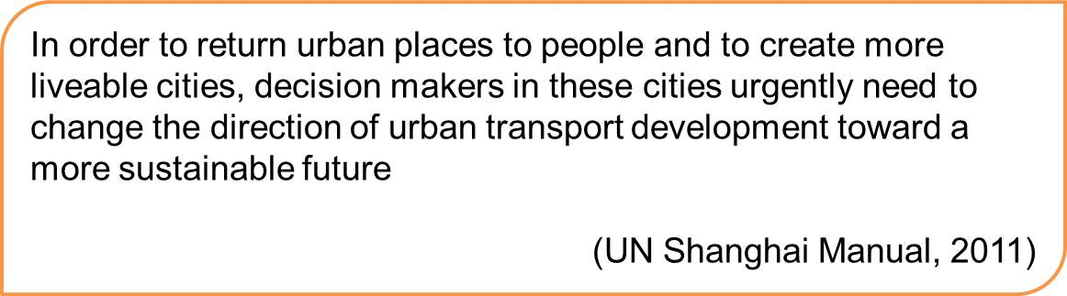

1.1 Chapter contents

The aim of this chapter is to demonstrate the rationale behind the dissertation topic, to clarify the research aims and its objectives and to go over the contents of each chapter in this dissertation.

1.2 Rationale for the research

Since the 1960's cities in the industrialized world increasingly relied on the motorcar as their main mode of transport. In the process, streets have been built to accommodate the never ending growth of capacity for traffic, and urban growth has been shaped with private transportation in mind (Newman, 2003).
Sustainability awareness has turned its sights on to transportation in the last two decades, as the relationships between transport and wider problematic issues are made more and more clear by researchers worldwide. In fact, changes in transportation have greatly added to our inactive lifestyles which contribute to health risks; they have enhanced inequalities; and they are one of the largest and fastest growing contributors of CO2 emissions worldwide: transport is the only sector of the UK economy where emissions have been projected to be higher in 2020 than those in 1990 (DfT, 2006).
As well as emphasizing that it is essential to reduce the need for travel, Banister (2005) is very clear about the role that transport must play in achieving sustainable development, the measures available point towards the limited role the car can have in our cities in the near future, in fact, he says “the sustainable city has no place for the car. Transport would be by walk and cycle, together with new combinations of eco-public transport” (Banister, 2005, p. 249). Although change has not been so radical, modal shift towards Active Travel has already been emphasized as part of a reduction of car-based travel. For example, EU guidance encourages non-motorized modes as a long-term sustainable alternative for short trips (Dekoster and Schollaert, 1999).
Changes in infrastructure can be used as a tool in achieving Active Travel policies. Urban design is seen as a piece of the puzzle in delivering quality urban public spaces and many car-dependant cities are investing in retrofitting design solutions to make people choose active travel, as it emerges as a practical response for both leisure and utilitarian trips, and as a solution to broader issues for those working not only in planning and transport, but also those in health, environment and social inclusion (Douglas, Watkins et al. 2011) : “the British Medical Association estimates the health benefits of cycling to outweigh the hazards by a factor of 20 to 1” (Horton, 2007, p.136).
Designing a transport infrastructure that supports car dependency has led to the decline of "people dominated streets, community surveillance, local streets as play streets and meeting areas, and walking and cycling as a daily routine" (Hull, 2011, p. 63) and thus, gradual loss of quality of life in built-up areas. Already in 1958, Jane Jacobs was pointing out how redesigning "downtown" and removing cars from it was not enough: "the whole point is to make the streets more surprising, more compact, more variegated, and busier than before-not less so" (Jacobs, 1958), this was later also explored by Gehl (1980), who considered in detail the speed of the city, and emphasized how slow traffic (walking) meant that cities were livelier and that people spent more time outdoors.
Horton summarizes the need for cycling infrastructure by saying that if we want cycling to thrive we need to replace the set-up which allows the car to command urban mobility: just like we have created a system where using the car has become "normal", we have to build infrastructure to allow for cycling to become "normal" (Horton, 2011).
Edinburgh, like many cities, recognizes the need to reduce car-based travel. The Council states: “We are committed to promoting sustainable transport, increasing the share of journeys made by public transport, foot or bicycle” (Edinburgh City Council, 2011). The city's latest addition to encourage Active Travel is the Quality Bike Corridor, which links two major university campuses, is a main route into the city centre and already attracts a significant number of cyclists. The aim, as per the City's Active Travel Action Plan, is to get people cycling more often and more safely, and in this way contribute to targets, and reflect the changes in urban transportation in the city.

1.3 Aims and objectives

Research question
Contribution of Urban Design to the delivery of Active Travel: Does the Edinburgh Quality Bike Corridor enable people to cycle more safely and more often?

Aim
To explore general design principles for cycle paths in urban areas and subsequently analyse the quality of the design in the Edinburgh Quality Bike Corridor critically.

Objectives
To outline the role of Active Travel as a Sustainable Transport Mode, and to review the contribution of Urban Design in achieving a more sustainable transport network.
To establish general design principles for cycle paths and set criteria against which the Quality Bike Corridor can be measured.
To investigate the tools Edinburgh City Council uses to support active travel and to assess the design solutions that have been incorporated in the Quality Bike Corridor against the principles set.
To consider user (and potential user) perceptions, as to whether the Quality Bike Corridor transmits a feeling of safety and encourages cycling.
To critically analyse the contribution of the Quality Bike corridor design improvements in achieving the Edinburgh Active Travel Action Plan targets.

1.4. Relationship to chosen specialism

The RTPI recognizes town and country planning as one of the tools for the promotion of sustainable development, and highlights travel as one of the new concerns in the creation of quality places (RTPI, 2001). Furthermore, professionals, such as Gehl (1980) affirm that the scope and character of outdoor activities are greatly influenced by the physical environment.
This dissertation proposes to explore the relationship between design and transport, and how they can contribute to the delivery of Active Travel by supporting the same interests. Planning has always been about the incorporation of many specialisms so, once again, the intention is to explore a subject – Active Travel – which is high on the government agenda because of the impact on so many of its objectives (such as emissions, health and equality).
Through urban design, planners can encourage different attitudes in the individual, including their transport choices: just as up to now cities have been designed "for the car", new designs can contribute to the fundamental shifts which are essential in the delivery of urban development that is sustainable.
The focus of this study is the suitability of design of cycle paths in urban areas, and how they can make users and potential users feel safer and thus change their behaviour. Much has been already done in establishing design principles for Active Travel. By adopting, and then adapting, design criteria we can establish if it works in a particular setting.
Following the RTPI requirement for accreditation of the MSc Urban and Regional Planning, this dissertation focuses on the specialism of Urban Design.

1.5 Outline research methodology

Both secondary and primary data were used for this study: a Literature Review, followed by collection of quantitative and qualitative data. Detailed information of research methods and the methodology design are explained in a dedicated chapter (Chapter 4, Methodology).

1.6 Synopsis

Chapter 2, Active Travel, is divided into three parts. The first part highlights the importance of Active Travel for the individual, and sets the context for Scottish Active Travel. The second part sets the context of Active Travel in the wider frame of Sustainable Transportation. The third part examines how land use planning can promote the delivery of quality environments that stimulate Active Travel.
Chapter 3, Design for Cycling, is divided into two parts. The first part focuses on design principles for cycle paths and establishes the criteria used further on in the findings. The second part observes other criteria that can influence the individual's decision to travel by bicycle (or not) in general, and discusses safety in detail.
Chapter 4, Methodology, is divided into five sections which (in this order) identify the most common research methodologies, describe the research design for this dissertation, outline the design of the questionnaire and the observations that were carried out, and review the limitations of the methodology.
Chapter 5, The Quality Bike Corridor, is divided into two parts. The first one introduces the cycling context in Edinburgh, and the second one outlines the City of Edinburgh Council actions to improve cycling in the city, including the Quality Bike Corridor.
Chapter 6, Findings and Discussion, analyses and assesses the results of the primary research in five different sections that correspond to the five criteria that have been established in Chapter 3.
Chapter 7, Conclusions and Recommendations, evaluates the dissertation and closes it by developing some suggestions.

CHAPTER 2 - Active Travel

2.1 Introduction

The aim of this chapter is to establish the benefits of Active Travel at an individual level, review Active Travel in Scotland, and also to portray this mode in the wider context of Sustainable Transport. Furthermore, this chapter will consider the role of the planning system in creating environments that promote Active Travel.

2.2 The importance of Active Travel for the individual

Active Travel is sometimes referred to as non-motorized transport, and is defined as “travel and transport by physically active, human powered modes as opposed to motorised ones, largely for functional reasons” (Cycling Scotland et al, 2012). In most cases, the literature refers to walking and cycling when citing active travel. However, there are broader definitions, such as Pettinga et al's (2009, p. 212) in their document “Cycling Inclusive Policy Development: A handbook”:

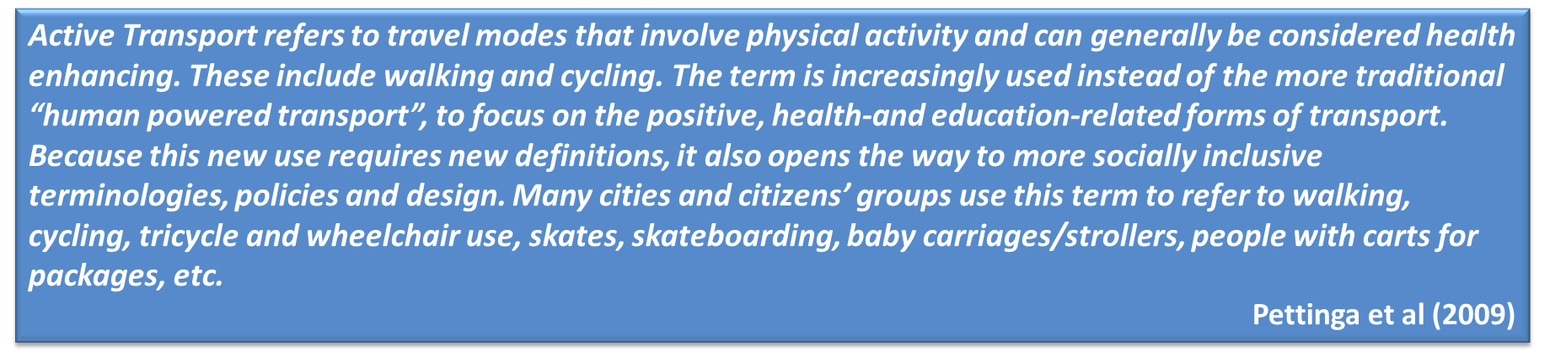

Although much emphasis has been put on walking, because of its speed and the distances that can be covered on it, it is cycling really which could provide an alternative to the car. “In urban areas, walking and cycling, together with public transport, often provide better alternatives not only in terms of emissions, but also of speed: they could readily substitute the large share of trips which cover less than 5km” (European Comission, cited in ECF 2011, p.1).
Of course there are no set definitions of the distance considered as “Active Travel” as this depends on the individual and varies according to the literature, but recommended distances are up to 2 miles walking and up to 5 miles cycling. The World Health Organization (WHO) advocates up to 5 km for adults (2004). In the UK, many of these trips are currently being made by car (Sustrans, 2011, see figure 2.2.1).
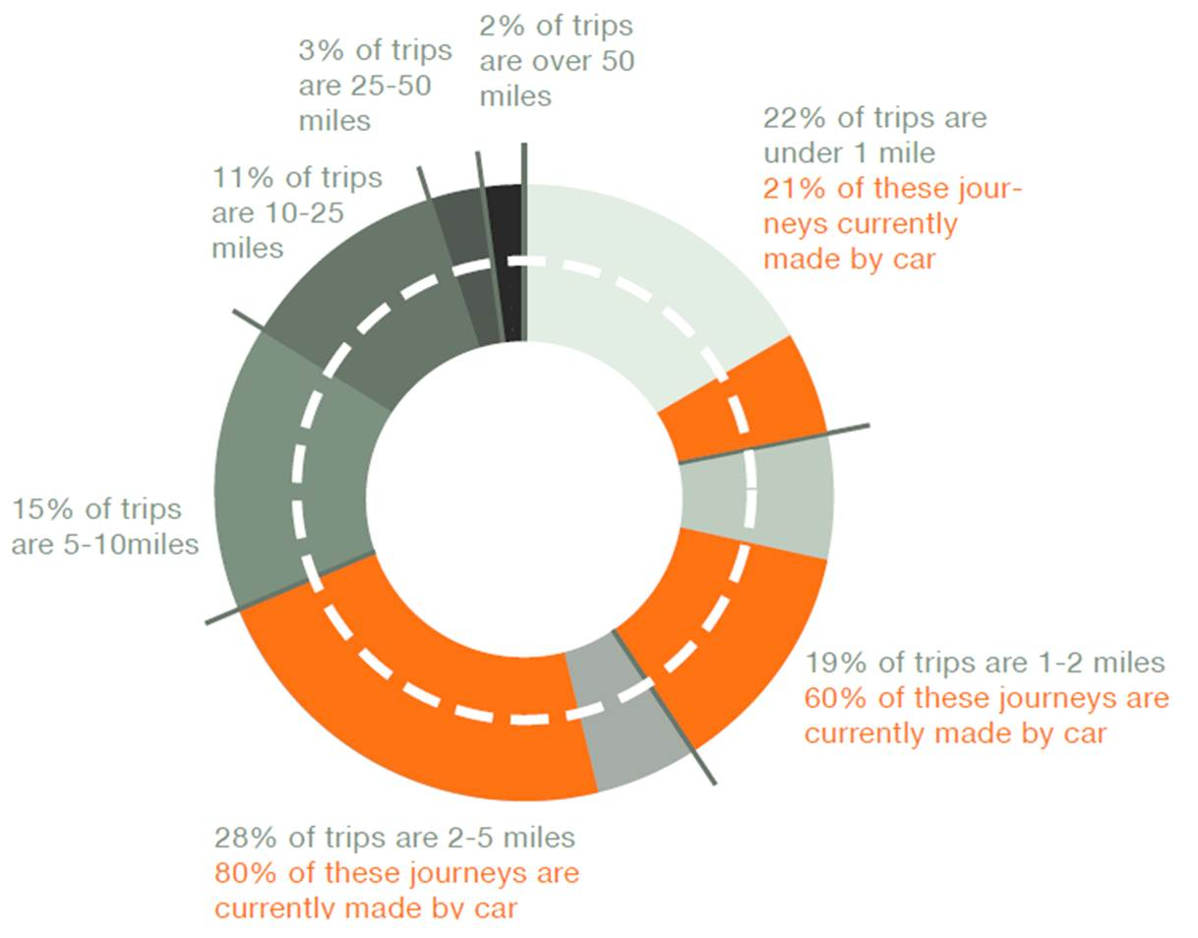
Figure 2.2.1 - Trips per person per year by distance – showing (in orange) percentage in each group made by car (Sustrans, 2007)

Choosing Active Travel also enables the fulfilment of a physical activity. Although walking and cycling can be choices for utilitarian or recreational purposes, when referred to as Active Travel it is mostly included with the former category, as shown in the above definition and the figure below (Figure 2.2.2), this is why it can also be referred to as Transport Related Physical Activity (TPA).

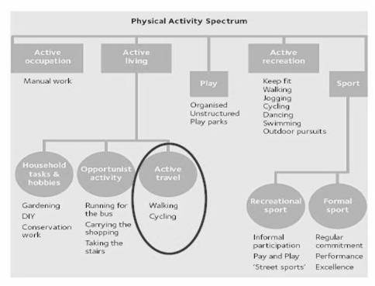
Figure 2.2.2 – Physical Activity Spectrum (Phillips, 2010)

The health benefits that transport related physical activity provides have been proven at an individual and societal scale (Cooper et al 2006, cited in Macmillen and Givoni 2009). On the other hand, physical inactivity is listed as the 4th highest risk factor causes of death in middle and high income countries (WHO, 2009, p.11) and road traffic has been singled out as the largest contributor to human exposure to air pollutants and linked to a wide range of negative health effects including increased mortality (WHO, 2006, p.1). For example, in their study of admissions for asthma during the 1996 Atlanta Olympic Games, Jackson and Kochititzky (2001) registered a decrease of 41.6% of patients, as restriction of cars in the downtown area translated into 22.5% less driving.
Shift to active travel modes thus can benefit significantly our health. In addition, there are possible benefits such as enhancing the community, improving society’s wellbeing and having an impact on crime rates (Hillman, 1990 and Rabl & de Nazelle, 2009).
The recent report Active Travel, Active Scotland, calls for key decision makers to significantly increase investment in active travel, precisely because it can have an impact on policy at many different levels: “transport, health, social inclusion, local economic development and regeneration” (Cycling Scotland et al, 2012).
Literature cites Active Travel as a major role player in the prevention of ill-health and the promotion of good health, for example (Douglas & Watkins et al, 2011; Shayler, Fergusson et al 1993; Edwards and Tsouros 2008; Hillman 1990): the prevention of osteoporosis, improved respiratory function, contribution to mental well-being, improvement of cardiovascular fitness, diabetes, reduced obesity, reduced deterioration in older age... And Barton et al (2010) list the promotion of healthy lifestyles, in particular facilitating active travel, as a critical issue in determining health and well-being in our settlements. Well-being is on this occasion seen as a more complete aim, not just physical health but also mental health: Appleby’s “Liveable Streets” (1981) findings exposed the harm that traffic caused to social cohesion; as shown on figure 2.2.3, the more traffic, the less friends and acquaintances an individual had on their street, this translated to comments from residents from "I don't feel alone" on a light traffic area, to "no one offers help" on a heavy traffic one.

Figure 2.2.3 - Number of friends and acquaintances depending on traffic. Appleyard D.(1981)

Hence, Active Travel entails some benefits that other forms of sustainable travel, such as car sharing or use of public transport networks, do not offer. As developed in the next section (2.3), it does not only offer benefits to the individual, but also to the environment.
At an international level, "there are large variations in the use of ‘active travel’ modes" (Steinbach et al 2011, p.1123). Nationally, people are choosing to use Active Travel less and less: Sustrans' information sheet on Active Travel and healthy workplaces point out a few of the UK's national characteristics (Sustrans, 2008):

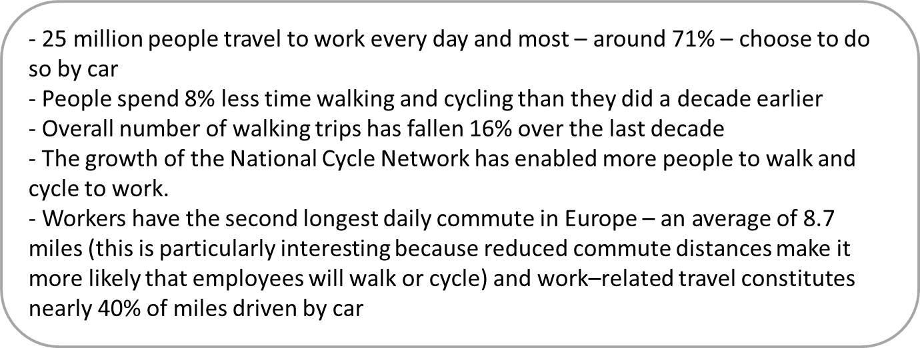

2.2.1 Active Travel: Scotland in context

Some cities, such as Copenhagen, have been at the forefront of adapting urban infrastructure to encourage active modes of transport; some of their adaptations go back to the 1960’s and so, active transport modes have actually become the most convenient way to get around in many instances and so, active travel rates are very high. In general, when comparing door-to-door journey speeds in the urban environment cycling is often as fast as travel by car (Dekoster and Schollaert, 1999).

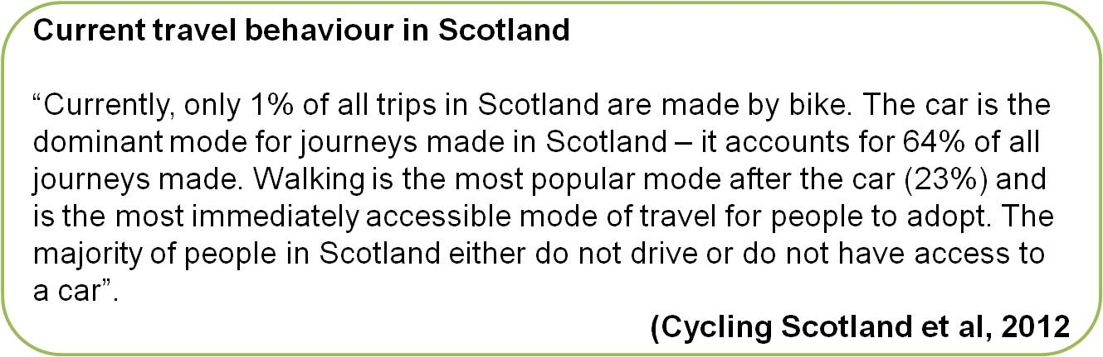

In Scotland Active Travel currently represents a very small proportion of all journeys: 1% by bike and 23% by foot (Cycling Scotland et al, 2012) compared to 64% of all trips made by car. And if we look at the figures for commutes to work active travel represents an even smaller percentage of the total. Travel within GB data (Transport Scotland, 2011b) revealed that in 2010, walking and cycling accounted for 153km and 34km respectively per person per year of distance travelled.
To put it into perspective, data which includes the entire population shows how in Denmark the average distance travelled by bicycle per inhabitant, per year was 958km in 1995, whilst in the UK it was 81km (Eurobarometer, 1995), as seen in Figure 2.2.4.
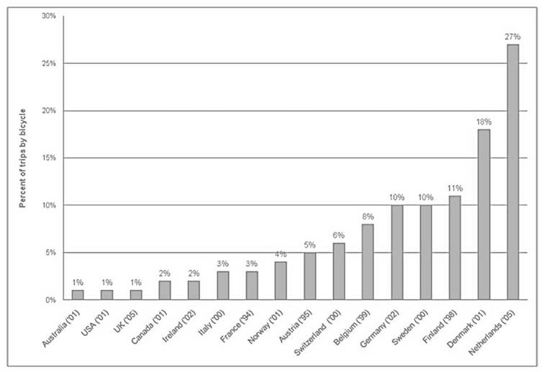
Figure 2.2.4 - Bicycle share of trips (percentage of total trips by bicycle) in Europe, North America and Australia. Pucher and Buheler (2008)

2.3 Active travel as a sustainable mode of transportation

The concept of Sustainable Development has globally gained weight since the publication of the Brundtland Commission Report. It reiterates that the environment, the economy and society are interlinked and that it is only by consciously making an effort at all levels (not only aiming for economic growth), that nations can hope for a development that meets the needs of both present and future generations (UN, 1987).
Within this context, of economic challenges, climate change and growing inequalities, in an era where populations in cities are exceeding those in rural areas for the first time ever (OCDE, 2010), we also need to think about what makes our current urban lifestyles possible: the material and energy requirements of cities, as well as the associated wastes and emissions (Corfee-Morlot et al, 2008). Sustainable Development calls for a holistic approach in the management of cities that will encourage local and global positive outcomes for city dwellers.
Active Travel can be a tool for sustainable travel. The following are only some of the interactions of the transportation network with other fields: the development and use of more environmentally friendly forms of transport are perceived as important factors for keeping emissions down (Stern
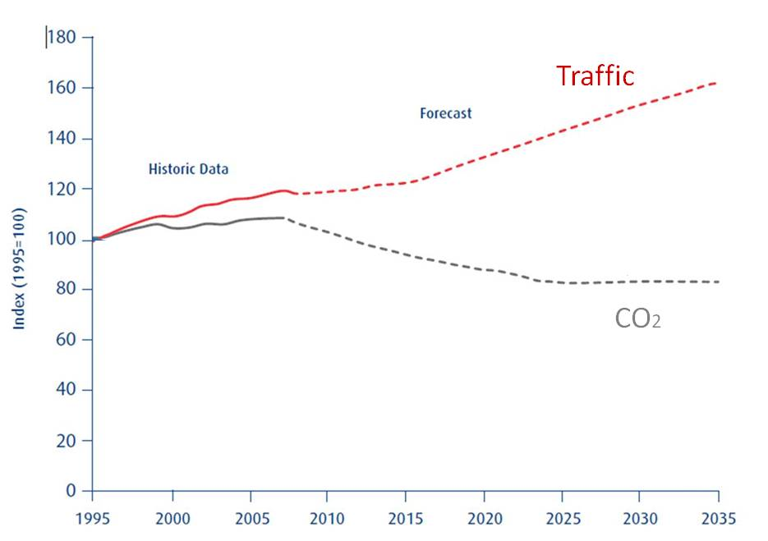
Figure 2.3.1 - Historic and Forecast Traffic and Emissions, England (adapted from DfT Road Transport Forecasts, 2009 cited in Sustainable Development Comission 2011)

Review, 2006); by providing more accessible mobility, the choice and availability of transport systems can contribute to social inclusion and quality of life (UN, 2011) and some authors such as Ravetz (1980) talk about the travel-rich and the travel-poor. Furthermore, active travel has been shown to have a beneficial effect on the economy, from dropping the share of the budget that is devoted to the car (Dekoster and Shcollaert, 1999), to more complicated Cost Benefit Analysis that leads to conclusions such as the following cited by Gehl (2011): society benefits up to $0.25cents per km cycled, as opposed to car travel, which has a detrimental effect on it. The estimated cost to society was quantified in 2009 by the Cabinet Office Strategy Unit as follows:
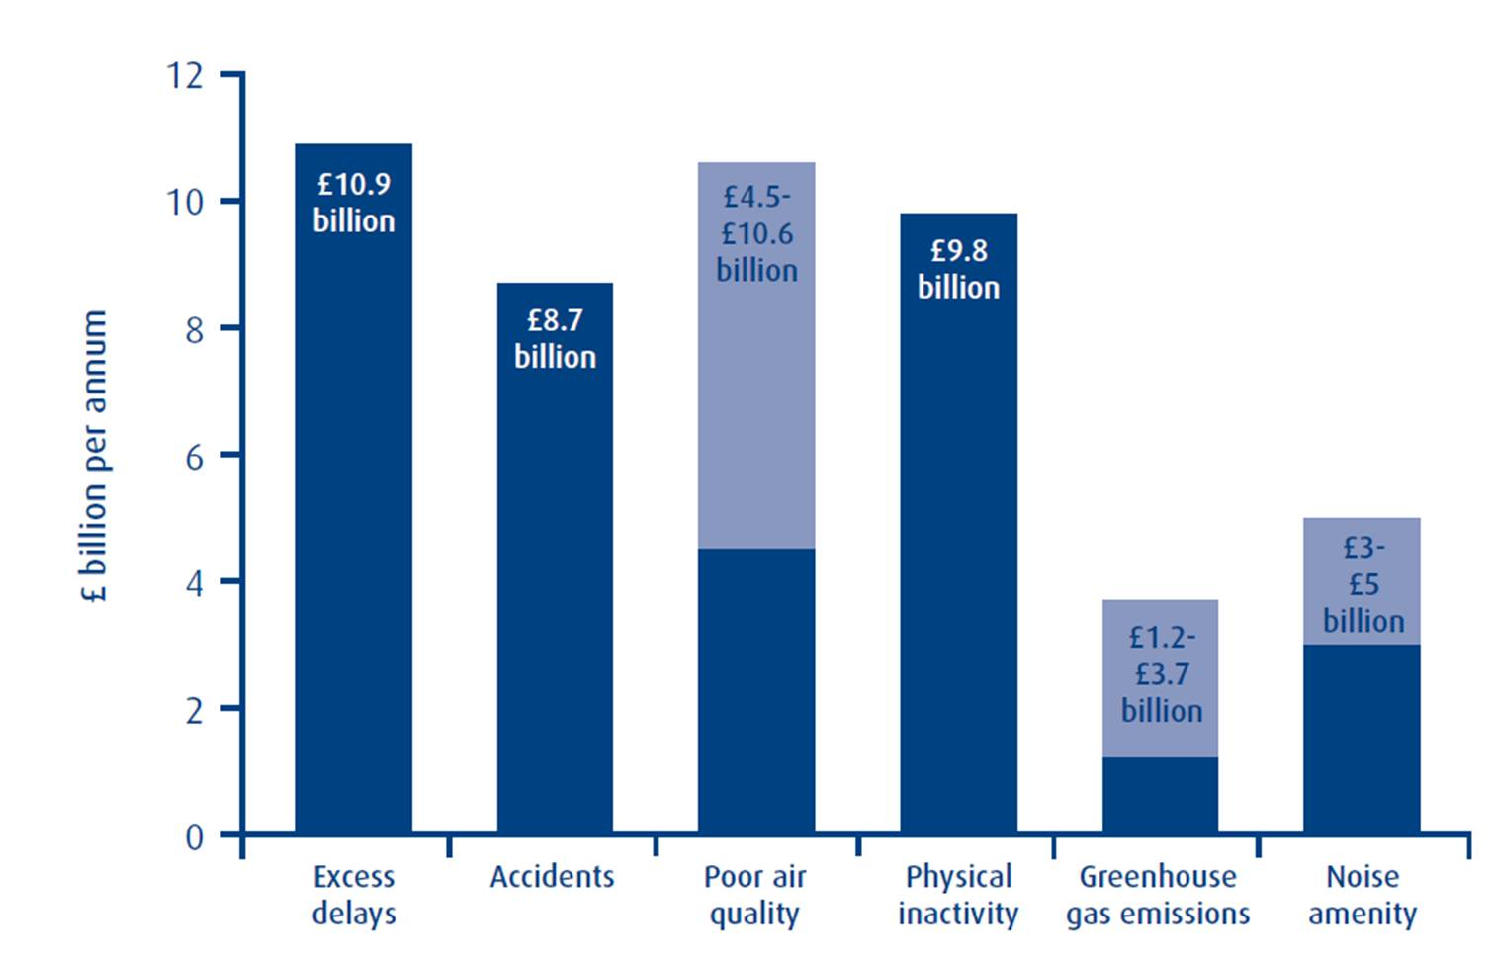
Figure 2.3.2 - Comparison of the wider cost of transport in English urban areas - £billion per annum, 2009 prices and values (Cabinet Office 2009)
In a reverse trend of transport modernisation seen as an interdisciplinary adaptation to the automobile, and thus the creation of society's dependence on private transportation, cities need to understand that it is transport that needs to be moulded to the needs of the individual, cities and regions.
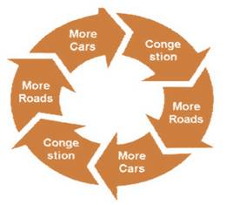
Figure 2.3.3 - Car-oriented transport development (Buis 2009)

And, as David Burwell suggests (undated), if we think of transportation as a public space we can start to imagine streets for people. We are not short of examples where this is becoming a reality: Project for Public Spaces (2005) pinpoints “21 great places that show how transportation can enliven a community”, and Newman concludes that it is possible to see values shifting towards ecosocial values and thus the belief that “reorientation of transport priorities is happening in most cities around the world” (Newman, 2003, p.41).

2.4 Encouraging Active Travel through land use planning

The last two sections emphasize the benefits of Active Travel, but indicate that the use of these modes is declining in the UK. So, how can planners contribute to the creation of spaces that favour Active Travel?
According to De Nazelle (2011), the built environment has been the focus of recent research as a determinant of walking and cycling. Halcrow Group (2009) reviewed some 250 papers that cover this subject to produce a technical report on settlement patterns and the demand for travel. This
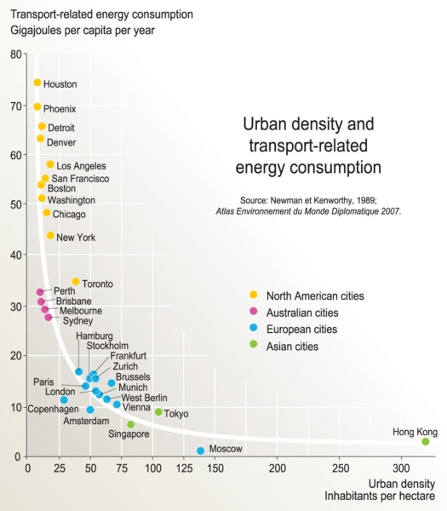
Figure 2.4.1 Urban density and Transport related energy consumption (Kirby 2008 citing Newman and Kenworthy, 1989)

new wave of research intends to be more unequivocal than early findings, such as those by Newman and Kenworthy. Their analysis focused on the global scale, and demonstrated an inverse correlation between two criteria: urban density and Transport-related energy consumption in high income countries (Figure 2.4.1 - Kirby, 2008).
Traditional urban forms, such as Ebenezer Howards' Garden City, have advocated proximity to public transport, mixed land use, and moderate-high density of housing; as this type of settlement can support services and facilities, and consequently this has an influence on travel distances, trip frequency and car use, this urban form can be used as a tool in encouraging walk, cycle and public transport use (Ferguson and Woods, 2010). Although “there is certainly little agreement as to the extent of influence or causality”, there is general consensus that that travel behaviour and land use are related ( Hickman and Banister, 2005). So, can planning incentivise Active Travel? When discussing the contribution of Spatial Planning to Transport Policy, Hull (2011, p.71) says: “the land use regulatory system can be a powerful tool to restrain and influence the travel behaviour of individuals through development location policies”, and when reviewing Sustainable Transport and Land Use, the NPF2 states that one of the challenges for planning is to create urban environments that facilitate walking and cycling (Scottish Government, 2009).
There is a variety of research that backs up the influence that urban design has on our travel choices. The message from the literature is clearly stated by the Institute of Public Health in Ireland's report on the health impacts of the Built Environment (2006, p.22):
“Design of street networks, the availability of open spaces, and the perceived and actual safety of an area as well as personal resources are important environmental and social influences. For example, encouraging people to walk and cycle around a neighbourhood means making streets safe and attractive, ensuring it meets the needs of all users, not just drivers”.
Many (The Scottish Strategy for Physical Activity, 2003; Barton, 2009; Badland et al 2005; Heath et al 2006; Giles-Corti et al., 2007) recognize urban design as one of the elements that has successfully been used to influence the individual's choice to use Active Travel and in some occasions to affect the behaviour of entire adult populations. Cervero and Radisch (1996) believe that it is a combination of design, land use and density that are necessary to achieve meaningful changes in transportation; in their comparative study of a suburban and a more compact mixed use neighbourhood in the San Francisco Bay Area, they concluded that neighbourhood design exerted a very big influence on local non-work trips : for trips under one mile, those living in the more compact neighbourhood made 28% by foot and 66% by automobile; among the suburban dwellers, just 6% were by walking and 81% were by car.
This view does not remain uncontested and authors such as Handy (1996) question whether enough variables are taken into account when gathering this empirical evidence, whether they reflect individual or household choices and whether they consider perceptions of a place amongst other issues. What is clear, is that urban design can support the interests of health to increase physical activity, and measures such as restricting city blocks to pedestrian only access, placing car parks away from building entrances, and making stairways more accessible and convenient have been seen to be conducive to physical activity in individuals (Badland and Schoefield, 2005).
In a study of bicycle behaviour for regular cyclists in Portland metropolitan area, Dill (2009) found that participants were likely to travel out of their way to use bicycle infrastructure. And, in their Auckland (NZ) study of urban design variables and travel behaviour, Badland et al (2008) concluded that when comparing those who travelled along the least connected routes and those who had the highest street connectivity along their commute network, the latter were approximately seven times as likely to actually engage in TPA to access their study or work place.
The literature highlights the significance of investment in cycling infrastructure as a means to increase this transport mode share. The correlation has been recorded, especially for trips to work, and in countries that have a long standing tradition of cycling: commuters will be responsive to the bicycling option if only it were made available (Nelson and Allen, 1997).

2.6 Conclusion

Active Travel can contribute to the provisions of solutions in our future transport networks. It is equally beneficial for the individual and for the environment at many different levels, and can have an effect on our quality of life in a sustainable way.
At present, in the UK people rely on the car for most of their transport needs and Active Travel is not a significant means of transport. This entails significant economic, social and environmental disadvantages which translate into individuals that are less healthy and live in less accessible locations.
The literature points out that planning has a role to play in the creation of environments which are more conducive to Active Travel, and that urban design can stimulate walking and cycling, thus promoting the use of these transport modes as an alternative choice to the automobile.

CHAPTER 3 - Design for cycling

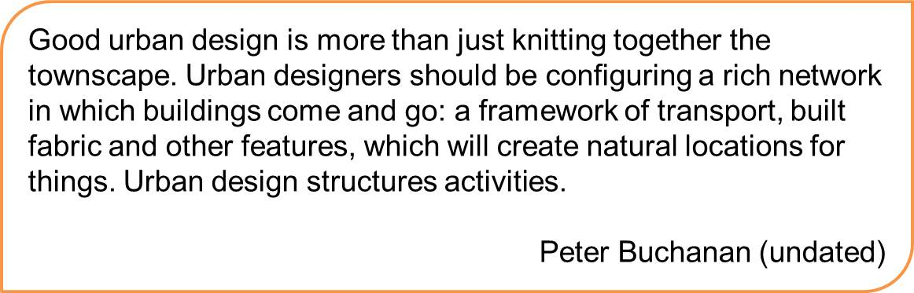

3.1. Introduction
The aim of this Chapter is to review the literature on cycling design, determine the criteria followed by best practice design principles for cycle paths, and explain why it is relevant in the QBC. As well as focusing on the hard infrastructure, the chapter will observe the influence of soft infrastructure on the individual’s Active Travel choices.

3.2 Design principles for cycle paths
Before tackling “design for cycling”, the matter of urban design should be clarified, as trying to determine an explanation for urban design is not an easy task. Many definitions hover around a definition, whilst they state its purpose: “people”, “buildings”, “spaces”, “connections”... And some definitions just explain what it is not and all the different disciplines it draws from. Rowley (1994, p179) is of the opinion that, just like in planning, this lack of clear-cut role has been an advantage for Urban Design, and this is how he defines it:

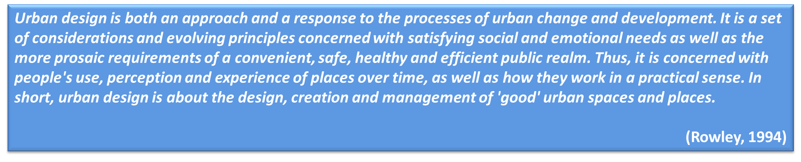

International guidelines for auditing from numerous governmental sources (Transport Scotland, 2011a; the EU Directorate-General for Transport and Energy available from Safetynet, 2009; the Irish National Transport Authority, 2011; Queensland Department for Transport and Main Roads, undated) and authors (Barton et al, 2010; Sustrans, 1999; Interface for Cycling Expertise 2009) list the same design principles for cycle paths, they are: coherence, directness, attractiveness, safety and comfort. These are listed as the desired requirements for cycling infrastructure and they have been adopted from the Dutch Guidelines `Sign up for the Bike' that were made available in 1993 (McClintock, 2000; Yeates, 2002; Ryley et al 2007, Parkin et al 2007).
These five design principles have been widely adopted (Figure 3.2.2) and accepted as what they stood for when they were originally published by the Centre for Research and Contract Standardization in Civil Engineering (CROW): the conditions for the bicycle to be able to compete with other modes of transport over short distances (CROW, 1993). Each main criteria was divided into a number of criteria that judge how cycle-friendly an infrastructure is (Figure 3.2.1).
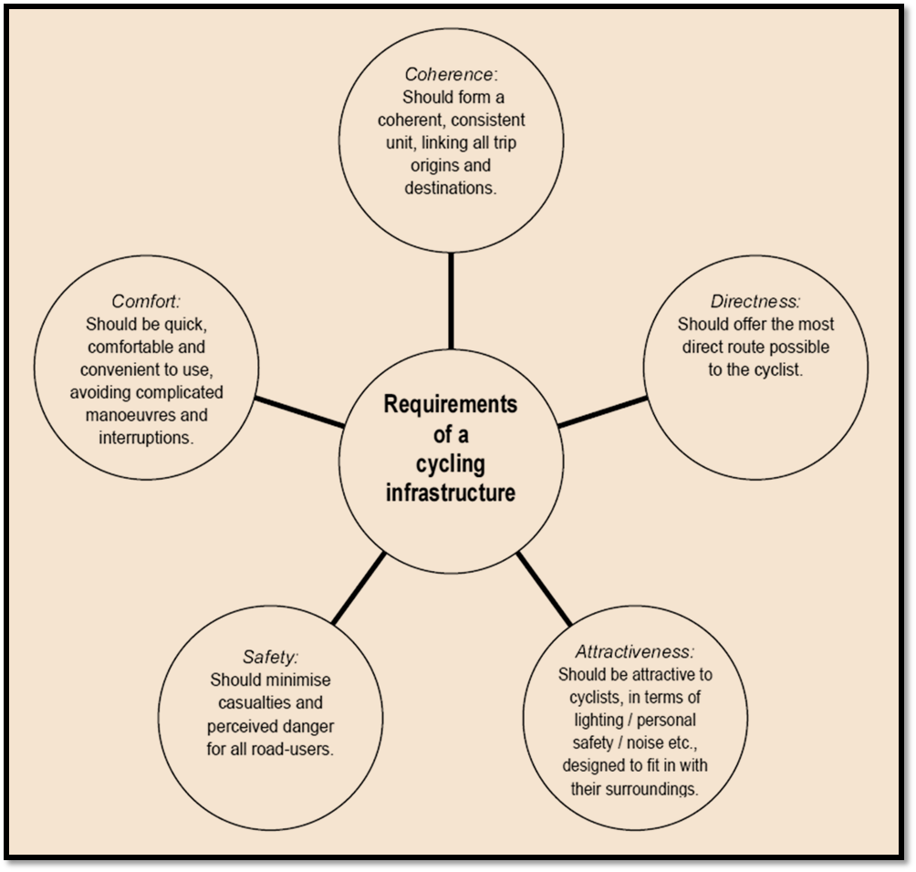
Figure 3.2.1 - Main requirements of cycling (CROW, 1993)

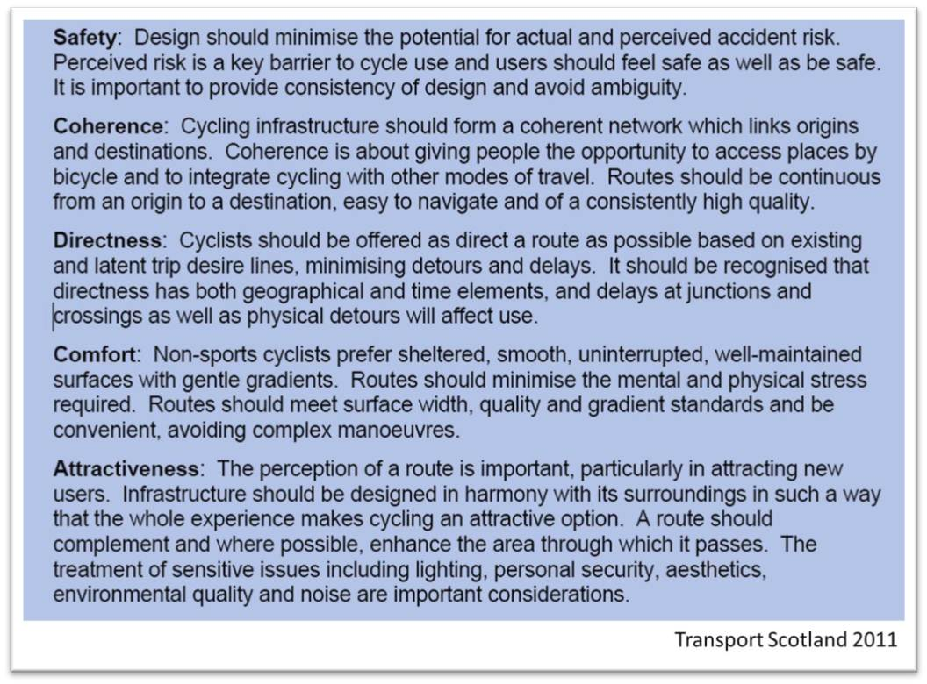
Figure 3.2.2 - Cycling Infrastructure core Design Principles (Transport Scotland, 2011a)

So, design guidelines, government sources and academic literature concur on these design principles, regardless of whether the facility is on or off road and weather the cycle infrastructure is being retroffited or not. The five principles must be given emphasis during the design and construction phases, and should remain an aim in the maintenance of routes. Furthermore, quality and quantity of facilities for cyclists are important in achieving positive outcomes (McClintock, 2002).
Designing for retrofit will have a lead role in the pursuit of sustainable cities and regions, as Birkeland (2008, p.26 and p.39) very bluntly puts it “we can neither abandon our cities, nor leave them the way they are” and so, “sustainable settlements will eventually require retrofitting on a whole region scale”. Throughout her reflection, Birkeland really emphasizes the importance of working with what we have at present, and of being proactive through design, about the health of the urban environment.
In their aim to assess design implications to cater for the need of the cyclist, Forsyth & Krizek (2011) reviewed over 300 articles that examine ways to increase safety and cycling levels, one of their comments in regards to retrofitting city areas to provide more sustainable travel is that cycling should play a key role, so as to make it and experience that is "delightful" and safe.
The Government of New Zealand uses the same principles, however it classifies their importance according to “cyclist type”, according to them (Land Transport NZ, 2005), the requirements that most benefit commuters are: direct routes and minimal delays, high quality riding surfaces, and continuity, as well as complimentary facilities (the full chart can be seen in Annex A). Furthermore, SEStran (2008) classifies the priority of design principles according to user group categories. For those likely to use main commuter routes, especially within urban areas, they believe directness overrides all other priorities (Figure 3.2.3), for the full table please see Annex B.

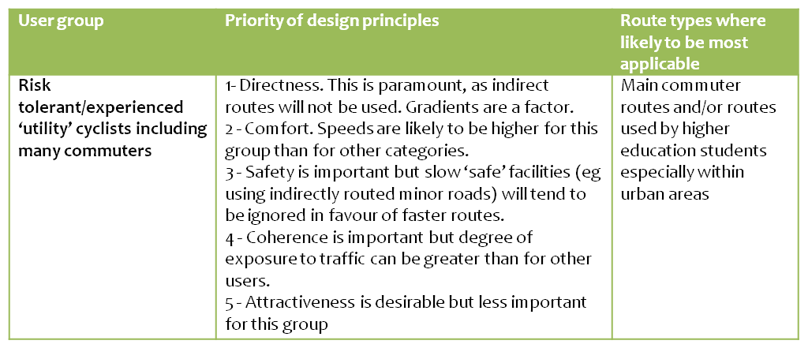
Figure 3.2.3 - Priority of design principles for utility cyclists (adapted from SEStran, 2007)

In order to measure the criteria, the Chartered Institute of Logistics and Transport (undated) have compiled a design checklist that has reviewed the most up to date guidance and practice. This has been assigned to one of the main categories in Figure 3.2.4 in order to facilitate the analysis of the selected route for this study.

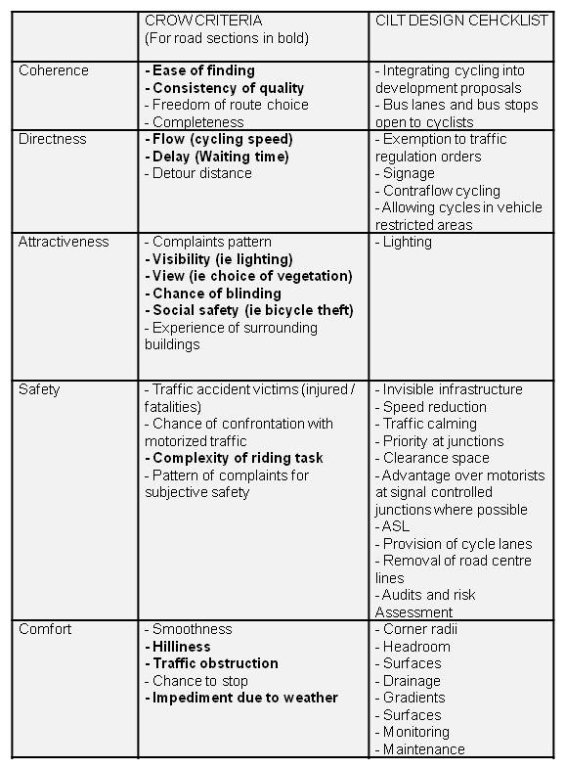
Figure 3.2.4 - CROW guidelines for design criteria: CILT design checklist assigned to each criteria

3.2.1 Designing for cycling : Edinburgh policy context

In Scotland, Planning Policy or SPP (Scottish Government, 2010b) sets out policy on transport: the SPP the NPF2 and further guidance (such as Designing Streets, Designing Places and PAN 75), underline the significance of shifting towards active travel modes in creating a more sustainable transport network. Both Designing Streets (Scottish Government 2010a) and PAN 75 (Scottish Executive, 2005) – Planning for Transport – highlight the importance of accommodating cyclists on the existing network, in the carriageway, thus reallocating road space.

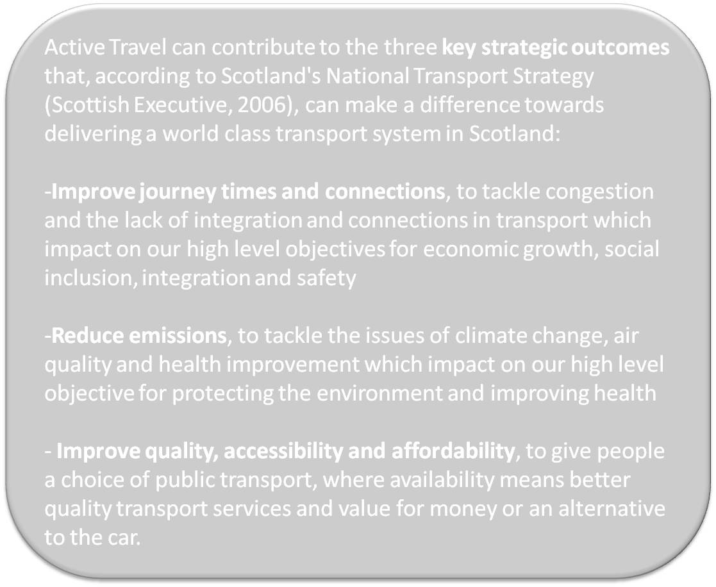

In 2010 the Scottish Government published their revised version of their Cycling by Design guidelines. The document aims to establish guidance that ensures consistent and suitable design for those who are developing Scotland’s cycling infrastructure, and puts forward desirable and absolute minimums. It highlights two elements that need to be taken into account when planning for infrastructure: the cyclist’s skill level and the purpose of their trip.
In 2010, the Government published its Cycling Action Plan for Scotland, which seeks to actively contribute to the National Physical Activity Strategy (2003), and acknowledges that active travel can help both central and local governments to deliver their outcomes (the Scottish Government, 2010). It also sets out a framework that will deliver their vision for Scotland in 2020: 10% of all journeys made, to be taken by bicycle.

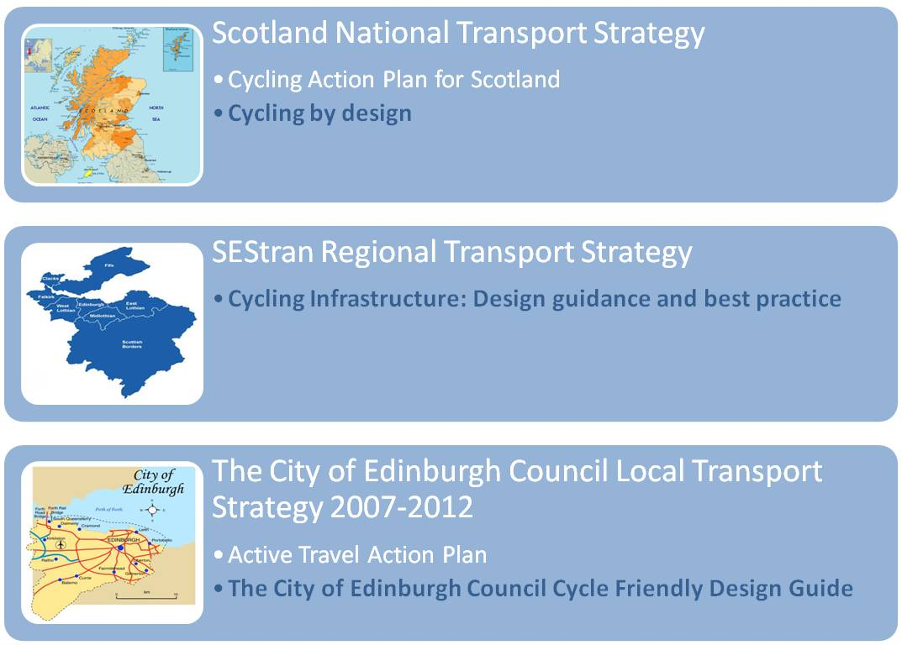
Figure 3.2.5 - Edinburgh’s Transport Strategy hierarchy and cycling design guidance

Edinburgh is the main city of the South East Scotland strategic development area, as set out by the Planning etc (Scotland) Act 2006. The planning authority (City of Edinburgh Council, East Lothian Council, Midlothian Council, West Lothian Council, Scottish Borders Council and the southern part of Fife Council) has prepared the Regional Transport Strategy, which provides the framework for SESplan to achieve a sustainable transport framework (SESplan Main Issues Report, 2010). The SEStran strategy states that “increasing trips by walking and cycling” is one of its objectives (p. VIII) as they are the healthiest and most environmentally friendly forms of transport. This emphasis is supported by Policy 23 “Schemes that improve the accessibility by public transport, walking and cycling of key development areas will be afforded higher priority for implementation”. Cycling is also taken into consideration in policies concerning new roads (P.14), accessibility (P.19), new development (P.20), personal security in transport (P.36) and strategy and policy integration(P.40).
To contribute to their cycling objectives and targets, SEStran published “Cycling Infrastructure: design guidance and best practice” in May 2008, a document to assist those who are involved in providing new infrastructure, which sets out detailed design process steps. It draws attention to the fact that, since the bicycle is legally defined as a vehicle, all new road infrastructure and traffic management schemes on existing roads should make provision for cyclists. For infrastructure that successfully attracts cyclists, it draws on the five Dutch basic design principles, lists the different priorities for on-road and off-road provision (including hard and soft measures) and stresses the importance of maintenance.
The Edinburgh Local Transport Strategy 2007-2012 acknowledges the importance of integrating transport and land use policies (Policy LU 1) and the Main Issues Report (which sets out the preparation for the Edinburgh Local Development Plan) sets out an aim in regards to sustainable transport and accessibility to jobs: ensuring new development is directed to locations which can be accessed via non-car modes, furthermore, it recognizes the role of cycling links in achieving quality of space. The local transport strategy sets out 12 cycling through which the Council aims to “support cycling as an attractive, safe and secure option for all short and medium distance journeys” (City of Edinburgh Council, 2007, p.56). Also the Edinburgh Standards for Urban Design give priority to addressing the needs of pedestrians and cyclists in order to make neighbourhoods more attractive and accessible places (City of Edinburgh Council, 2003).
It is the Active travel Action Plan that sets out the Council’s objectives and priorities to ensure that people in Edinburgh are choosing to cycle and walk more as both as means of transport and for pleasure.
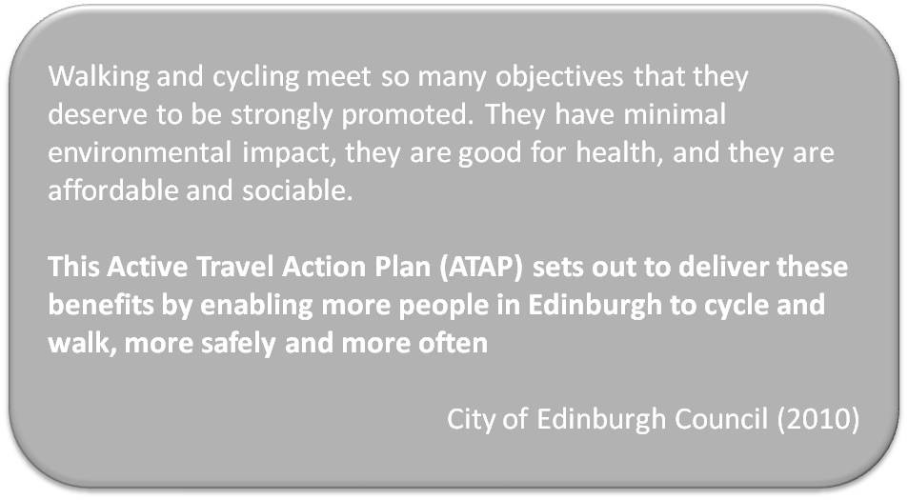

The City of Edinburgh Council published the Cycle Friendly Design Guide in 2000 as part of a wider traffic and transport design guide (Movement and Development); this document set out the transport criteria for development proposals for all non-car modes as well as for the road network, and thus acknowledged that it could not provide detailed advice on all aspects of design for cycling, it did refer the reader to a more extensive list of publications.
The Council is hoping to undertake a review of this guidance in the near future (correspondence with C. Smith of Edinburgh City Council, 16.05.2012) and new guidance will take into account “Cycling by Design” published by Transport Scotland (City of Edinburgh Council, 2010). It is for these reasons – brevity and date of publication (and thus expected forthcoming replacement) –, that the most recent “Cycling by Design” criteria has been used to establish policy principles against which the Quality Bike Corridor can be measured in Figure 3.2.6. For facilitating purposes for this particular research, only criteria that was relevant to on road and urban settings has been recorded in the table.
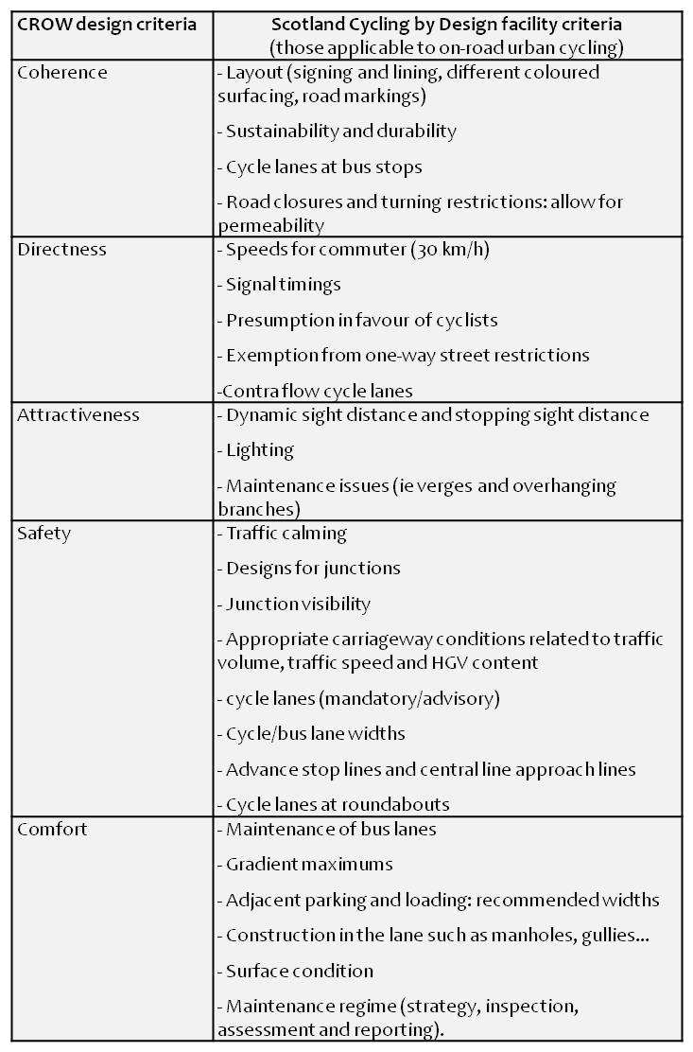
Figure 3.2.6 – Urban on-road Cycling by Design criteria assigned to the Dutch design guidelines

3.4 Further influences on Active Travel choices

Although it is not the topic of this dissertation, it is imperative to acknowledge that other than well-designed road cycle infrastructure, the individual’s predisposition to cycling is influenced by many other factors. These have been summarized by Bracher et al (1991) cited in McClintock (1992, p.10).

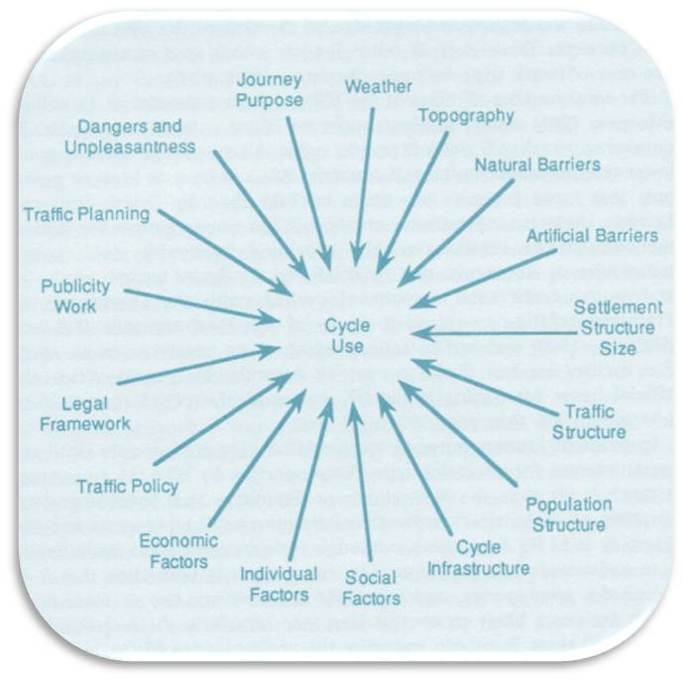
Figure 3.4.1 - Influences on cycle use (Bracher et al 1991, cited in McClintock, 1992)

Both design guidelines and research stress the importance of additional facilities, such as provision of bicycle parking or showers. “Having no facilities at work has been cited as a reason not to cycle” (Moritz, 1998). Literature (Cairns et al 2008, Halcrow Group 2001/02, Tolley, 2003) also highlights significance of the reduction of car use and the promotion of cycling through what is called “soft infrastructure”, as opposed to physical infrastructure or, as Gehl calls it (2012) software and hardware. For example, Towen (1999, cited in Cairns et al 2004) determined that travel plan basic measures could achieve a reduction of 8% in kilometres travelled by employers driving alone to work. Wardman et al. (2007) forecast almost double the amount of cycling after an incentive of £2 per day.
Although soft measures are an integral part in the successful achievement of increased levels of cycling, and it is understood that only an overarching set of measures can positively influence cycling levels, they will not be developed in this particular study because of the length of research this would entail and, primarily, because the focus is on design. There will be a dedicated section on safety perceptions (below), as this is one of the elements will be assessed through primary research. Because of their repetition on the literature two elements deserve mentioning, even if just briefly: cultural attitudes to cycling and gender.
Countries with long-standing traditions of utilitarian cycling are favourable in that cycling is seen as “normal” and therefore a matter of convenience above other modes of transport, this also translates into more respect from motorists (Pucher et al, 1999, Shayler et al 1993). Seeing as in Britain, cycling is mostly regarded as a hobby or as a child's toy, not a form of transport (Horton cited by Walker, 2011), one of the cultural barriers cited by Hull (2010) prevails: the important status of the car in society, this is supported by Horton’s statement that “the UK is a massively automobilised society” (Horton, 2007, p.135). Nevertheless, Parkin et al (2007) point out that greater propensity to cycle is not linked to car ownership. A three year investigation of cycling in England revealed there is not a normal view of everyday cycling, there are two "cultures" of cycling: one with an indifferent (and even hostile) perception of cycling, mostly within urban less affluent working-class population, and one with a positive association to cycling, prevailing in white suburban middle-class communities, but who feels uneasy about cycling on roads (Horton, 2011).
In regards to gender, research points out to the predominance of lower rates of female cyclists in the UK (Banister and Gallant, cited in Heinen et al 2010; Steinbach et al, 2011). Athough research documents reasons for lower cycling levels of women, some countries such as Denmark and the Netherlands have higher rates of cycling women (Garrard, 2003 cited in Steinbach et al, 2011). In their document for women who want to cycle, Sustrans (2010) points out that 79% of women don't cycle, and only less than 10% cycle more than once a month and states that not feeling safe enough was the reason cited the most for not cycling.

3.4.1 Safety

Safety is a very much debated theme in the literature, as a major influence on bicycle use. “Danger and safety” are cited as the most prominent deterrent for potential cyclists (CTC et al 1997, cited in Horton 2007 p.133). Some point out the difference: it isn't cycling that is an unsafe mode of transport, but motorized transport that entails the problem of road safety and thus makes cycling hazardous (Ensik 2012, Shayler et al 1993). It is important thus to mention the speed at which motorized transport travels and how it affects the gravity of outcomes in case of accident: in case of a collision 45% are fatally injured if the vehicle is travelling at 48km/h, this goes down to 5% when the speed is 32 km/h (Mackay 1979, cited in Safetynet 2009). Speeds of 30km/h (20mph) are regarded as safe and there is only a need for separation if motor vehicles exceed this speed (Yeates 2002, Ensik 2012).
There is general consensus that by increasing the number of cyclists, safety for them is increased: the fewer people who cycle, the more dangerous it is for the individual cyclist (for example, Ensik 2012, Horton 2007, Hass-Klau and Crampton 1990, Yeates 2002). For example, Portland's bicycle mode share went from 1.2% in 1990 to 5.8% in 2000. In comparison, road fatalities went from averaging over 60 per year around 1990 to fewer than 35 per year since 2000 (City of Portland Bureau of Transportation, cited in Marshall and Garrick, 2011). In a recent paper, Marshall and Garrick (2011), pointed out that these benefits might be extended to other road users: as the dynamics of the street environment changes to attract more cyclists, a much lower risk of fatal or severe crashes benefits all road users. Director of the Institute for Road Safety Research, Wegman (2011), offers a complementary explanation: yes more cyclists create more awareness for other road users, but also, more cyclists, mean more cycling facilities are constructed, which in turn lowers the risks.
A much debated issue on cycle safety is the use of cycle helmets, once again, although this is an important debate it will not be discussed in this research. It is however agreed, that implementation of compulsory use of helmets drastically reduces use of this mode (Welleman 2002); for example introduction of a helmet wearing law in Victoria, Australia, deterred 20% of adults and over 40% of teenagers (Hillman, 1993, p.14).
Within the topic of safety there is the ambiguity of the actual perception of safety and the fact that, although safety is normally looked at in terms of accidents and serious and fatal accidents (SF), cycling accidents are seriously under-reported (Hass-Klau and Crampton 1990). Furthermore, these do not measure how safe people feel, in fact if conditions become safer perhaps more risks will be taken (Hanna, 1990) just like use of seat-belts in cars increases the driver’s sense of safety and promotes a decline in their standards of driving (Horton, 2007). The Cycling Embassy of Denmark (2012, p.50) summarizes like this: “Safety and a sense of security are not the same thing. A sense of security is the cyclist’s subjective perception of what cycling in traffic feels like, whereas safety is the objective registration of accidents”.
There is strong evidence that well-designed bicycle facilities, physically separated networks, reduce risks for cyclists (Wegman et al 2012), however, in the UK policy and guidance has traditionally endorsed the use of bus lanes as a “particularly useful facility for cyclists” as they can improve safety and convenience for cyclists in an urban setting (Reid and Guthrie, 2004), and in fact a survey in the same study showed that the majority of cyclists agreed that lanes were easy to use, 97% in the Edinburgh case study, and with the great majority considered cycling in the bus lane to be safer than cycling in a similar road without a bus lane (Reid and Guthrie, 2004).
In a UK survey of 1550 commuters (Brake, 2012), two thirds of respondents thought roads are not safe enough for cycling, and 35% said that if roads were less dangerous, they would commute by bicycle. In comparison, in a recent survey of cyclists in the National Cycle Network (off-road), 91% of less experienced cyclists agreed that feeling safe encouraged them to use the routes (Sustrans, 2012). However, since cycle lanes and off road cycling routes have been developed simultaneously in the UK, it is argued that although off-road cycling boosts cycling participation, it “may be that the dominant public perception of cycling is becoming of an activity which best occurs in ‘safe’ and pleasant places” and that “‘normal’ roads are no place to cycle; they are to be feared” (Horton, 2007, p.143).
A review of the 250 20mph zones in the UK revealed that there has been an overall reduction in crashes involving cyclists of 29% (ATAP, 2010). Yet, commenting on the Government's release of data on cycle casualties, the Cycling Tourist Club Campaign director recently stated:
“Britain’s cycle safety record is falling even further behind other north European countries which have far higher levels of cycle use. We still have only a tiny fraction of our residential streets covered by 20 mph schemes, while hostile roads, bad driving, and weak law enforcement remain serious barriers to getting more people cycling” (Geffen cited in Peck, 2012).
Horton concurs, as he states that it is fear that has driven huge numbers of cyclists off the roads in the UK. Although, he adds, we must not ignore that western societies have never been so safe and that it is our culture that exaggerates the dangers that people face (Horton, 2007).

3.5 Conclusion

When it comes to design criteria for cycle paths, academic literature, design guidelines and government guidelines agree on the five requirements that were first published by CROW in 1993, they are coherence, directness, attractiveness, safety and comfort.
Both the CILT Design Checklist and the Cycling by Design (Scottish Government, 2010) audit considerations supply a set of measures which can be used in the assessment of the Quality Bike Corridor facilities. They can be complemented by the importance of each criteria set in other guidelines such as NZ's department for Land Transport and Sustrans.
Design of cycle paths is not the only influence on individual travel choices: and although benefits outweigh hazards, in the UK the feeling of safety is a major deterrent of bicycle use, as are cultural perceptions of cycling not being "normal". In any case, soft measures should complement hard ones.

CHAPTER 4 - Methodology

4.1 Introduction

This chapter will outline the different methodologies that are frequently used for research and provide an explanation of the methods selected for this particular research; it will include the limitations associated with it.

4.2 Research methodologies

An escalating percentage of the information produced by and about human society is now being channelled through the internet; as a result literature search has been transformed by access to online library catalogues across the world, databases, articles, theses and dissertations (Ó Dochartaig, 2002). Secondary research contributes to the development of what Strauss and Corbin (1990) call theoretical sensitivity, however, often it cannot answer the question posed by the research and thus primary research is necessary (Adams et al, 2007).
According to Amaratunga et al (2002), primary research can either focus on:
- the collection and analysis of numerical data to represent opinions or concepts
- words and observations, to express reality and attempt to describe people in natural situations
Since each of the above, quantitative and qualitative, has their weaknesses and strengths, many researchers believe in combining them as a solution to counteract each method’s limitations, and provide a more complete representation, this is called triangulation (Dawson, 2002 & Friedman, 1998).

4.3 Research design

Taking advantage of the vast offer of internet resources, secondary data collection for this particular research included materials found in the university’s database “Discovery” (mainly academic journals), conference papers and reports, resources from the network of public and higher education libraries of Edinburgh, national and international government and non-government organization websites; additionally, attendance to the 5th National Active Travel Conference (Walking, Cycling, Connecting Communities) provided a valuable up to date portrait of today’s active travel state of affairs in Scotland. The data gathered through secondary research has been presented in Chapters 2 and 3 of this dissertation; it reviews observations on active travel, urban design and cycling design guidance, as well as the policy framework for active travel and cycle design in Edinburgh. A review of government and non-government sources was essential in establishing base knowledge on the Quality Bike Corridor.
The Quality Bike Corridor is the first in a series of improvements of the Edinburgh Cycle network by the City of Edinburgh Council, thus it seemed appropriate to examine whether this Quality Bike Corridor is contributing towards the Active Travel Action Plan Targets – to get people cycling more often and more safely – and if it isn’t, what can be learnt improve conditions that will achieve an increase of this mode share in further infrastructure improvements.
The literature review facilitated a set of criteria which directed primary research towards five broad categories that could be examined in detail. In order to gain a more comprehensive understanding of this set of measurements and their application in the Edinburgh Quality Bike Corridor (the subject selected for analysis), primary research aimed to retrieve both quantitative and qualitative information.
In the instance of coherence, directness, attractiveness and comfort the approaches used were direct observation, with photographic evidence, and participant observation. This allowed perceiving the Quality Bike Corridor as the everyday cyclist perceived it. The nature of the fifth criteria being measured – safety – meant that observation was not sufficient: “A sense of security (or insecurity) can be recorded by different types of interviews: focus groups, telephone interviews, street surveys. Safety (or accidents rather) is registered by the police, categorized according to whether or not the situation involves personal injury” (Cycling Embassy of Denmark, 2012, p.50). For this reason, a survey was deemed to be a good way to record cyclists’ subjective views on safety: surveys are the most appropriate collection method when information should come directly from people (Fink and Kosecoff, 1985). The survey could also be useful in a) documenting qualitative data that could complement the researcher’s own observations, in order to determine their validity, and b) directly finding out if people would cycling more often as a direct result of the changes (which cannot be measured through quantitative methods such as a bicycle count). Both cyclist questionnaires and the monitoring of enquiries and complaints are cited in cycling design guidance (SEStran 2008) as a useful means of monitoring cycling. On this occasion, formal and informal sources of “enquiries and complaints” were found on the World Wide Web: on the City of Edinburgh Council’s website (all meeting minutes and consultation data) and on cycle-led forums and blogs. Combining the use of observation and surveys, and the collection of quantitative and qualitative data, could contribute to triangulation of results.

4.3.1 Design of the questionnaire

A list of questions which will enable examination of the research topic is the starting point for a questionnaire (Hoxley, 2008). The questionnaire (Survey 1) set out to find out perceptions of the Quality Bike Corridor improvements by suggesting a set of statements on the following:
- Provision of wider transport choices
- Encouragement to cycle more
- Feeling of safety
- Further improvements
A second questionnaire (Survey 2), for those who had cycled along the route after the implementation of the first phase of the improvements (July 13th 2012), set out to enquire about:
- Changes in frequency of use as a result of the improvements
- Perception of safety
- Changes in frequency as a result of increased feeling of safety
- Ratings for design criteria
- Implementation of improvements elsewhere in the cycle network
Both questionnaires included closed and open ended questions and can be viewed in appendix F. In order to reach as many people who lived or travelled into the area, in the limited amount of time, they were distributed online, via mailing lists, and so it was found best to use an online format, on this occasion it was through Survey Monkey, which is the world’s leading provider of web-based survey solutions (Survey Monkey, undated).
Trying to reach as many cyclist and non-cyclist citizens that lived, worked or studied in the area the link to the survey was sent with an introductory email. Collections started on 19.07.2012 and ended on 31.07.2012. Community groups and employers that were contacted (Figure 4.3.1)
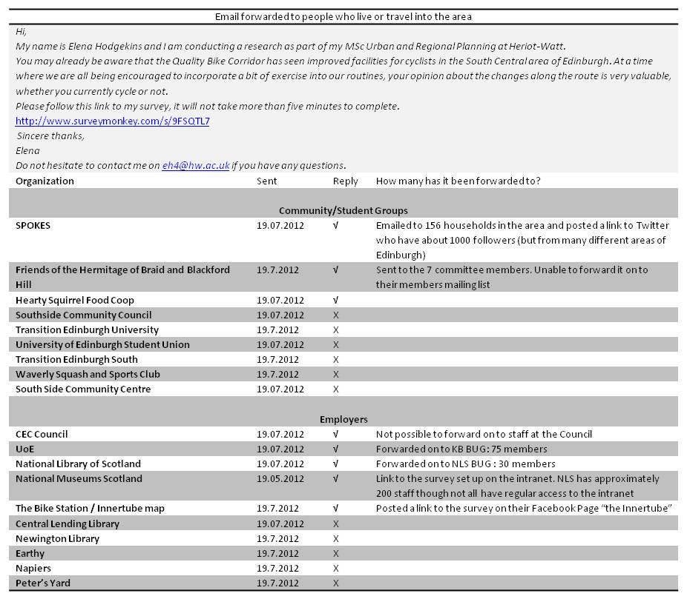
Figure 4.3.1 - Email survey approaches and responses

4.3.2. Direct observation and participant observation

Observation, carried out weekdays between July 15th and July 30th 2012, was both direct, by observing the path itself and the cyclists at different times; and participant observation, where cycling along the Quality Bike Corridor allowed familiarization with the path, as cyclist would experience it. A combination of stationary and mobile (walking along the path) direct observation was carried out five times – around 2 to 3 hours each – , between 3pm and 7pm. In order to record direct observation some pictures were taken, and these will be used as part of the findings developed in Chapter 6.
Participant observation involved cycling the whole path five times in both directions, starting on the Mound at 11am, 1pm, 4pm, 5pm and 9pm.

4.4. Limitations

Time imposed the main constraint of the research methodology, as a more lengthy research would have allowed to include in depth qualitative data such as a focus group or interviews or face-to-face surveys with cyclists arriving to a particular destination. Furthermore, it would have generated the opportunity to include respondents who were not cycling at the moment, and students, who are mostly away during the summer (only 6% of respondents were 25 years old or under). Additionally, response levels were much higher for the first survey (88 out of which 82 replied all questions) than for the second (15 replies), indicating that perhaps one survey would have been more adequate and that qualitative data in regards to the completed design improvements should have focused on other research methods rather than online surveys. Although all respondents answered all questions in the second survey, the responses were not compulsory and this has been reflected in the first survey where response rates per question fluctuate.
The aim of the observation was to gain an insight that was as objective as possible, however the fact that cyclists confidence varies according to their experience and the environments they are accustomed to, might have posed objectivity to the views expressed.
The fact that respondents were aware of the subject of the survey meant that it is mostly cyclists that responded: only 13.4% said they cycled occasionally or never (as opposed to "often"). Thus, the views of those who currently do not cycle, vital in the response in infrastructure that should be provided according to their needs, has not been represented as extensively as it should have been. Additionally, the views of women were reasonably recorded in the first survey (31% of respondents) but only just in the second one (13.3%).
Time also posed a limitation in regards to measuring safety: objective safety will be measured by recording accident rate changes over time, whereas perceived safety might not be reflective of the improvements as the survey was sent out just a few days after the first phase was completed.

4.5. Safety and Ethics

The following have been considered in this dissertation in relation to the 1998 Data Protection Act:
- Data protection was not pertinent to primary research aimed at residents of Edinburgh as the survey information was collected anonymously. The fact that all replies were anonymous was reminded to participants on the survey introduction page.
- Informed consent was requested and granted in regards to data collected via email correspondence, so it has been referenced as such.
In regards to ethics, research was always presented openly as to the nature of the inquiry and the details of the researcher.

CHAPTER 5 - The Quality Bike Corridor

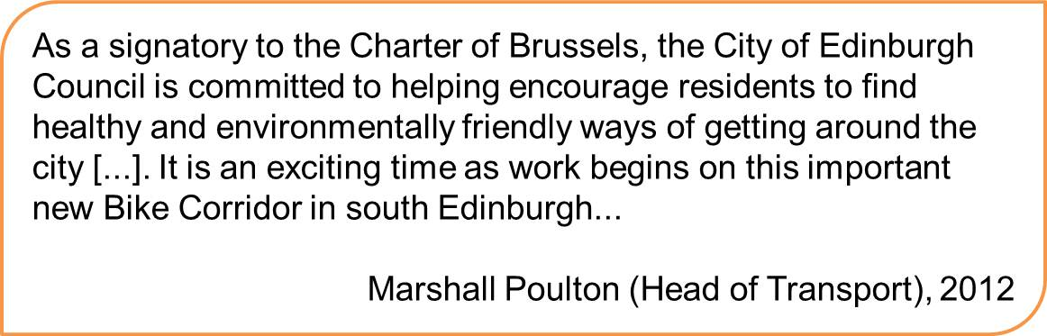

5.1 Introduction

This chapter will set out the background for the cycling context in Edinburgh and present the activities which have been undertaken by the City of Edinburgh Council to increase cycling in the city, this includes the recent improvements in the Quality Bike Corridor.

5.2 Cycling in Edinburgh

Although one of the world’s first cycling clubs was established in Edinburgh in 1870 and a cycling campaign organization –SPOKES– has been active since 1977 (Williams, 2002), cyclists still represent a small proportion of road users in the city: the Council estimates that currently 7,250 residents cycle to work; this represents a 4.9% which it aims to increase to 15% by 2020 (City of Edinburgh Council, 2010). Current non-car mode trip share is low when compared to many European cities; nevertheless Edinburgh “has achieved the highest levels of cycling and walking of Scotland’s cities” (City of Edinburgh Council, 2010, p 5) and has made a commitment to dedicate a 5% minimum of the 2012/2013 Transport budget to cycling.
As part of improvements to the cycle network, the Active Travel Action Plan proposed the development of a proposal for The Family Network, and the implementation of a Cycle Friendly City Programme, “which will make travel by bike on the whole road network as easy and attractive as possible” (Sustrans, undated). The design approach priorities for these two networks will differ and the Council states that whereas coherence is essential in the family network, cyclists on the cycle friendly city programme routes might have to accept sub-optimal sections on some circumstances. For the full design approach for the cycle friendly city programme see Appendix C.
The literature has pointed out the importance of soft measures accompanying hard infrastructural changes and, although not an issue that will be discussed in this research, it should be mentioned that the City of Edinburgh Council has taken various steps such as a review of the provision of cycle parking spaces and the introduction of a new 20mph limit in south Central Edinburgh, which covers part of the Quality Bike Corridor route.

5.3 The South Central area improvements

The Council’s actions for the cycle friendly city programme included cycling corridor improvements to the South Central area, followed by a program of further corridor improvements. The first of these is the Quality Bike Corridor used for the purpose of this research; the route provides a major link and goes South from Edinburgh City Centre: it starts on the Mound (thus connecting it to the National Cycle Network Route 1), crosses the Royal Mile, goes onto George the IVth Bridge and leads onto Potter Row via Lothian St. The route then goes straight along the same road (although it changes names until it becomes Mayfield Road) and ends at the Edinburgh University Kings Buildings.
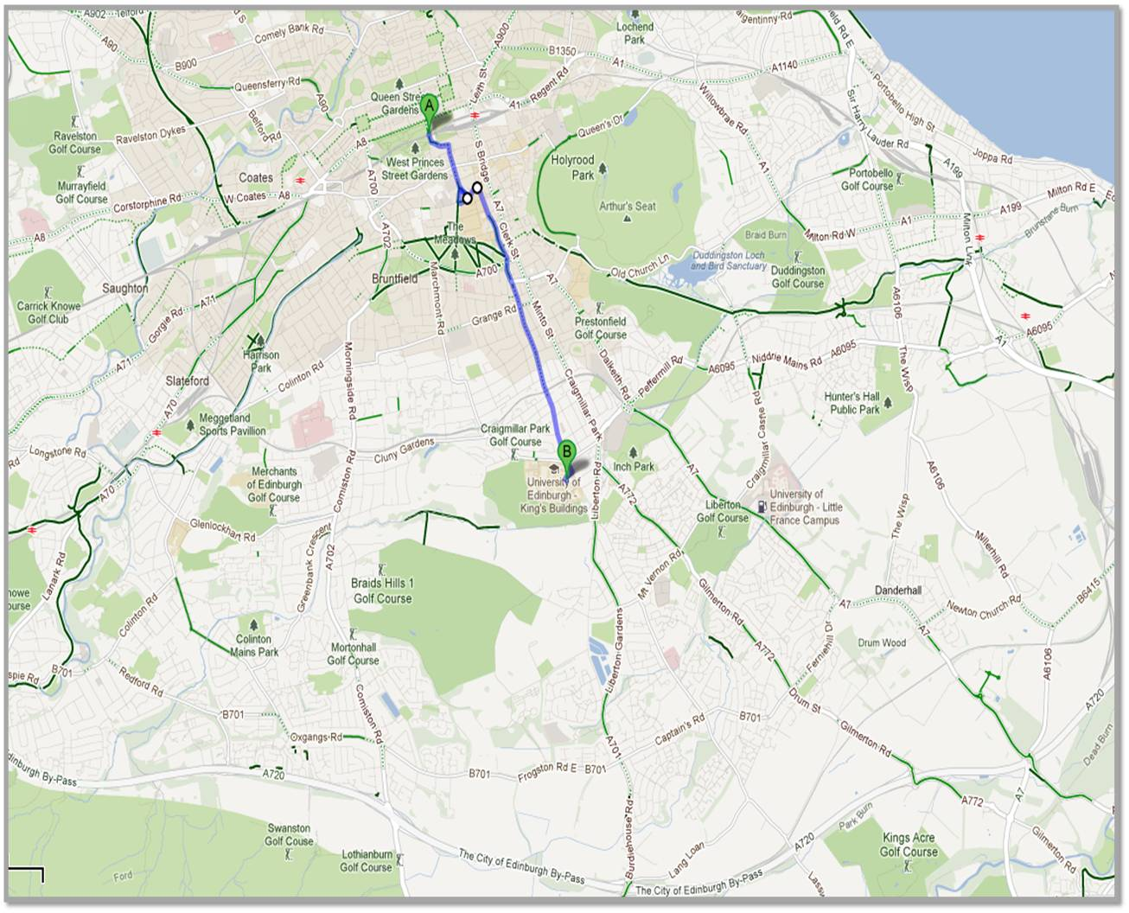
Figure 5.3.1 - The Quality Bike Corridor in relation to the city of Edinburgh (Google maps, 2012)

This route runs parallel along the A7, one of the main arteries into the city and, is used as such for commuting. Because of its high level of accidents, was already recommended for comprehensive treatment in the 1985 report “Lothian Cycle Route Project. Opportunities and Policies” (Grimshaw et al 1985). A map of the proposals suggested by the report can be found in Appendix D.
In response to a previous motion “calling for a report improving conditions for cyclists on the route between University of Edinburgh King’s Buildings site, and the George Square city centre campus”, a report was presented to Committee on the 22nd of September 2009, and proposed measure that would improve safety and attractiveness for cyclists, improve bus priority and address demand for kerbside parking and loading. Details of the proposal can be found on Appendix E.
A public consultation was carried out in November and December 2010 and, after consideration of the issues that were raised and the legal processes necessary approval was granted by the Transport, Infrastructure and Environment Committee in November 2011. Work began the last week of March in 2012 and although the completion of the first phase of the scheme was expected twelve weeks after, some gas maintenance works delayed this forecast. The Council’s Weekly Road effective from the 9th of July indicates the latest finish date for Quality Bike Corridor road works as the 13th of July and the Council corroborates this (personal correspondence with C. Smith).
As per the dual network that is proposed in the Edinburgh Active Travel Action Plan, the South Central area will also be provided with an alternative quieter route between Kings Buildings and George Square that offers a quieter off-road itinerary, as part of a route from the city centre via Marchmont to King’s Buildings and the Royal Infirmary (City of Edinburgh Council, undated). Nevertheless, a bicycle count by The Bike Station revealed that cycling on Causewayside was up 15% from November 2010 to November 2011, the rise went up to 23% when taking into consideration the Southward route to King's Buildings only (The Bike Station (username Mark), 2011).
The Quality Bike Corridor offers a corridor into the city centre for an area of Edinburgh that is not served by any off-street traffic free paths (please see the Innertube map below).

Unfold this way (up then left)

CHAPTER 6 – Findings and discussion

6.1. Introduction

This chapter will discuss the information collected through Primary Research and review it, linking it to relevant data presented in the Literature Review. The data will be presented according to the five criteria that have been taken from the design guidance: coherence, directness, attractiveness, safety and comfort. The information will try to develop from the research question: do the design improvements encourage people to cycle more often? And, do they make them feel safer? Consultation of the final drawings indicated that minimum widths were respected throughout the design and thus the review in this chapter will not focus on the technical aspects of design but on the user's perceptions of the five core design principles which are being reviewed.

6.2. Coherence

Design guidelines (CROW, 1996, CILT, undated; Scottish Government, 2010a) point out to the following criteria, in order to assess the coherence of the cycle path: layout, continuity and ease of finding.
In the Quality Bike Corridor, observation revealed that the path has been laid out with a new coloured surface treatment only on some recently improved sections, and not consistently. Additionally, most of the improved sections are not paved with the standard different coloured surface, but a mix of black tarmac with red chippings, which has been used as it "ages" better and thus won't need as much maintenance.
The fact that the greenway bus lanes are also there to be used by cyclists, similarly hinders the paving uniformity. So, for example, a cyclist travelling South from George the IV Bridge (royal Mile end), in the first 500m will consecutively find themselves on: mixed chipping tarmac bus lane, black tarmac bus lane, a bus stop with no path through it, old red surfaced tarmac cycle lane, new red tarmac cycle lane (that goes through the bus stop), and the new mixed chipping tarmac cycle lane. Hence, the mixed use of surfacing, does not transmit a feeling of coherence. Also, there are sections of the path further along where there is no cycle lane at all. There are bus stops where mixed chipping surface has been used and seems to designate a cycle path, but the white marking lane is discontinued. Although the adjustments have been made in order to adapt to current road conditions (ie, minimum width standards prevent cycle lanes in some roads and green ways cannot give priority to cycle lanes), road surfacing reflects that it is precisely current road conditions, not cycling priority, which have dictated the adjustments. One of the respondents says: "we still have the problem of painted areas stopping and starting all the times at which it is convenient…".
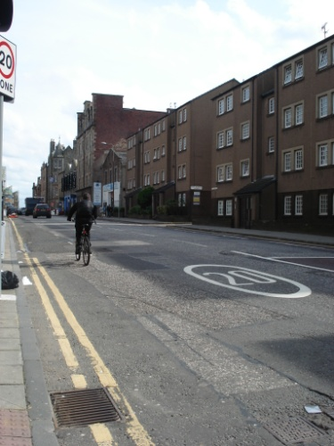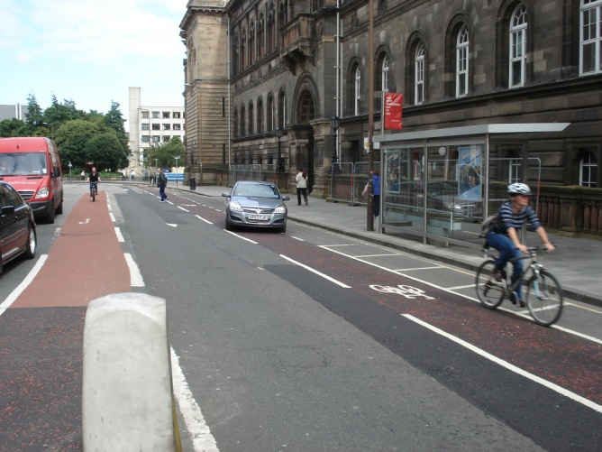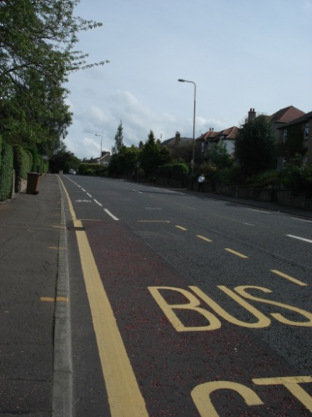
Figure 6.2.1 - Road surfaces

Road markings on the other hand provide an unequivocal and regular prompt that the path is for bicycle use, regardless of the “shade” of the tarmac, although one comment draws attention to the fact that "the painted bike lanes of the QBC have a tendency to appear and disappear". Signs on posts are also visible and a warning that there is a cycle lane ahead.
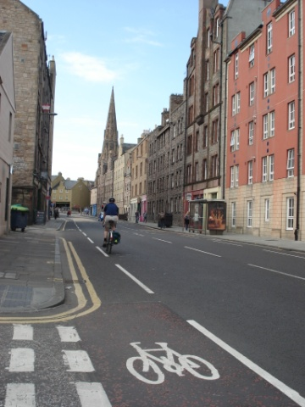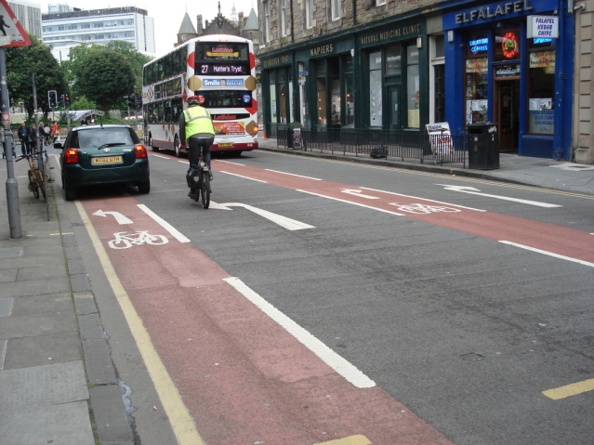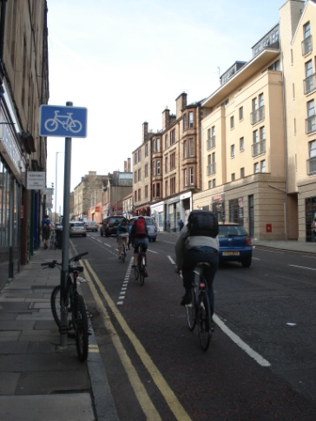
Figure 6.2.2 - Road signs and markings

Qualitative data gathered through the open ended questions in the questionnaire for those who had cycled after July 15th raise coherence, for example “I rated low on coherence because the lanes come and go, weave in and out, etc.. It is very much a motor corridor with differing ad-hoc cyclist facilities tagged on...” and “the lanes are well marked”. And for survey 1, when asked about further improvements would make them cycle more often along the route, some respondents said: "consistent lane marking, what's there is good but it disappears", “more coloured road surface, it is only marked for short sections”, "signage indicating clearly it is a route to University of Edinburgh King's Buildings", "they should paint a stronger red colour to ensure cars don't encroach it", and "the lanes aren't continuous and the red chippings aren't as visible as the solid red surfaces, in particular when the road surface is wet and the sun is low in the sky".
The topic of uninterrupted cycle lanes was also raised during the public consultation (22 times) and the response from the City of Edinburgh Council (undated) was the following:
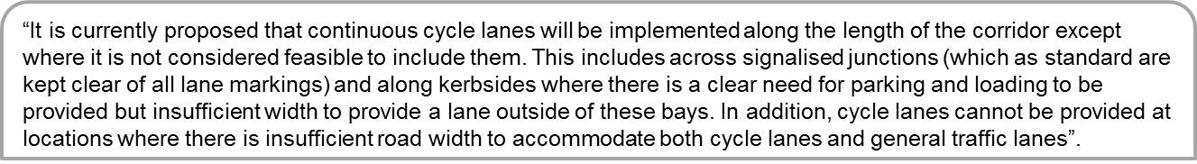
As shown in Figure 6.2.3, when rating coherence, those who had cycled the QBC after the first phase of road works had been completed, out of 14 people mostly rated it 3 and 4 (where 1 is the least and 5 is the most).
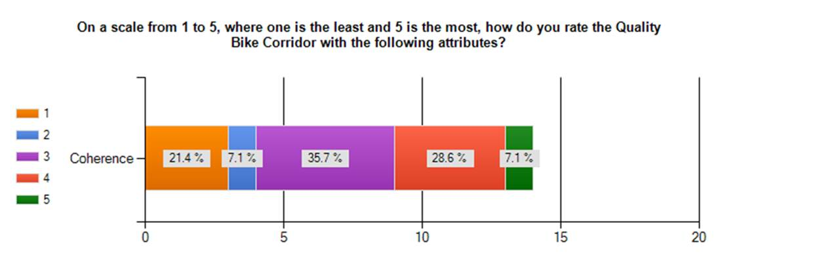
Figure 6.2.3 - Coherence rating

Coherence in relation to the rest of the network (well-connected routes) was considered an imperative to engage in travel related physical activity in Badland et al (2008). The Quality Bike Corridor offers a link to the Meadows, which leads on to National Route 75, and with National Route 1. By providing further connections and making the route more accessible, it can contribute to a network that stimulates quality of life and social inclusion (UN, 2011) and decreases the level of what Ravetz (1980) calls the travel-poor.

6.3 Directness

As rated by SEStran (2008), directness is paramount for the cyclist user group which includes many commuters. The QBC almost follows a straight line on the roads travelling into the city centre, with the exception of the one-way road system at Bristo Place and Forrest Road. Although this only adds under 100m to the journey for those using the corridor to join up with the Meadows, direct observation revealed that several of the cyclists travelling South (5 out of 27 in the space of 45 minutes) chose not to follow the cycle lane between the traffic lights at the Bedlam Theatre and the North side of Middle Meadow Walk, they continued across the pedestrian traffic lights and along the pavement on to the South end of Forrest Road, as shown on Figure 6.3.1

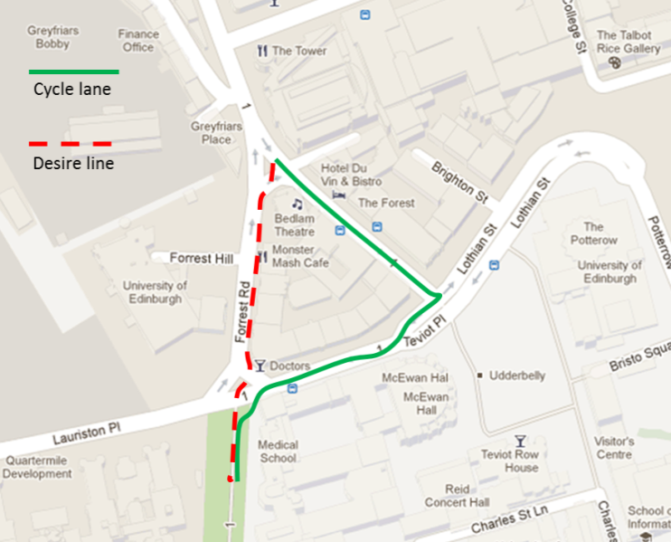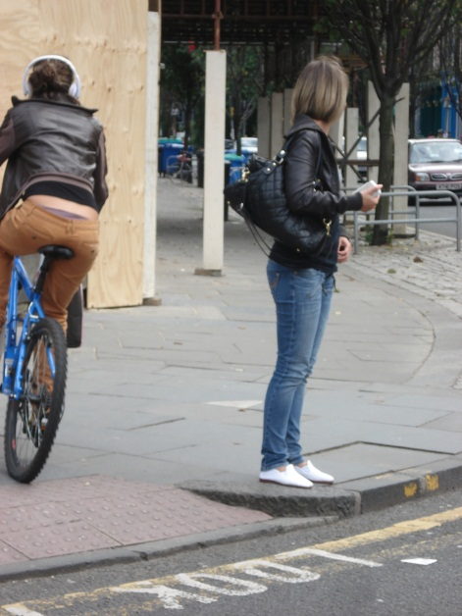
Figure 6.3.1 - Cycle lane versus desire line path

As well as physical directness of the route, timing needs to be taken into consideration. From the participant observation experience, timing did not give the impression to pose and issue, waiting times at traffic lights being reasonable and flow not being noticeably hindered. Although speed expectations may vary according to cyclist type (Land transport NZ, 2005), flow was only mentioned once (out of 52 comments) as something that would make the respondent cycle more along the QBC: "Less traffic lights. Currently use Nicholson St to get into town". Additionally, there are three comments from people who say that advance bike green traffic lights would make them cycle more along the route.
Some comments in response to improvements encouraging citizen's to cycle more along the route (or not) reflected on the importance of directness being most important ie "If the measures had been braver […] I would probably have gone out of my way to cycle along the route for part of my commute. As it is, the new smooth road surface is nice, but I won't go along the QBC when another route is quicker" and "not enough of a change from before to warrant diverting along it. Will use it when it's the most efficient route", this does not correspond with findings in Dill (2009), whose responses showed that participants were likely to travel out of their way to use bicycle infrastructure. However it might be due to expectations of the cycle infrastructure improvements: “I'll try it sometime, and if it's very good, then I would maybe choose to cycle in town more often than I do”. Nevertheless, when asked about the likelihood of improvements changing behaviour when travelling along the route, 40.6% of those who already cycle along the route, and 59.4% of those who don't said they would be encouraged to cycle more along it, as shown in figure 6.3.2
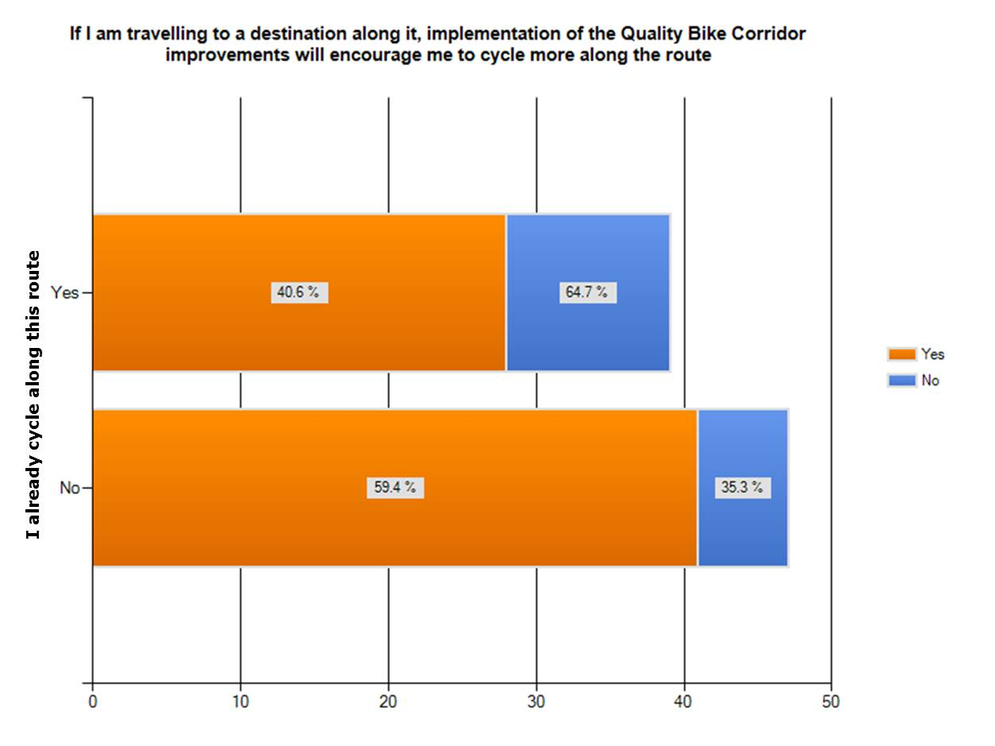
Figure 6.3.2 - Encouragement to cycle more along the route

6.4 Attractiveness

As pointed out by the Institute of Public Heath in Ireland (2006), we all are more predisposed to walk and cycle around a neighbourhood when a street is made safe (discussed in the next section) and attractive. Naturally, the perception of the route is important, but attractiveness is not considered of much importance in a route that is being used for commuting (Land Transport NZ, 2005 and SEStran, 2008).
Assessment of attractiveness can be measured by the visibility, and chances of blinding, the view, such as choice of vegetation and social safety (CROW, 1996, CILT, undated; Scottish Government, 2010a). As expected from a route which is mostly in a straight line on a main artery of the road infrastructure, the observation (direct and participant) did not reveal any apparent issues regarding visibility (both dynamic and for stopping) or lighting (including the test cycle at night) or the views along the route, and certainly no issues which could be caused by (overgrown) vegetation.
CROW (1996) also considers social safety, and the chance of bicycle theft, a factor that can contribute to attractiveness. Earlier this year, Lothian and Borders Police launched an operation to tackle the theft of bicycles and vandalism, and works with the University of Edinburgh to provide advice on bike security to the student community (Lothian and Borders Police, 2012).
Problems at junctions were mentioned twice in the qualitative data that was gathered, as further improvements which would make the respondent cycle more along the QBC listed: "better provision for traffic and cyclists turning right (both north and south) at the junction at the southeast corner of the Meadow" and "much more emphasis on pedestrian and cycle crossing facilities at the KB end"; although it is not clear if these comments are due to problems related to visibility or other matters. Survey 2 data surfaced the following: “I try and avoid cycle lanes painted across side roads because some motorists treat the outer edge as the stop line”, conveying that the user feels there is a problem at crossings, but similarly, it cannot be linked specifically to an issue of visibility without further investigation.
The rating for attractiveness is the criteria where respondents best agreed, although none rated it 5 (the highest), most gave it a 3 or 4 and only 2 out of 14 surveyed rated it 1 or 2, see Figure 6.4.1.
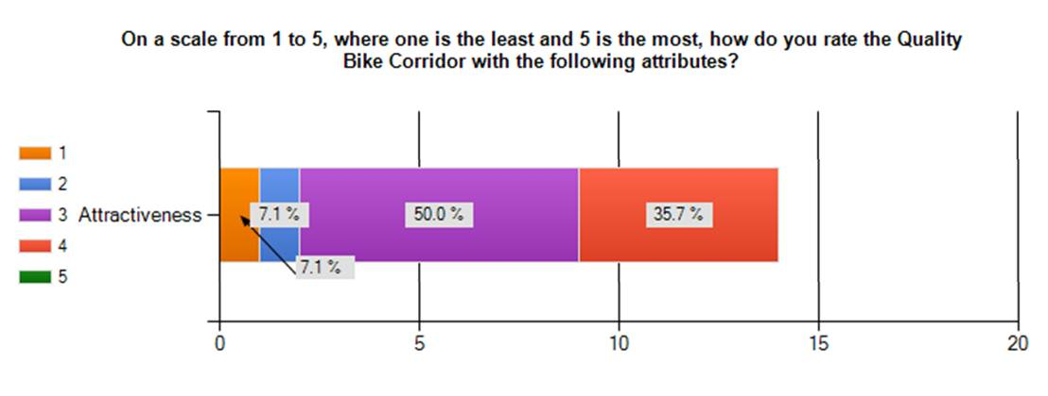
Figure 6.4.1 - Attractiveness rating

6.5 Safety

The literature reiterates that a main deterrent of cycling is the feeling of safety (Horton 2007, Sustrans 2010, Brake 2012) and achieving more safety for cyclists is one of the aims of the Edinburgh Active Travel Action Plan (City of Edinburgh Council, 2010). By trying to measure if people felt safer and if so, whether they would cycle more as a result of this, qualitative primary data tried to establish the sense of security or insecurity (Cycling Embassy of Denmark, 2012).
Safety needs also vary considerably depending on the experience or type of cyclist: cyclists trying to get to shops or schools, and risk averse cyclists will put safety on the top of their list, whereas cyclists in main commuter routes such as higher education students might relegate the feeling of safety below directness and comfort (Land Transport NZ, 2005 and SEStran 2008). Thus, responses on the views of the complexity of the riding task will be subjective depending on the experience. Those who responded Survey 1, just over 80% already cycle along the route, and the majority cycle often: several of the qualitative comments reflect on this and respondents acknowledge their experience, for example “... I am an experienced and relatively courageous cyclist”, “I am a hardened urban cyclist”, “I’ve been cycling for over 50 years and have never been put off cycling by traffic or road conditions or weather...”.
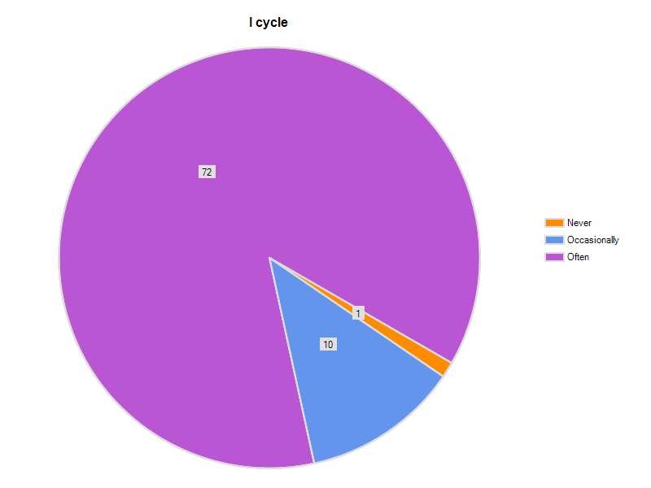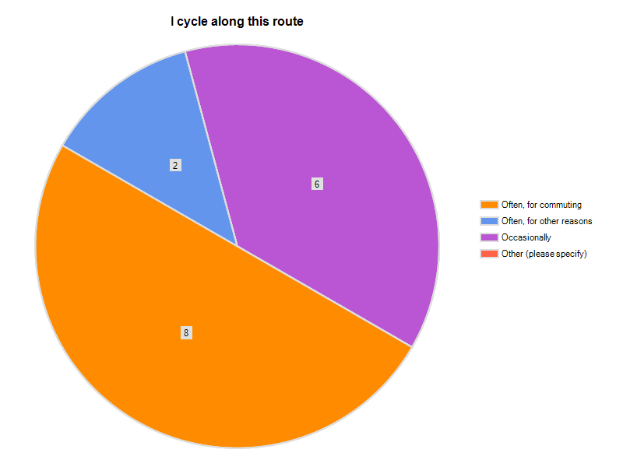
Figure 6.5.1 Figure 6.5.2
Cycling experience – Survey 1 respondents Cycling experience – Survey 2 respondents

As well as complying with lane width minimums, the improvements provided along the QBC have included many of the elements cited in the design guidance (CROW, 1996, CILT, undated; Scottish Government, 2010a) such as: speed reduction (including traffic calming measures), priority at junctions (such as Advance Stop Lines (ASL) at signalled controlled junctions), clearance space and the removal of road centre lines where the width of the road makes it safer to do so.

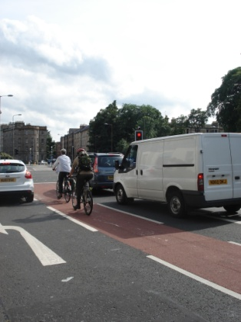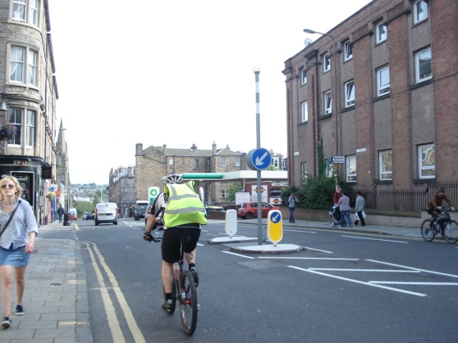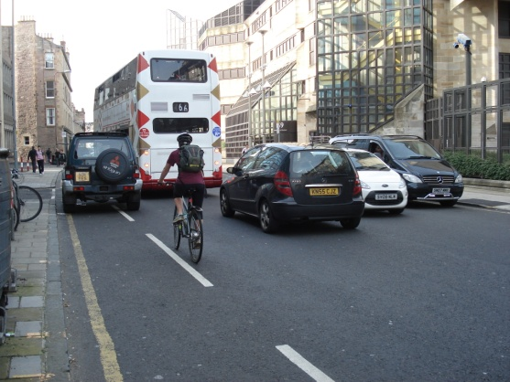
Figure 6.5.3 - Security improvements 1 (ASL, traffic calming and centre line removal)

Qualitative data showed that not all opinions concurred that these measures were providing more security, there are mixed feelings, especially regarding clearance space along parked cars: “when they (parking/loading bays) are occupied they guide you right into the dooring zone and when they are occupied motorists do not expect cyclists to follow the lane, so take driving further to the left. My strategy is [...] to ignore the lane entirely and clear the dooring zone when occupied...”, “drivers are more likely to expect cyclists, especially in some of the danger areas like cycling outside parked cars”. Concern about bike lanes outside parking bays was also raised ten times during the consultation and the response from the council was that this had been implemented elsewhere and no safety issues arisen and that this was seen as a better option than having no cycle lane (city of Edinburgh Council, undated).

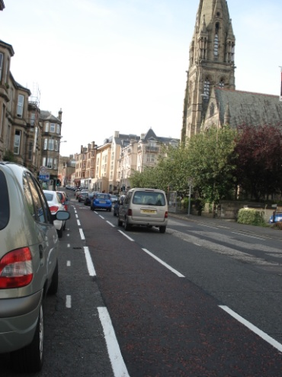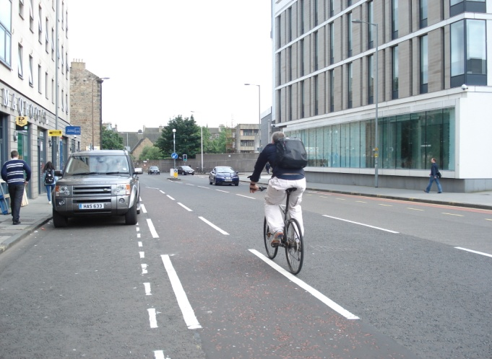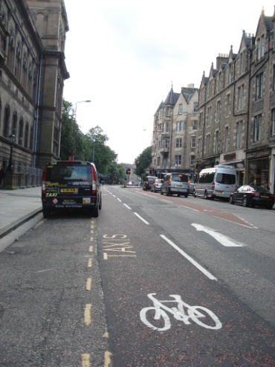
Figure 6.5.4 - Security improvements 2 (Clearance space)

Comments in response to the question as to what further improvements would make the respondent cycle more often along the QBC included: “much reduced car parking along the route to reduce the dangers of car doors” and “... you are vulnerable as drivers can open doors without looking properly”.

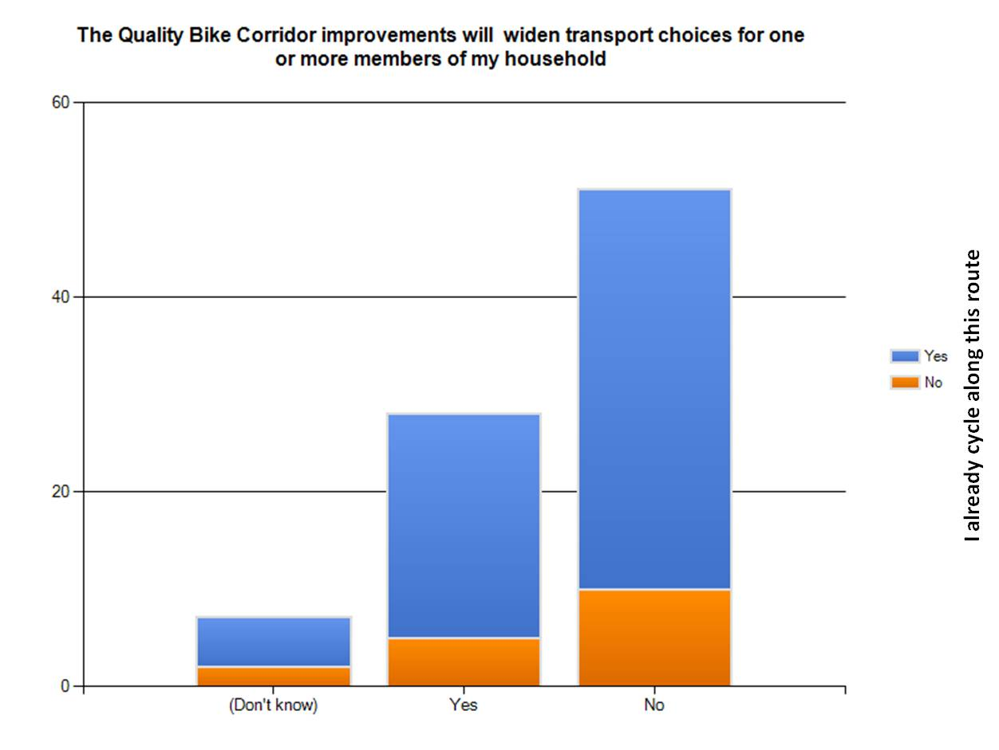
Figure 6.5.5 - Wider transport choices according to user of the route

Despite the negative comments, 32.2% agreed that the QBC improvements would widen transport choices for one or more members in their household, although the data gathered cannot directly link this to an increased sense of safety. For those respondents who had cycled after completion of the first phase (Survey 2) and were asked if they would cycle more often along it because they feel safer as a direct result of the improvements, 81.3% said they would not.
Although inclination to cycle more might not be changed, perceptions were: out of all respondents of Survey 1, 64.4% agreed or strongly agreed that the QBC improvements made it safer to cycle along it, this is shown in Figure 6.5.6 according to how often a respondent cycles.

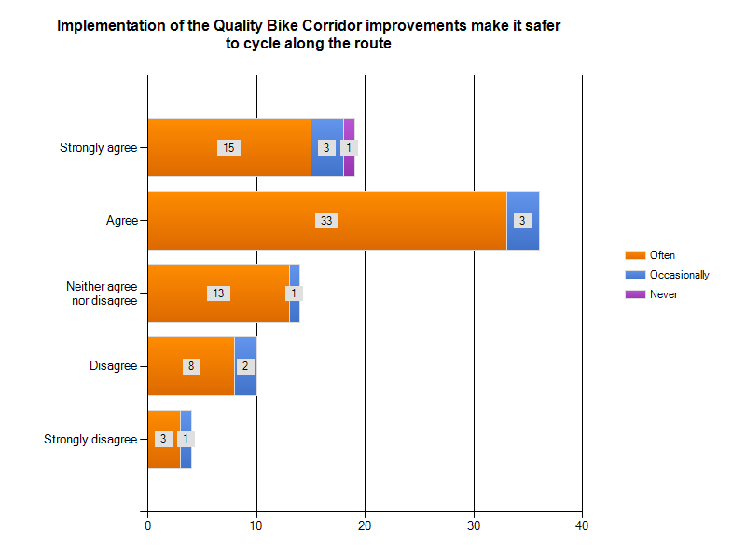
Figure 6-5-6 - Perception of safety according to cycling user group – survey 1

For those who had already cycled the route after completion of the first phase of improvements, the figure was 56.3% (agree), as per Figure 6.5.7
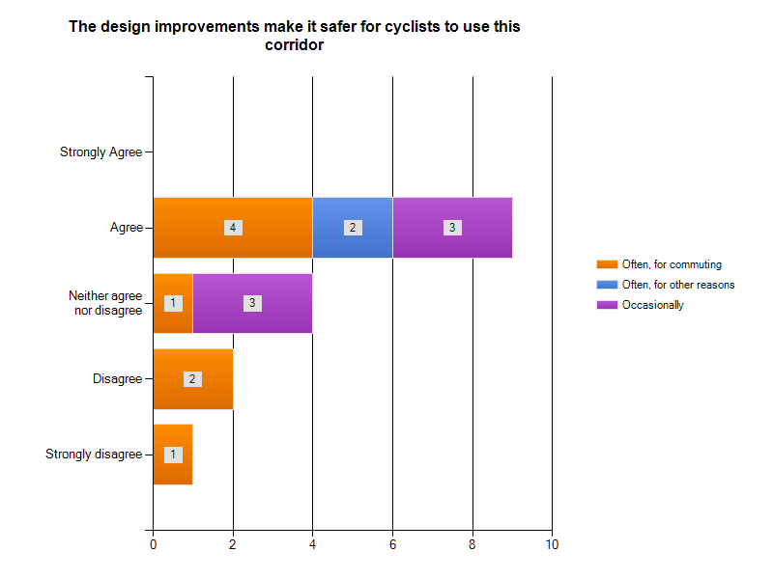
Figure 6.5.7 - Perception of safety according to cycling user group – survey 2

Quantitative research from survey 1 (question 3) enquired if improvements would encourage them to cycle more along the route and qualitative examination about the reason that would encourage the respondent to cycle more along the route (there was no prompt to safety). Many respondents commented on safety, Positive comments included those who believed the improvements would raise awareness amongst other road users, thus making them feel safer, and those who didn’t state why they felt safer such as: “Safety is critical, and it will mean I will go out of my way to use a safer route such as the QBC”.

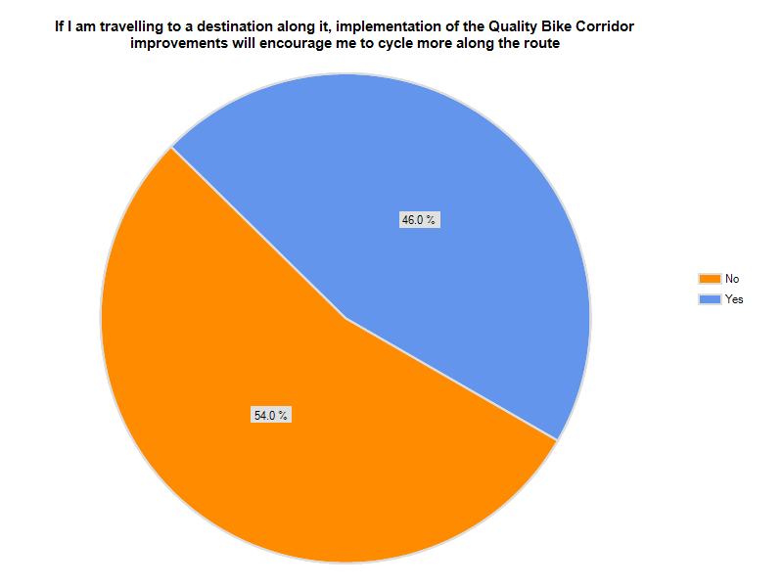
Figure 6.5.8 - Likelihood to cycle more along the QBC

Negative comments were straight forward, such as: “would still not feel safe on the roads”, but also raised concern expressed in Hanna (1990): perhaps more risks are taken when conditions become safer or are perceived as safer. This issue was further developed with the replies to the question In my opinion, implementation of the QBC improvements make it safer to cycle along the route, and the explanation required as to why a particular answer had been chosen: “...I'm also concerned about the cyclist getting a false sense of safety”, “I think any safety they (cycle lanes) provide is merely psychological and could be counterproductive”.
As reviewed in the literature, there is also a broad consensus that safety for cyclists is increased by increasing the number of cyclists (Ensik 2012, Horton 2007, Hass-Klau and Crampton 1990, Yeates 2002). This issue was also expressed by those surveyed: “More cyclists will probably use the route in spite of its limitations and that makes it safer, the more users there are”.
As opposed to “feeling of safety”, the Cycling Embassy of Denmark (2012) refers to safety as accidents that can be registered by the police. The "see me save me" map, which records the last ten year's casualties, fatal and serious injury, shows that there have been serious injuries at various points along the route (Road Peace, 2012), however, due to the short amount of time that the changes have been implemented, it is difficult to say whether the Quality Bike Corridor has made a difference, only comparison after a certain amount of time can establish whether safety (measured as accident rates) has improved.
Cycling by Design guidance directs to appropriate carriageway conditions related to traffic volume, speed and HGV content and states that “Where existing carriageways are deemed to be unsuitable for cycling, the first consideration of the designer should be whether changes can be made to the volume, speed and composition of traffic to improve cycling conditions” (Scottish Government, 2010a). In order to increase safety, Yeates 2002 and Ensik 2012 judged the need for a physically separated network when motor vehicles exceeded speeds of 30km/h (20mph). Although the City of Edinburgh Council has extended part of the South Central Edinburgh 20mph scheme, so that it includes the Quality Bike Corridor route on Causewayside / Ratcliffe Terrace between Fountainhall Road in the south and West Preston Street in the north (City of Edinburgh Council, undated), speed reduction was mentioned seven times as further improvements that would encourage respondents to cycle more along the route. The speed of motorized vehicles is further mentioned in the qualitative data, both because it does not cover the full route and because of lack of enforcement: “the 20mph zones are very short”, “There is a 20mph speed limit here but it is totally unenforced thus widely ignored”, “Cyclist are still vulnerable motor traffic and the short stretch of 20mph speed limit is not enforced or respected by drivers”, “Vehicles are still passing me too closely and too fast - up to 40 mph”, “bicycles still share the streets with motor traffic that’s too far and too aggressive”. One comment on Survey 2 expressed how the feeling was that there was still insufficient separation from motor vehicles for genuine safety advances, and how traffic continues to go too fast. This could be substantiated with Ensik (2012) and Shayler et al’s (1993) statement that cycling is not an unsafe mode of transport, but motorized transport that makes cycling hazardous.
Furthermore, the risk posed by motorized transport was very much expressed in both questionnaires, in regards to parking and loading restrictions not being enforced and thus making the cycling lane unsafe: “...the cycle path has not made cycling any safer. On the contrary, the need to duck in and out of the cycle path is dangerous”.
As well as in the qualitative data, the need for restriction enforcement was evident from participant observation (not one journey was made without obstructions), from direct observation, see Figure 6.5.9 (with one car parked on the cycling lane in Bristo Place for over 25 minutes at peak-time), from information from the public consultation, and from the Quality Bike corridor “watch” blogs on www.citycyclingedinbrugh.info .
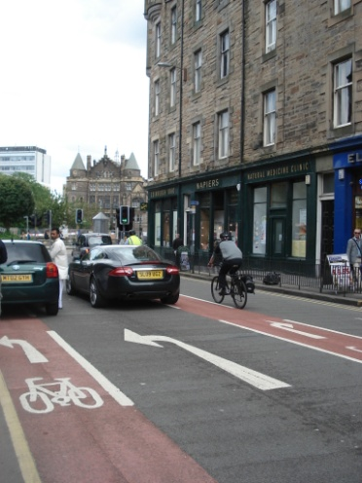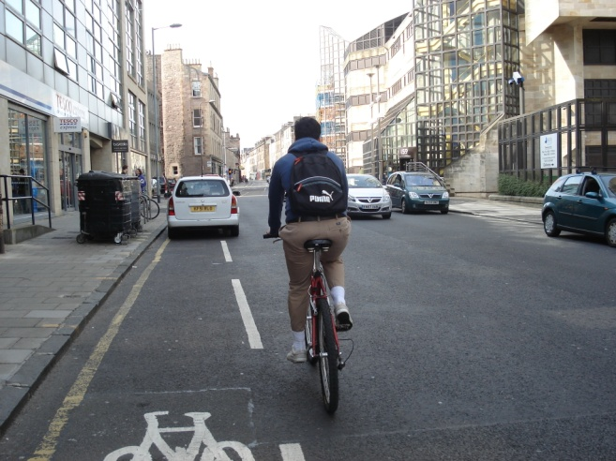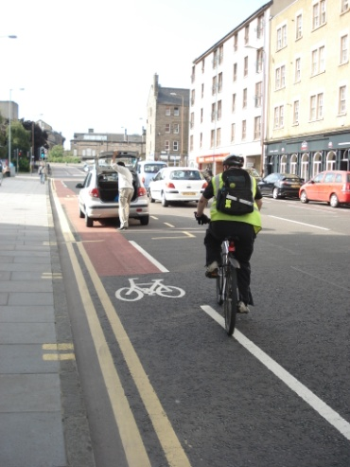
Figure 6.5.9 - Parking on cycle lanes

One blogger of this site says “While cycling home for lunch today along about a mile of the QBC I counted 53 obstructions, most of them parked motor vehicles. On the way back to work it had gone down to only 44”. Survey respondents say, “we will still see cars stopping on the route for pick ups/deliveries,short stops and this will mean that bikes are still forced to swerve around cars in an intrinsically unsafe way ”, and “I still have to cycle around parked cars right into the main flow of traffic, so safety has not improved in this respect at all”, “the fact that cars are free to park on the QBC means that cyclists will have to move out into the road to go past them, potentially causing accidents”. Car parking was the most mentioned improvement that people said would make them cycle more often along the QBC, followed by more segregation from cars.
Reducing risks for cyclists by physically separating networks has not only been acknowledged by research (Wegman et al 2012), but is also perceived by cyclists as such: “Paint is not infrastructure. We need something far more substantial and separate if we wish to genuinely maximise safety to an extent that those currently not cycling for fear of their safety may be encouraged to use the route”, “at the very least it should have cleared away the parking there already was, to create a section of road dedicated solely to bicycles, with incursion of motor vehicles into it being made physically impossible”.

6.6 Comfort

When assessing if design of the cycle facility supports comfort, guidance (CROW, 1996, CILT, undated; Scottish Government, 2010a) suggests taking into account the following: hilliness, traffic obstructions, impediment due to weather, corner radii, widths for adjacent parking and loading, surface condition and surfaces (including drainage, manholes and gullies). The aim is to achieve a route that is convenient to use and avoids complicated manoeuvres and interruptions so as to minimize physical and mental stress.
Comfort allows for speed, which is important for those who are commuting (SEStran, 2008), this includes high-quality road surfaces (Land Transport NZ, 2005). One reply as to whether the QBC makes it safer to cycle along the route said: “There is too much emphasis on safety (as if it was almost the only thing that mattered). Convenience and efficiency (eg speed of getting to work) are more important”. As for interruptions, direct observation revealed that approach lines facilitate arriving slower at a red traffic light, so that the cyclist might not have to stop and start, and can just adjust their speed to continue once the lights are green.
Although there are some inclines along the route, participant observation did not expose any particular issues will hilliness (even though it was on a bicycle with three gears only), and there are no comments in regards to this concern in the qualitative data. In addition, weather conditions were also not mentioned in any replies. Further qualitative research would need to establish if these two issues are of concern to those who would like to cycle more along the route.
Traffic obstructions have been discussed in the above section (6.5. Safety), because qualitative data directly linked them to feelings of safety, they are a recurring occurrence along the route. One comment did not see this as a matter of safety but as one of comfort: “...certainly it would make me feel more comfortable about taking the direct route rather than skirting it as I often do at present”.
The improved surfaces were remarked as an enhancement of the cycling experience, ie “the new smooth road surface is nice”, but the lack of consistency was also mentioned, ie “still hideous potholes at junctions”.
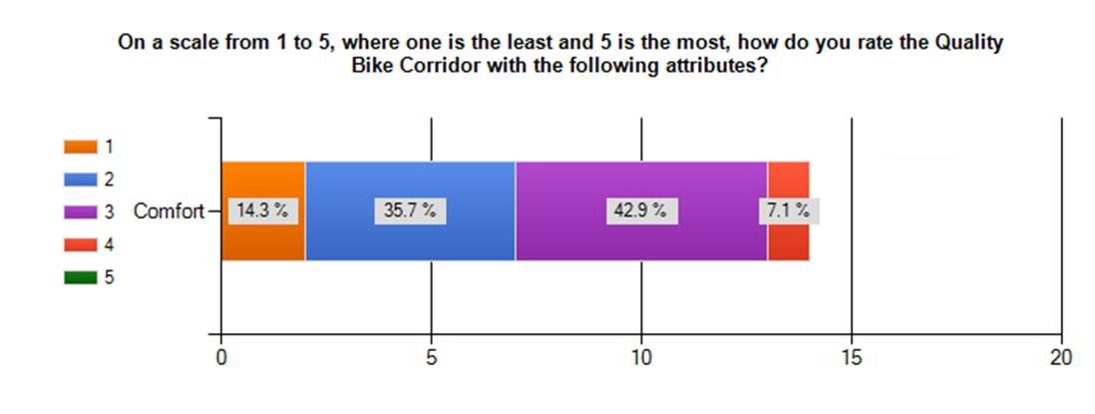
Figure 6.6.1 - Comfort rating

One third of those who cycled after completion of the first phase (survey 2) and commented on the design also said the road surface was not comfortable: “There are still some very rough bits on the stretches that they haven't re-tarred” and “Far too many potholes in the cycle lane”. As seen on Figure 6.6.1, they mostly rated comfort with 2 or 3 (1 being the lowest rating). Direct observation confirmed that there surfaces are not smooth on some sections and that there are some accesses to services (manholes) directly on the cycle path.

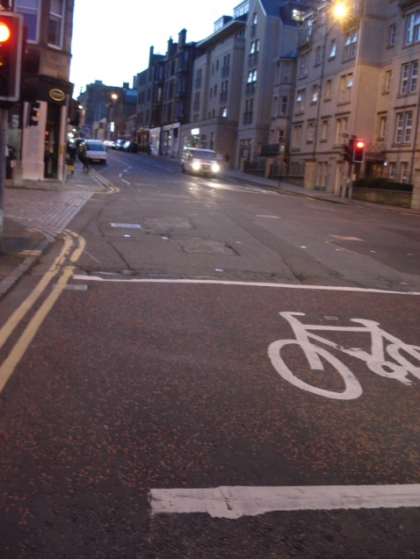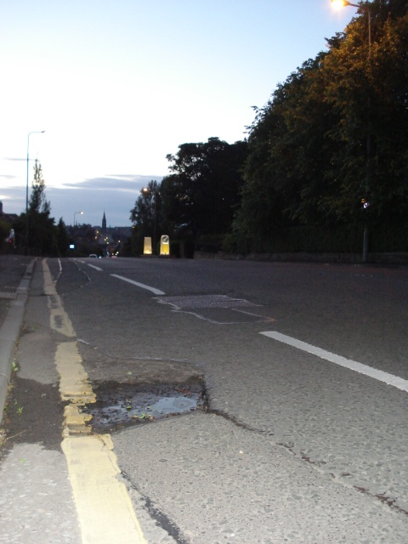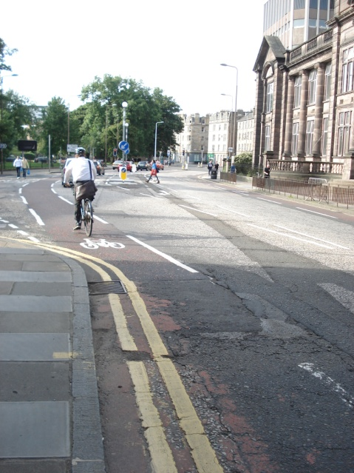
Figure 6.6.2 - Surface inconsistencies

Monitoring and maintenance is also cited (CILT, undated; Scottish Government, 2010a) as a criteria that should be taken in to account, and emphasized in the SEStran (2008) guidelines. Qualitative responses raised concern about this: "The white lines and lanes moving in and out are quite eye-catching, but have to be maintained as such, as the surface itself isn't" and "relaying the bike surface is of limited benefit, as the history of these is that they soon deteriorate and are neglected".
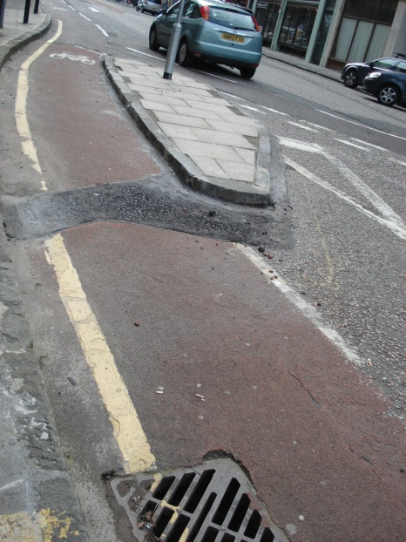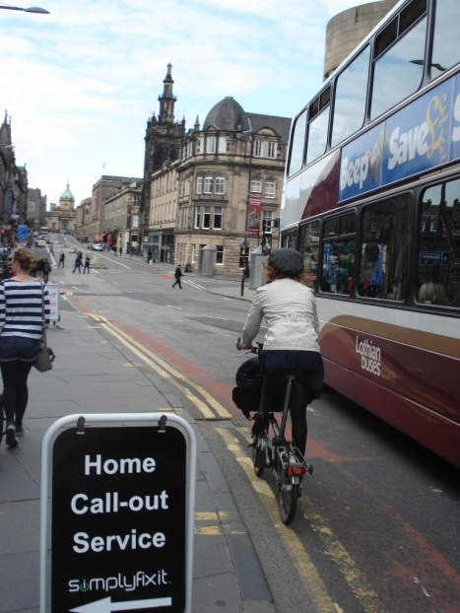
Figure 6.6.3 - Path sections in need monitoring and maintenance

6.7 Conclusion

Although the positive aspects of the improvements are welcome, design guidelines point towards further improvements, and qualitative data shows that further ameliorations would be welcome by users and potential users alike: it would enhance their feeling of safety and encourage them to cycle more. The following were the most prominent issues for each criteria:
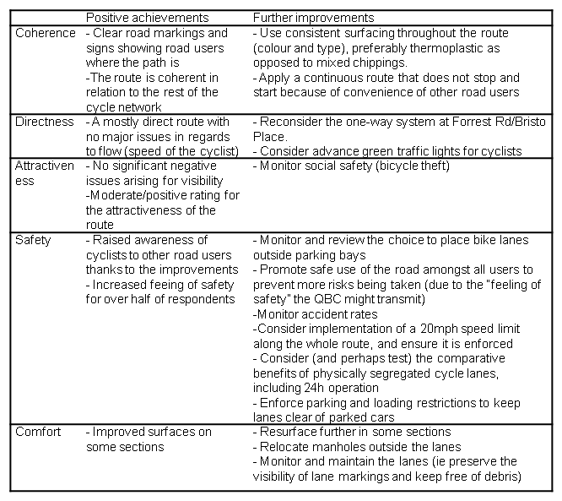
Figure 6.7.1 - Qualitative data findings

In response to the objective of the survey as to whether the design improvements would enable more cycling and safer cycling:
- Almost 46% of Survey 1 respondents said that implementation of the QBC improvements would encourage them to cycle more along the route, and almost 44% of survey 2 respondents (those who had already cycled the route after the first phase had been completed) said they would cycle more often as a direct result of the improvements. In addition, Survey 1 respondents said the QBC would widen transport choices for one or more members of their household: 33.3% of those who already cycle along it, and 29.4% of those who don't.
- 64.4% of Survey 1 respondents agreed or strongly agreed that the QBC improvements made it safer to cycle along it, but only 18.8% of or those respondents who had cycled after completion of the first phase said they would cycle more often along it because they feel safer as a direct result of the improvements.
The fact that only 13.2% of Survey 1 respondents cycle often or never must be taken into consideration, and further research should establish the opinions of this user group.

CHAPTER 7 – Conclusions and Recommendations

7.1. Introduction

This chapter will reflect on the previous chapter, Findings and Discussion, and examine how it complements the information examined in the Literature Review. Furthermore the chapter proposes recommendations based on the research results and considers their contribution to research in urban design and active travel.

7.2. Conclusions

Literature evidenced the relationship between urban design and the achievement of a more sustainable transport network. The design improvements of the Quality Bike Corridor constitute a step for Edinburgh City Council, in their aim to increase Active Travel rates, and as part of their objective to increase targets of residents who cycle to work to 15% by 2020, and thus contribute to the prevention of ill-health and a more sustainable transport infrastructure.
Design principles have been widely adopted from the Dutch criteria and have also set the basis of the design for the Quality Bike Corridor. Research established that although the criteria had been taken into account, motorized transport remained a priority during the design process of the Quality Bike Corridor. However, findings show that the design improvements on the Quality Bike Corridor have achieved a greater feeling of safety amongst the majority of respondents, and that improvements will encourage almost 65% of those who do not currently cycle along the route to do so: individual travel choices have been influenced (granting the low response rate of this group might mean results are not accurate).
Scottish national and local policy establishes the importance towards increased Active Travel through hard and soft measures, but in the case of the QBC, design implementation does not reflect the commitment stated in the policy. We can learn from other countries such as the Netherlands: during their Bicycle Master Plan period they posed the question: “which mode of transport is the most efficient for which type of trip?” And accordingly provided facilities that encouraged bicycle use in instances where this was the obvious choice (Wellerman, 2002).
Although the review of the QBC according to the widely adopted Dutch design principles showed some positive achievements, it also revealed expectations (both from design criteria and from those who were surveyed) of further improvements if the QBC is to comply with these principles. The most outstanding issues to be addressed are the coherence of the network and safety: for greater levels of safety to be achieved, considerable advances in parking restrictions and speed limits should be made; if not, segregated lanes should seriously be considered as an option that could comply with all of the design principles. There are also some adjustments that should be made to surfaces in order to improve comfort.
Literature demonstrates that quantity and quality of cycling facilities are important in achieving positive results and Scottish policy (at a national, regional and local level) already expresses the intention to support the design of infrastructure that is based on these five principles. Research has shown that although it contributes to the quantity of facilities, the QBC only partly fulfils the characteristics of an infrastructure of quality. Additionally, in the UK, the (non) cycling culture and the development of a dual cycle network might determine perceptions that roads are not considered safe and thus not appropriate to cycle in. Again, this points towards separation of the infrastructure from motorized transport.
Increases in regards to feelings of safety and willingness to use the route more often as a result of the improvements were recorded. However, including the opinions of those who cycle occasionally or do not cycle at all will be crucial, as it is their behaviour that needs to be influenced if real modal changes are to be achieved.

7.3 Recommendations

The intention to work towards infrastructure that facilitates sustainable transport is stated by the Scottish Government and in the Edinburgh Active Travel Action Plan. For this reason, the priority given to motorized vehicles when designing facilities for the bicycle should be reconsidered. Physically segregated lanes might facilitate adoption of design expectations, from guidance and users (and potential users) alike.
Concerns in regards to speed of adjacent traffic and parking restriction enforcements dominated comments in the qualitative data and thus should be prioritized and addressed.
Since over 80% of respondents of this survey where those who already cycle often, it would be desirable to carry out further research, and this way establish the opinions and grounds for behaviour change of those who do not already cycle often.
Over 70% of respondents said that further improvements would make them cycle more along the route, indicating that there are more opportunities to increase cycling levels along the QBC. More research could help establish what further improvements would enhance safety for those who would be encouraged to cycle.

REFERENCES

Amaratunga, D et al (2002). Quantitative and qualitative research in the built environment: application of “mixed” research approach. Available from http://usir.salford.ac.uk/522/
Anderson D. (2010). Edinburgh City Local Plan. Available from http://www.edinburgh.gov.uk/eclp
Appleyard D. (1981) page 21, Livable Streets, , University of California Press, 1981
Badland H, Schofield G, Garrett N. (2008) Travel behaviour and objectively measured urban design variables: Associations for adults travelling to work. Health & Place 14. 85–95
Badland, H. and Schofield, G. Transport, urban design, and physical activity: an evidence-based update Original Research Article. Transportation Research Part D: Transport and Environment, Volume 10, Issue 3, May 2005, Pages 177-196
Banister, D. (2005). Unsustainable Transport: City Transport in the new century. Abingdon: Routeledge
Barton, H. (2009). Land-use planning and health and well-being. Land use Policy 26S (2009) S115-S123.
Bike Station, The. Posted by Mark (15.11.2011). Cycling up 26% on the Edinburgh Cycle Path Network. Available from http://www.thebikestation.org.uk/blog/2011/11/15/cycling-up-26-on-edinburgh-cycle-path-network.html
Birkeland, J. (2008). Positive development. From vicious circles to virtuous cycles through built environment design. London: Earthscan.
Blondel, B. (2011). Cycle more often to cool down the planet. Available from http://www.ecf.com/wp-content/uploads/ECF_CO2_WEB.pdf
Brake (2012). Commuters call for safer streets for cycling, to enable more to get on their bikes. Available from http://www.brake.org.uk/latest-news/commuters-call-for-safer-streets-for-cycling-to-enable-more-to-get-on-their-bikes.htm
Buis (2009). Car-oriented transport development, in Shangai Manual Chapter 4: Sustainable Urban Transport. Available from http://www.un.org/esa/dsd/susdevtopics/sdt_pdfs/shanghaimanual/Chapter%204%20-%20Sustainable%20urban%20transport.pdf
Burwell, David. (Undated). Way to go! Three simple rules to make transportation a positive force in the public realm. Available from: http://www.mayorsinnovation.org/pdf/PPShasaradicalidea.pdf
Cabinet Office. ( 2009). The wider costs of transport in English Urban Areas. www.cabinetoffice.gov.uk/media/307739/wider-costs-transport.pdf
Cairns et al (2008). Smarter Choices: Assessing the Potential to Achieve Traffic Reduction Using ‘Soft Measures’. Transport Reviews, Vol. 28, No. 5, 593–618
Cervero, R. and Radi’sch, C. (1996) Pedestrian versus automobile oriented neighbourhoods. Transport Policy, Vol. 3, No. 3, pp. 127-141
Chartered Institute of Logistics and Transport (Undated). Design checklist, available from http://www.ciltuk.org.uk/download_files/Cycle%20design%20checklist%20110628.pdf
City of Edinburgh Council (Undated). Quality Bike Corridor – consultation comments and responses. Available from http://www.edinburgh.gov.uk/downloads/file/4652/qbic-comments_and_responses
City of Edinburgh Council (2003). Edinburgh Standards for Urban Design. Available from http://www.edinburgh.gov.uk/info/207/planning-policies/824/edinburgh_standards
City of Edinburgh Council (2007) Local transport Strategy 2007-2012 Available from https://www.edinburgh.gov.uk/downloads/file/410/local_transport_strategy_2007-12
City of Edinburgh Council (2010). Active Travel Action Plan. Available from http://www.edinburgh.gov.uk/downloads/file/4409/active_travel_action_plan
Cooper et al, cited in Macmillen and Givoni (2009). Evaluating Active Travel: A challenge to prevailing frameworks. Available from http://www.velo-city2009.com/assets/files/paper-Macmillen-Givoni-sub7.2.pdf
Corfee-Morlot, J., Cochran, I. and Teasdale P. (2008) Competitive cities in a changing climate in: Competitive Cities and Climate Change OECD Conference Proceedings, Milan, Italy, 9-10 October 2008. Available from http://www.oecd.org/dataoecd/12/38/42554913.pdf
CROW (1993) cited in The European Network for Cycling Expertise (Undated). Cycling and Planning. Available from: http://velo.info/Library/Cycling_Planning.pdf
CROW (1993). Sign up for the Bike. Design manual for a bicycle friendly infrastructure. The Netherlands: CROW.
Cycling Embassy of Denmark (2012). Collection of cycle Concepts 2012. Available from http://www.cycling-embassy.dk/2012/06/26/download-the-collection-of-cycle-concepts-2012/#
Cycling Scotland et al (2012). Active travel, active Scotland full report. Available from http://www.transformscotland.org.uk/new-report-sets-out-path-to-active-travel-active-scotland.aspx
Dawson, (2002). Introduction to research methods. A practical guide for anyone undertaking a research project. Oxford: How to books Ltd
De Nazelle et al. (2011). Improving health through policies that promote active travel: a review of evidence to support integrated health impact assessment. Environment International V.37 pp 766-777.
Dekoster, J. and Schollaert, U. (1999). Cycling: The way ahead for towns and cities. Luxembourg: Office for Official Publications of the European Communities.
DfT (2007). Manual for streets. London: Thomas Telford.
DfT (2006) . Reducing carbon emissions from transport. Ninth report of session 2005-06. Volume 1. Available from: http://www.publications.parliament.uk/pa/cm200506/cmselect/cmenvaud/981/981-i.pdf
Douglas, M., Watkins, S., Gorman, D., Higgins, M. (2011). Are cars the new tobacco? Journal of Public Health. Vol 33, No2, pp. 160-169.
ECF (2011). Call for an integrated European Cycling Policy. ECF Position on the European Comission's White Paper on Transport. Available from http://www.ecf.com/wp-content/uploads/ECF-Paper-on-White-Transport-in-Layout-JF.pdf
Edinburgh City Council (2011). Sustainable Edinburgh 2020. Engaging with our city's future. Available from http://www.edinburgh.gov.uk/downloads/file/4827/sustainable_edinburgh_2020-engaging_with_our_citys_future-full_version
Edwards, P and Tsouros A. (2008). A healthy city is an active city. Copenhagen: WHO Regional Office for Europe Publications. Available from http://www.euro.who.int/__data/assets/pdf_file/0012/99975/E91883.pdf
Ensik, B. (2012). Road Safety for Cyclists – Principles and Best Practice. PRI World Congress Papers. Available from http://www.ecf.com/wp-content/uploads/Road-Safety-for-Cyclists-Morroco-Speech.pdf
Eurobarometer (1995), cited in p. 19 in Dekoster, J. and Schollaert, U. 1999. Cycling: The way ahead for towns and cities. Luxembourg: Office for Official Publications of the European Communities.
Ferguson, N. and Woods, L. (2010). Travel and Mobility in Jenks, M and Jones C. (2010). Dimensions of the Sustainable City. London: Springer.
Fink, A. and Kosecoff, J. (1985). How to conduct surveys. California: Sage Publications.
Forsyth, A. and Krizek, K. (2011). Urban Design: Is there a Distinctive View from the Bicycle?, Journal of Urban Design, 16:4, 531-549
Friedman, B. (1998). The research tool kit: putting it all together. California: Brookes/Cole Publishing Company
Gehl, J. (1980). Life between buildings. Wokingham : Van Nostrand Reinhold Company Limited
Gehl, J. (2011). Jan Gehl Cities for People. Australian Broadcasting Corporation. Available from http://fora.tv/2011/05/02/Jan_Gehl_Cities_for_People
Gehl, J. (2012). Copenhagen: governed with people in mind. Available from http://gehlcitiesforpeople.dk/
Google maps, accessed 12.07.2012, available from http://maps.google.co.uk
Grimshaw, J. and the Lothian Cycle Routes Project. Lothian Cycle Route Project. Opportunities and Policies. A report for the Regional Council.
Halcrow Group (2001/2002). Multi-Modal Studies: Soft Factors Likely to Affect Travel Demand, Update Final Report. London: Department for Transport
Halcrow Group (2009). Land Use and Transport: settlement patterns and the demand for travel. London: Halcrow Group Ltd for CfIT.
Hanna, J. (1990). Feet first: putting people at the centre of planning. In Tolley R (1990). The greening of urban transport: planning for walking and cycling in Western cities. London: Belhaven Press.
Hardy, S. (1996). Methodologies for exploring the link between urban form and travel behaviour. Transpn Rex-D, Vol. 1, No. 2, pp. 151-165.
Hass-Klau, C. and Crampton, G. (1990). Cycle safety: a comparison between three British and three West German towns. In: Cycling and the Health City. Papers from a one day conference. London: Friends of the Earth Trust.
Heinen, et al. (2010). Commuting by Bicycle: An Overview of the Literature. Transport Reviews, Vol. 30, No. 1, 59–96
Hickman, R. and Banister, D. (2005). Reducing Travel by Design: what about change over time? In Williams K (2005). Spatial Planning, Urban Form and Sustainable Transport. Aldershot: Ashgate Publishing Ltd.
Hillman, M. (1990a) cited in p.26 in Shayler M, Fergusson M and Rowell A. (1993). Costing the benefits: the value of cycling. Godalming: Cyclists' Touring Club Publication.
Hillman, M. (1990b). Cycling and Health: a policy context. Cycling and the Health City. Papers from a one day conference. London: Friends of the Earth Trust.
Hillman, M. (1993). Cycle helmets. The case for and against. London: Policy Studies Institute.
Horton, D. (2007). Fear of cycling, in: Horton D, Rosen P and Cox P. (2007). Cycling and Society. Aldershot: Ashgate. pp. 133-152
Horton, D (2011). Save our cities, build for bicycles, not cars. Available from http://www.bikehub.co.uk/news/sustainability/save-our-cities-build-for-bicycles-not-cars/
Hoxley, J. (2008). Questionnaire designs and factor analysis in: Knight, A. and Ruddock, L., (2008). Advanced research methods in the built environment. Chichester : Wiley-Blackwell
Hull, A. (2011). Transport Matters. Integrated approaches to planning city regions. Oxon: Routeledge.
Institute of Public Health in Ireland (2006). Lavin, T., Higgins, C., Metcalfe, O. et al. Available from: http://www.publichealth.ie/publications/healthimpactsofthebuiltenvironmentareview
Interface for Cycling Expertise (2009). Cycling Inclusive Policy Development: a Handbook. Available from http://germany-wuf.de/upload/Cycling-Inclusive_Policy_Development.pdf
Irish National Transport Authority (2011). Planning for the bicycle. Available from http://www.cyclemanual.ie/manual/planning/
Jackson and Kochititzky (2001) cited in p. 196, Jackson L (2003). The relationship of urban design to human health and condition. Landscape and urban planning 64. 191-200
Jacobs, J. (1958). Downtown is for people. Available from: http://features.blogs.fortune.cnn.com/2011/09/18/downtown-is-for-people-fortune-classic-1958/
Kirby, A (2008). Kick the Habit. A guide to climate neutrality. Malta: Progress Press for UNEP/ GRID-Arendal
Land Transport NZ (2005). Cycle network and route planning guide. Available from http://www.nzta.govt.nz/resources/cycle-network-and-route-planning/
Lothian and Borders Police. (06.03.2012). Bike theft initiative. Available from http://www.lbp.police.uk/information/latest_news/march_2012/bike_theft_initiative.aspx
Marshall, W. and Garrick, N. (2011). Evidence on why bike-friendly cities are safer for all users. Environmental Practice 13 (1), pp 16-27. Available from http://files.meetup.com/1468133/Evidence%20on%20Why%20Bike-Friendly.pdf
McClintock, C. (2000). Planning for the bicycle: current issues and future challenges. Municipal Engineer 145. Issue 1 pp. 37-45
McClintock, H. (1992). The bicycle and city traffic : principles and practice. Belhaven Press
McClintock, H. (2002). The development of UK cycling policy in McClintock H (2002). Planning for cycling. Cambridge: Woodhead Publishing.
Moritz, W.E. (1998) cited in Heinen et al (2010) Commuting by Bicycle: An Overview of the Literature. Transport Reviews, Vol. 30, No. 1, 59–96.
Nelson, A.C. and Allen, D. (1997). If You Build Them, Commuters Will Use Them. Transportation Research Record. 1578: p. 79-83
Newman, P. (2003). Global cities, transport, energy and the future: will ecosocialization reverse the historic trends? In: Low, N and Gleeson, B (2003). Making Urban transport sustainable (2003). New York: Palgrave Macmillan.
Ó Dochartaig, N. (2002). The internet research handbook. London: Sage
OCDE. (2010). Cities and Climate change. Available from http://www.oecd.org/document/34/0,3746,en_2649_37465_46573474_1_1_1_37465,00&&en-USS_01DBC.html
Parkin, J., Ryley, T. and Jones, T. (2007). Barriers to cycling: an exploration of quantitative analyses. in Rosen, P. and Horton, D. and Cox, P. (2007) Cycling and Society. Aldershot: Ashgate
Peck, C. (28.06.2012). Cycle casualties increase sharply in 2011. Available from http://beta.ctc.org.uk/news/2012-06-28/cycle-casualties-increase-sharply-in-2011
Buchanan, P. (undated). Cited by UDG in http://www.udg.org.uk/about/what-is-urban-design
Pettinga A. et at (2009). Cycling Inclusive Policy Development : A handbook. Eschborn : Deutsche Gesellschaft für Technische Zusammenarbeit (GtZ). Available from : http://germany-wuf.de/upload/Cycling-Inclusive_Policy_Development.pdf
Phillips, E. (2010). Physical Activity Spectrum from Physical Activity/Active Travel within a Single Outcome Agreement context http://walkcycleconnect.org/wp-content/uploads/downloads/2010/07/Eddie-Phillips.pdf
Poulton, M., cited in City of Edinburgh Council (29.03.2012). Work begins on new Quality Bike corridor. Available from http://www.edinburgh.gov.uk/news/article/844/work_begins_on_new_quality_bike_corridor
Project for Public Spaces (2005). Going Places. Available from the Making Places Newsletter from: http://placemaking.pps.org/info/newsletter/june2005/
Pucher, J., Komanoff, C., Shimek, P. (1999) Bicycling renaissance in North America? In Wheeler, S. and Beatley, T. (2004). Sustainable Urban Development Reader. London: Routeledge
Pucher, J. and Buehler, R. (2008). Making Cycling Irresistible: Lessons from The Netherlands, Denmark and Germany. Transport Reviews, 28:4, 495 — 528
Queensland Department for Transport and Main Roads (undated). Selecting appropriate cycling facilities. Available from http://www.tmr.qld.gov.au/~/media/02564db7-7724-4f51-8a2b-4951abf7d526/pdf_b2_selecting_appropriate_cycling_facilities_1.pdf
Rabl, A. and De Nazelle, A. (2009). Benefits of shift from car to active transport. Transport Policy 19 (2012) 121–131.
Ravetz, A. (1980) cited in p.98 in Haughton, G. and Hunter, C. (2003). Sustainable Cities. London: Routeledge.
Reid, S. and Guthrie, N. (2004). Cycling in bus lanes. TRL Report TRL610 for the DfT.
Road Peace (2012). See me save me. Available from http://www.seemesaveme.com/map/
Roberts, J. (1990). The economic case for green modes in The greening of urban transport: planning for walking and cycling in Western cities (1990) Tolley, R. London: Belhaven Press.
Rowley, A. (1994). Definitions of urban design: The nature and concerns of urban design, Planning Practice and Research, 9:3, 179
RTPI (2001). A new vision for planning. Available from www.rtpi.org.uk/media/1268410/new-vision-full.pdf
Ryley T, Jones T and Parkin J.(2007). Barriers to cycling. An exploration of quantitative analyses in Horton D, Rosen P and Cox P. (2007). Cycling and Society. Aldershot: Ashgate. Chapter 3.
SafetyNet (2009) Pedestrians & Cyclists. Available from http://ec.europa.eu/transport/road_safety/specialist/knowledge/pdf/pedestrians.pdf
Scottish Executive (2005). Planning Advice Note 75. Available from http://www.scotland.gov.uk/Resource/Doc/57346/0016795.pdf
Scottish Government (2009). National Planning Framework 2. Available from http://www.scotland.gov.uk/Resource/Doc/278232/0083591.pdf
Scottish Government (2010a) Designing Streets. Available from http://www.scotland.gov.uk/Resource/Doc/307126/0096540.pdf
Scottish Government (2010b). Scottish Planning Policy. Available from http://www.scotland.gov.uk/Topics/Built-Environment/planning/National-Planning-Policy/newSPP
Scottish Government (undated). Strategic objectives. Available from http://www.scotland.gov.uk/About/Performance/Strategic-Objectives
SEStran (2008). Cycling Infrastructure: design guidance and best practice. Available from http://www.sestran.gov.uk/files/Final%20SEStran%20Cycling%20Design%20Guidance%20Document.pdf
Shayler, M., Fergusson, M. and Rowell, A. (1993). Costing the benefits: the value of cycling. Godalming: Cyclists' Touring Club Publication
Steinbach et al. (2011). Cycling in the city: A case study of how gendered, ethnic and class identities can shape healthy transport choices. Social Science & Medicine 72 (pp. 1123-1130).
Stern Review (2006). Available from http://webarchive.nationalarchives.gov.uk/+/http:/www.hm-treasury.gov.uk/sternreview_index.htm
Survey Monkey (undated). Everything you wanted to know, but were afraid to ask. Available from http://www.surveymonkey.com/mp/aboutus/
Sustainable Development Commission. (2009). Fairness in a car dependent society. Available from http://www.sd-commission.org.uk/data/files/publications/fairness_car_dependant.pdf
Sustrans (1999). Routes for people information sheet FF21. Available from http://www.sustrans.org.uk/assets/files/Info%20sheets/ff21.pdf
Sustrans (2007). Connect 2 and Greenway Design Guide. Chapter 16: Usage and monitoring. Available from http://www.sustrans.org.uk/assets/files/connect2/guidelines%2016.pdf
Sustrans (2008). Active Travel and Healthy Wrokplaces. Available from http://www.sustrans.org.uk/assets/files/AT/Publications/Workplace%20toolkit/active_travel_healthy_workplaces.pdf
Sustrans (2010). Bike belles for women who want to cycle. Available from http://www.sustrans.org.uk/assets/files/BikeBelles_for_women_who_want_to_cycle_Feb_2010.pdf
Sustrans (2011). Usage and monitoring guidelines. Available from http://www.sustrans.org.uk/assets/files/connect2/guidelines%2016.pdf
Sustrans (2012). The real cycling revolution. How the face of cycling is changing. Available from http://www.sustrans.org.uk/assets/files/Press/real-cycling-revolution.pdf
Sustrans (undated). Active Travel Action Plan. Available from http://www.sustrans.org.uk/what-we-do/active-travel/active-travel-projects/active-travel-action-plan
Tolley, R. (2003). Ubiquitous, Everyday Walking and cycling: The acid test of a sustainable transport policy in Doherty, I (2003). A new deal for transport? The UK’s struggle with the sustainable transport agenda. Oxford: Blackwell.
Transport Scotland (2011a). Cycling by design 2010 (Revision 1, June 2011). Available from: http://www.transportscotland.gov.uk/files/documents/reports/Cycling_by_Design_2010__Rev_1__June_2011_.pdf
Transport Scotland (2011b). Key transport statistics. Available from http://www.transportscotland.gov.uk/files/documents/reports/j205924/j205924.pdf
UN, (1987). Towards sustainable development in: Our Common Future: Report of the World Commission on Environment and Development, available from http://www.un-documents.net/ocf-02.htm#I
UN (2011). Shanghai Manual. Available from http://www.un.org/esa/dsd/susdevtopics/sdt_pdfs/shanghaimanual/shanghaimanual.pdf
Walker, P. (2011). Britons unmoved by pro-cycling campaigns. Available from http://www.guardian.co.uk/lifeandstyle/2011/jun/03/britons-unmoved-cycling-campaigns
Wardman, M., Tight, M., Page, M. (2007). Factors influencing the propensity to cycle to work. Transportation Research Part A 41, p. 339–350
Wegman, F., Zhanga, F., Dijkstrab, A. (2012). How to make more cycling good for road safety? Accident Analysis and Prevention. 44(1):19-29

Wegman, F. (2011). Safety in numbers: more cyclists, lower risks? Available from http://www.swov.nl/rapport/Ss_RA/RA47.pdf
Welleman, T. (2002). An efficient means of transport: experiences with cycling policy in the Netherlands. in McClintock (2002). Planning for cycling. Cambridge: Woodhead Publishing
WHO (2009). Global health risks: mortality and burden of disease attributable to selected major risks. Available from http://www.who.int/healthinfo/global_burden_disease/GlobalHealthRisks_report_full.pdf
WHO (2006). Health Effects and Risks of the Transport System (HEARTS). Available from http://www.euro.who.int/__data/assets/pdf_file/0013/91102/E88772.pdf
Williams R. (2002). Planning for cyclists in Edinburgh in: McClintock H (2002) Planning for cycling. Cambridge: Woodhead Publishing
Yates, M. (2002). Making space for cyclists – a matter of speed? In McClintock (2002). Planning for cycling. Cambridge: Woodhead Publishing Ltd. pp. 50-71.

APPENDICES

Appendix A – Cycle design principles: importance by cyclist type
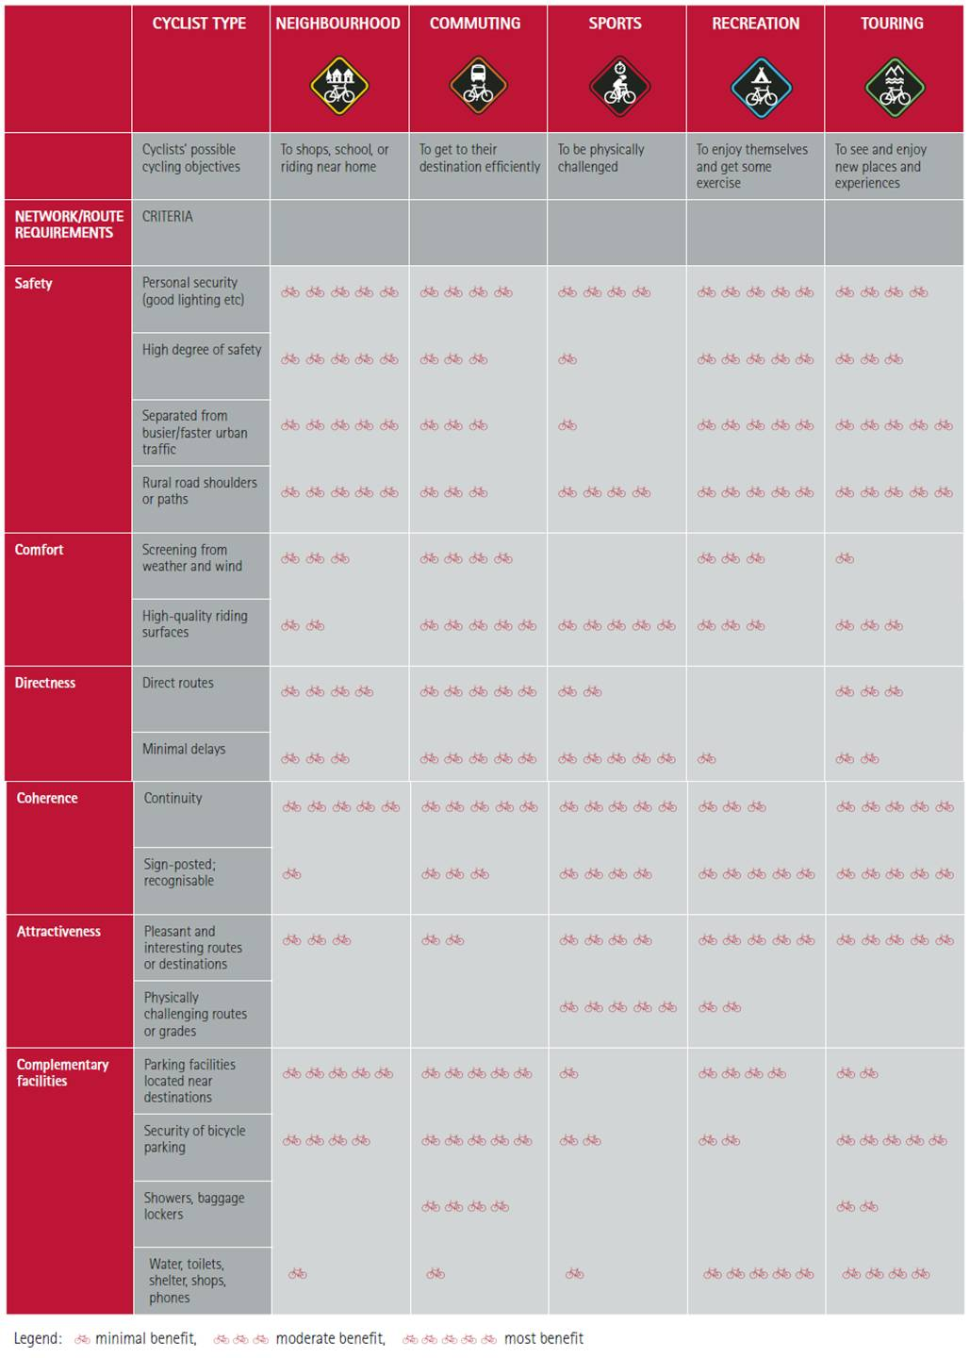
Available from: http://www.nzta.govt.nz/resources/cycle-network-and-route-planning/docs/cycle-network-and-route-planning.pdf

Appendix B – Cycle design principles: importance by user group categories

 | User Group | Priority of design principles * | Route types where likely to be most applicable
A | Leisure cyclists including families | 1 Coherence – continuity is paramount  2 Safety – Like coherence, this is critical  3 Attractiveness – significantly more important than directness though steep hills are an issue  4 Comfort is important but a traffic-free route with a less smooth surface would be better than a busy route with a good surface.  5 Directness is less important for leisure cyclists though see attractiveness | Long distance routes.  Rural routes.  Routes accessing the countryside from urban area
B | Risk-averse and child utility cyclists | 1 As for leisure cyclists safety and coherence are the first priorities. ‘Social safety’ for example routes supervised by being overlooked, is important.  2 Comfort and directness are secondary priorities, directness is more important than for leisure cyclists  3 Attractiveness is desirable but less important than the other factors | Routes to schools, shopping areas, hospitals  Commuter routes on main roads especially outwith urban areas
C | Risk tolerant/experienced ‘utility’ cyclists including many commuters | 1 Directness. This is paramount, as indirect routes will not be used. Gradients are a factor.  2 Comfort. Speeds are likely to be higher for this group than for either of categories ‘A’ or ‘C’.  3 Safety is important but slow ‘safe’ facilities (eg using indirectly routed minor roads) will tend to be ignored in favour of faster routes.  4 Coherence is important but degree of exposure to traffic can be greater than for users A or C.  5 Attractiveness is desirable but less important for this group | Main commuter routes and/or routes used by higher education students especially within urban areas
D | Sports and cyclists | Comfort and Directness are considered likely to be the main priorities for this group. | The main issue in designing for this group is in ensuring that cycle facilities have good geometric design, and are well maintained

Available from http://www.sestran.gov.uk/files/Final%20SEStran%20Cycling%20Design%20Guidance%20Document.pdf

Appendix C – Design Approach for the cycle friendly city programme

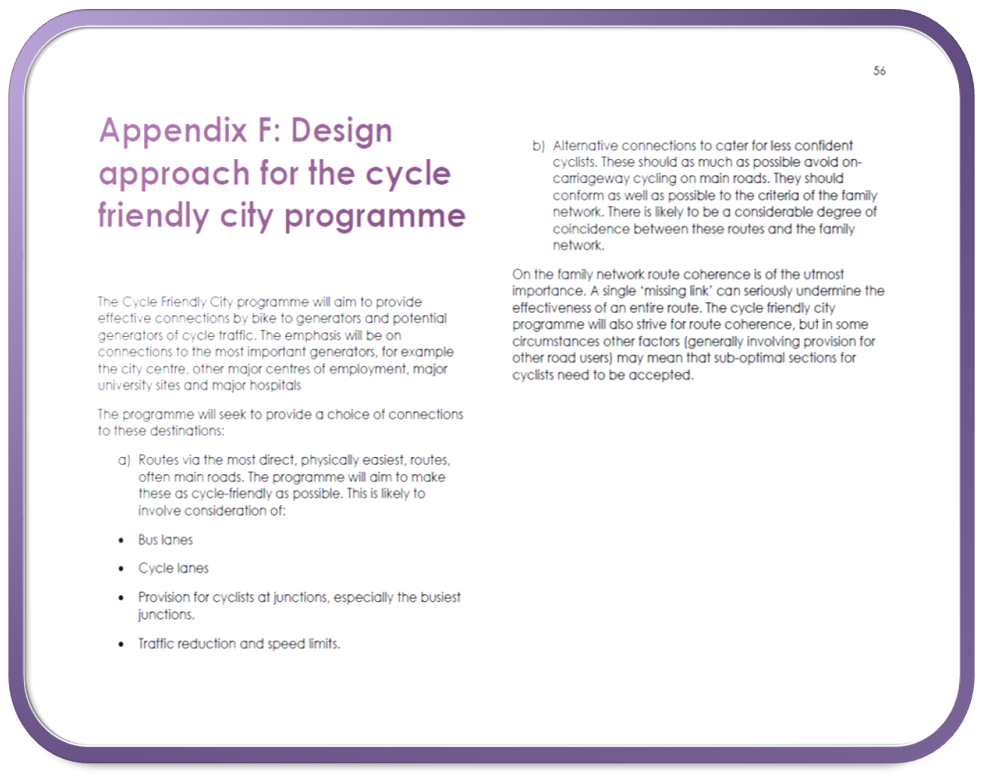

Available from http://www.edinburgh.gov.uk/downloads/file/4409/active_travel_action_plan

Appendix D – The Quality Bike Corridor initial proposal in the Grimshaw Report (1985)

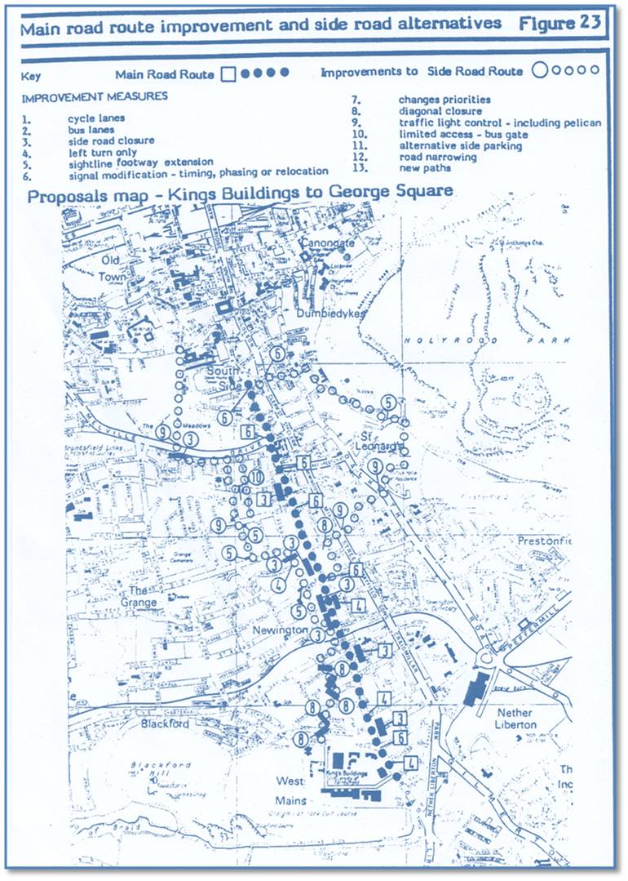

Appendix E – QBC Proposals in more detail

New cycle lanes
1. New cycle lanes are proposed from the junction of Mayfield Rd with Liberton Brae
northwards to the junction of Ratcliffe Terrace with West Mayfield. A new
northbound lane is also proposed between West Mayfield and Duncan Street.
Other short sections of new cycle lane may be provided between West Mayfield
and West Preston Street.
2. In a number of places the proposed cycle lanes would pass to the right of a
marked parking/loading bay, requiring some formalisation of the bays with buildouts
and/or road markings.

New bus lanes
3. New bus lanes are proposed on Potterow/Chapel St north and southbound and on
George IV Bridge southbound (with a short section of cycle lane at the junction
with Chambers St.)
4. The bus lanes have both been identified in previous work for the Council and,
together with the lane on Melville Drive discussed below, should assist bus
reliability on the relevant routes as well as helping cyclists.
5. Melville Drive forms an important link into the Kings Buildings - George Square
route. Subject to space constraints which will be examined during the detailed
design process, it is also proposed to introduce budcycle facilities at the east end
of Melville Drive which forms an important link into this route. Measures would
include an eastbound bus lane (with cycle lane on the immediate approach to
Hope Park Terrace) and a westbound cycle lane. A westbound cycle track may be
required in the near vicinity of the junction. Additional waiting and loading
restrictions are likely to be required but introduction should not be problematic as
there is no frontage access on to Melville Drive at this point.

Centreline markings
6. There is no centre line on the section of Causewayside/Ratcliffe Terrace south of
Grange Road. This allows motorists to respond flexibly to the different road
layouts at different times of day which effectively move the centre of the running
carriageway. (At peak times no waiting or loading is permitted, in the daytime offpeak
periods parking is permitted on one side of the road, overnight parking is
permitted on both sides of the road). It is considered that this is likely to assist
cyclists by encouraging motorists to pass them by an appropriate margin rather
than being psychologically constrained by the centreline. A pilot scheme involving
centreline removal implemented in Devizes (Wiltshire) and monitored by the
Transport Research Laboratory, reduced speeds and was considered likely to
have improved safety. In the light of the above it is proposed that as part of the
current project the centreline is also removed on the whole length of Ratcliffe
Terrace/Causewayside on which it is not possible to install cycle lanes, except on
the immediate approach to signalled junctions. The impacts of this - both on driver
behaviour and safety, would be monitored.

Waiting and loading restrictions
7. Several changes to waiting and loading restrictions are proposed to complement
the new cycle and bus lanes and improve the effectiveness of existing facilities.
The following changes are proposed:
a. Introduce 24 hour parking/loading restrictions:
- on cycle lanes for the immediate (approximately 25m) lead in to Advanced
Stop Lines. It is proposed to apply these restrictions on all arms of
relevant signalled junctions, not just the arms on the main radial route.
These lengths of cycle lane allow cyclists to safely bypass queues on the
junction approach and reach a (relatively safe) position at the head of the
queue.
- on both the north and southbound exits from the junction of Hope Park
Cres/Summerhall Cres with Melville Drive. These exits currently have
cycle lanes in place, but parked and loading vehicles can cause problems
for cyclists. The restrictions would cover the west (northbound) side of
Hope Park Crescent between Melville Drive and the entrance to the
Meadows and the east side of Summerhall CrescentISummerhall between
Hope Park Terrace and Summerhall Square.
- on both sides of Melville Drive between Hope Park Terrace and the
pedestrian crossing roughly 100m west.
- associated with the proposed bus lanes on Potterow/Chapel St as set out
in table 1.
Table 1: New waiting restrictions on Potterow and Chapel Street
Northbound -24 hour parking and loading ban West Crosscauseway to Bristo Place.
Southbound - 24 hour parking and loading ban Brighton Street to Marshall Street. Relaxation of restrictions Marshall St to Chrichton St
b. Other than in marked parking bays, amend parking restrictions to cover 0730 to
1830 Monday to Friday and 0830 to 1730 Saturday. Loading restrictions would
be amended to cover 0730 to 0930 and 1600 to 1830 Monday to Friday. (At
present restrictions cover 0800 to 1800 Monday to Saturday N of W Mayfield
and 0800 to 0915 and 1630 to 1800 south of West Mayfield - loading is banned
0800 to 0915 and 1630 to 1800 Monday to Friday along the whole route).The
changes in proposed start and end times are consistent with those recently
introduced in the citywide review of bus lane hours and associated parking and
loading restrictions.
c. Associated with provision of cycle lanes marked outside existing parking and
loading bays, remove the current peak hour parking and loading bans in these
bays. This is most likely to apply to the two parking bays between West
Mayfield and Duncan Street.
d. Subject to detailed design considerations, create new on street parking and
loading bays in the following locations:
North of West Mayfield
Teviot Place (north side)
Potterow (east side) between Marshall Street and Crichton Street South of W Mayfield
Ratcliffe Terrace south from West Mayfield (west side) to Relugas Road
Ratcliffe Terrace/Mayfield Rd east side in vicinity of shops S of Mentone Terrace
Mayfield Rd W side between W Saville Terrace and McDowall Rd
The northern bays exploit possibilities for provision that should not compromise bus
or cycle facilities -though creation of bays here. The southern bays cover the
places on this section of route where there is a greater need for parking and loading
associated with tenements and/or local shops. The demand and potential for other
parking/ loading bays will be examined. Catering for the houses at Braefoot Terrace
on Mayfield Rd will need careful consideration. The bays would provide 24 hour
loading, improving the current position. Subject to consultation it is likely that
parking will be banned at peak times to avoid the bays being used for all day
commuter parking. An alternative would be to limits on length of stay for the same
purpose.

Available from: http://www.edinburgh.gov.uk/download/meetings/id/8258/george_square_to_kings_buildings_improvements_for_cyclists-quality_bike_corridor

Appendix F – The questionnaires

Survey 1

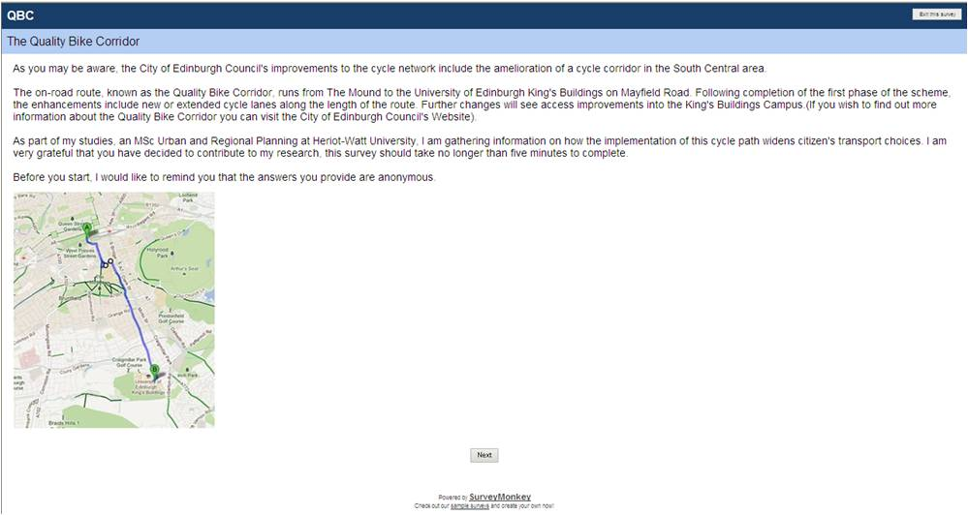

Survey 2

