Pilot of on-street residential cycle parking

The City of Edinburgh Council is committed to increasing the percentage of all journeys in the city by bike to 10% by 2020. One of the biggest barriers to cycling in the city is a lack of suitable cycle parking for residents in tenement areas.

In recognition of this, the Council is considering providing on-street cycle parking in areas with tenement residences. This will initially be done on a trial basis at a small number of locations. We are planning to trial:

- covered cycle racks;
- individual lockers; and
- uncovered cycle racks.

Examples of types of parking to be considered:

Covered cycle racks | Lockers | Uncovered cycle racks
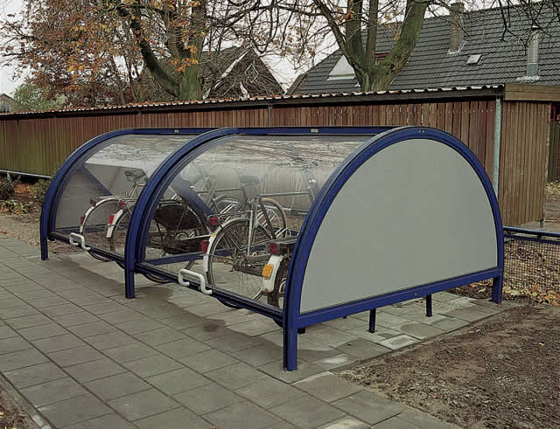 | 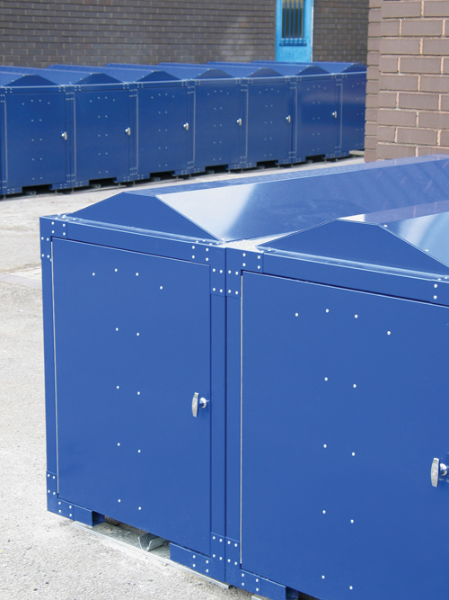 | 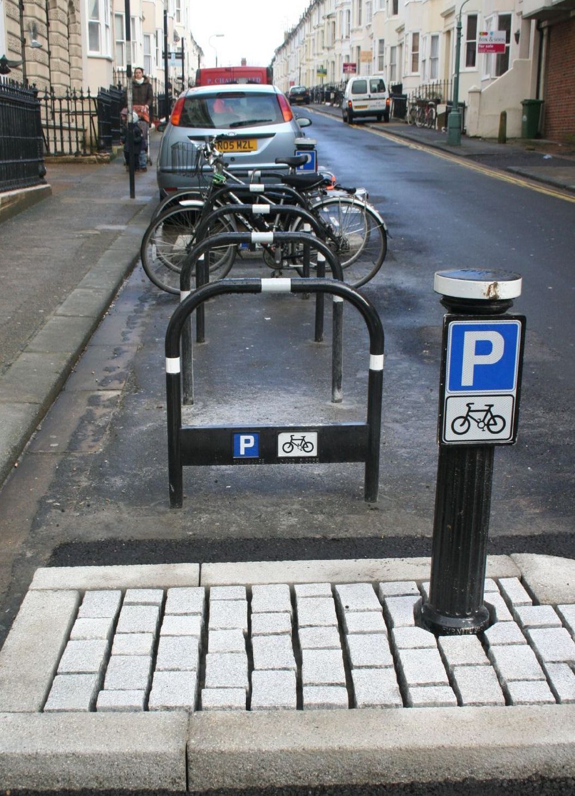

The pilot project will aim to evaluate the effectiveness of the different options and the potential for wider use. We aim to have the facilities available on a trial basis in time for summer 2012 with the trial then lasting around 2 years.

In order to identify the best locations for the pilot installations we are inviting residents to express an interest in participating in the scheme. For an application to be successful we are looking for evidence that there is demand for the parking. In addition, for the covered parking options we are looking for commitment to help in managing the access to and maintenance of the facilities.

To help us assess the suitability of your application for on-street cycle parking please complete the form below. We are looking for one application per shared stairwell

Due to the need to give priority to areas with the worst bike parking problems only the following are eligible:

1. Tenemental with no suitable alternative cycle parking
2. Other high density housing with no suitable cycle parking

Housing with accessible communal areas available to provide cycle parking will not be eligible.

Applications are subject to being selected on the basis of suitability and feasibility. We cannot guarantee that locations that are selected will be installed.

Should you require any further information please contact cycling@edinburgh.gov.uk

Please submit this form by 9 December 2011 to cycling@edinburgh.gov.uk or by post to:

Residential Cycle Parking Pilot
Strategic Planning (Transport)
Room 10.31
249 High Street
City Chambers
Edinburgh
EH1 1YJ

We will endeavor to be in touch regarding the success of your application by 28 January 2012.
Application Form

Name:
Organisation (if applicable):
Address:

Question |  | No.
1. Number of individual flats accessed from the stairwell
2. Number of residents in the stair (approximate total)
3. Total number of bicycles stored permanently by residents of the stairwell
4. Where are these bikes currently stored?
a. In flat
b. In stairwell
c. In backgreen
d. On external railings
e. Other on-street (e.g. lighting columns)
f. Other (please specify)
5. Please describe any problems with your current parking/storage situation:

Question | No.
6. How many cars are owned by residents within the building and are parked on-street (approximate total)
7. Please state what kind of on-street bike parking the residents of your stairwell would be interested in | Please tick relevant box
 | Definitely |  | Maybe | No
a. Cycle racks (uncovered)
b. Covered cycle racks (charge would apply - see Q11)
c. Cycle lockers (charge would apply – see Q11)
8. Please describe potential locations for the cycle parking you are proposing. Please give as much detail as you can (attach a sketch plan if possible).

Question |  | Answer
9. Are there any existing organisations associated with the upkeep/maintenance of your stairwell?
a. CEC Stairwell Partnership
b. Stair association
c. Factor
d. Other (please specify)
Covered cycle parking/lockers
The covered cycle parking will require residents to either individually or collectively manage the use of the spaces, depending on the choice of the communal storage or the individual lockers. To keep running costs to a minimum we are looking for people to take on as much responsibility as possible.
10. Are you/your organisation prepared to take responsibility for: |  | Yes/No
a. Managing access (issuing keys etc)
b. Reporting problems
c. Dealing with issues relating to the parking
11. The maintenance of covered cycle parking is likely to incur a cost that would need to be recouped. Please indicate how much per month you would be prepared to pay for covered/secure cycle parking: |  | Yes/No
a. Up to £1 per month per user
b. Up to £5 per month per user
c. Up to £10 per month per user

