
The Lothian Cycle Campaign
St. Martins Centre, 232 Dalry Road, Edinburgh EH11 2JG 0131.313.2114 [answerphone] competition@spokes.org.uk www.spokes.org.uk Twitter @SpokesLothian Facebook Spokes
This competition info/entry form is on the Spokes website in downloads > odds and ends
My Favourite Bike Ride
SPOKES SUMMER 2015 COMPETITION – OPEN TO ALL
For our summer competition we'd like to hear about your favourite local bike ride. In judging the competition, what we want to know most of all is why it is so special to you. Descriptions which might entice other people to cycle, or to cycle more often, or which give some other useful message, will be especially welcome. The route should be fairly easy to describe, without too many intricate instructions, frequent turnings, etc.
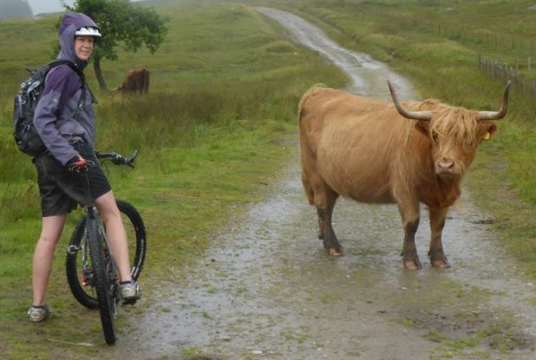Photo from our 2014 competition, Louise Humphreys
Please read these rules carefully –
- The competition is open to all, but members of Spokes Resources Group can't win prizes.
- Each person can submit no more than 2 entries.
- We'd like entries to inspire people to use a bike or to use it more often, or to give useful ideas about cycling – but most important is to say why this ride is so special to you.
- The ride must be entirely in Edinburgh and/or the Lothians, and take less than roughly 3 hours [it can be much shorter if you prefer]. It must not need car transport but it can use rail for part of the trip.
- It can be suitable for novice and/or experienced cyclists.
- The competition closes on 6 September - entries will be judged soon after.
- You can, if you wish, include one or two photos and/or a sketch - these should be sent as jpg files, not exceeding 1MB size if possible. If you are unable to use jpg and/or if you cannot reduce the size of your file, please let us know and we may be able to accept your entry. We can also accept printed/drawn material by post, but we will not return this.
- We may try out routes before or after judging, before finalising the results.
- So that we can easily compare entries, you must complete all the questions on the entry form overleaf, and judging will be on the basis of that. If you wish also to send an electronic description of your route (e.g. strava) that is fine – we may use it if we try out the route, but not in judging.
- Email the completed entry form and any attachments to competition@spokes.org.uk. For printed entries and/or photos, post to our office address.
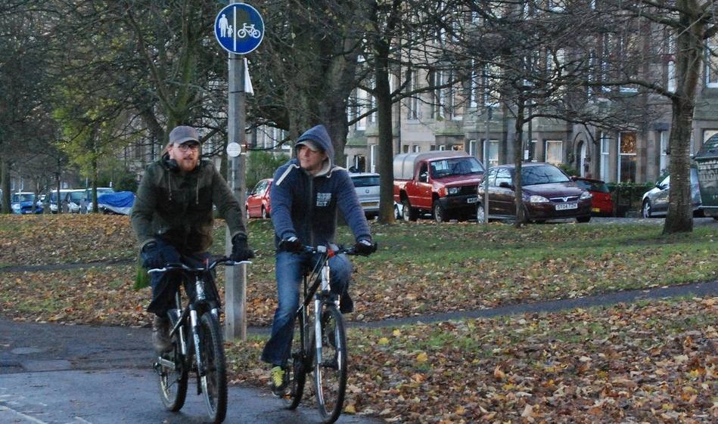Photo from edinburghcyclechic.wordpress.com

HOW ENTRIES WILL BE USED...
Spokes may use some or all entries on our website, in our Bulletin, in other publications or in other ways. We would of course credit your name, unless you ask us not to. We may produce a booklet of prizewinning entries, like we did in 2005. By entering the competition you give Spokes permission to use your entry material in our ongoing campaigning and promotional work in these or other ways.
PRIZES | Top prizewinner gets first choice of prizes, and so on till all prizes allocated  Good entries which don't win a prize will get to choose a free Spokes map

www.edinburghbicycle.com £50 Edinburgh Bicycle voucher
ScotRail www.scotrail.co.uk Return 1st class ticket for 2 between any 2 Scottish stations
Camera Obscura/World of Illusions www.camera-obscura.co.uk Family ticket [2 prizes]
Kalpna Indian Veg Restaurant www.kalpnarestaurant.com Lunch for 2
BikeTrax www.biketrax.co.uk £25 BikeTrax voucher
Filmhouse www.filmhousecinema.com Tickets for 2
Sustrans www.sustrans.org.uk Selection of Sustrans Scotland maps
Peter's Yard www.petersyard.com Jan Hedh Artisan bread book [2 prizes]
Reiss hairsalon 27 Hamilton Place Hair cut and finish
------------------------------------------------------------------------------------------------------------------
Your Name

Address Postcode

Email Phone number
------------------------------------------------------------------------------------------------------------------
*** Use separate sheet or email if you need more space. Be sure to follow the rules overleaf.

1. Please give a name for your favourite ride in Edinburgh and/or the Lothians
[e.g. Midlothian circular, or Dalry to Canonmills, or Portobello perambulation] …

2. Who is it suitable for? [it doesn’t need to suit everyone] circle all that apply...
Families with young children / Experienced cyclists / Novice cyclists / Other – specify...

3. Where is the route located? circle all that apply ...
Ed central / Ed north / Ed south / Ed east / Ed west / East Lothian / Midlothian / West Lothian

4. Brief description of route
a. Start point...

b. End point (or circular)...

c. Brief description...

5. Any interesting / useful / beautiful features / facilities en route …

6. Why is this a favourite route of yours? [This question is very important in the judging. You can just write one or two sentences or up to 300 words maximum].

Thanks for entering – Encourage your friends to enter too!

