
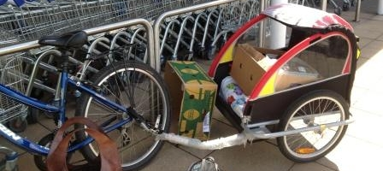
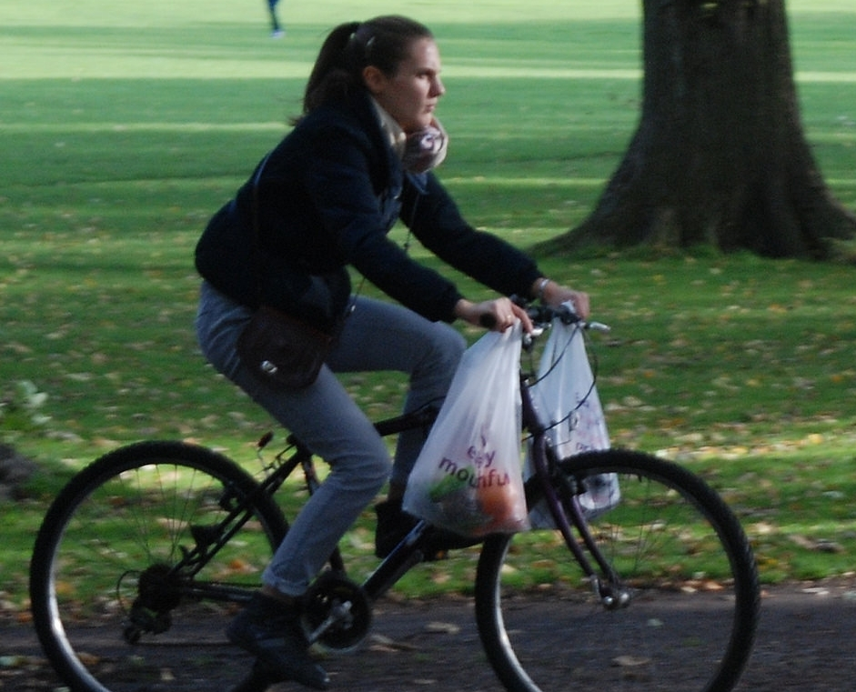
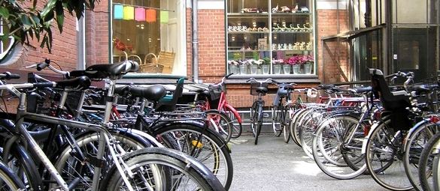
The Lothian Cycle Campaign
St. Martins Centre, 232 Dalry Road, Edinburgh EH11 2JG 0131.313.2114 [answerphone] competition@spokes.org.uk www.spokes.org.uk Twitter @SpokesLothian Facebook Spokes
This competition info/entry form is on the Spokes website in downloads > odds and ends
Shopping by Bike
SPOKES SUMMER 2016 COMPETITION – OPEN TO ALL
For our 2016 summer competition we'd like to hear about your experiences, ideas or handy hints for Shopping by Bike.
Whether you've a great idea that would help other people, a challenge you've overcome, an experience you'd rather forget, or something you'd not recommend – if it's about shopping by bike, we want to hear from you!!
An important factor in judging will be how useful your idea is, but interesting or unusual could also help you win a prize. Your entry must fit an A4 sheet, but apart from that it's up to you. Words alone are fine, even just one superb sentence, but pictures, diagrams etc often add value to an entry.
Please read these rules carefully –
- The competition is open to all, but members of Spokes Resources Group can't win prizes.
- Each person can submit 1 or 2 entries, but not more.
- If your entry refers to a place, or has pictures of a place, it must be in Edinburgh or the Lothians.
- The competition closes on Monday 5 September - entries will be judged soon after.
- You can send your entry in any common electronic format (a text email, doc, rtf, pdf, etc) or on paper – but we will not return anything sent by post.
- If your entry includes photos, diagrams etc, you can either make up your own final document; or if you are unsure how to do that you can send your text and up to 2 photos separately and we will put them together - photos should be sent as jpg files, not exceeding 1MB size if possible.
- So that we can easily compare entries when judging, please make sure that your entry includes answers to the 2 questions overleaf. Also please include all your contact details, as overleaf.
- Email the completed entry form and any attachments to competition@spokes.org.uk. For printed entries and/or photos, post to our office address.

HOW ENTRIES WILL BE USED...
Spokes may use some or all entries on our website, in our Bulletin, in other publications or in other ways. We would of course credit your name, unless you ask us not to. By entering the competition you give Spokes permission to use your entry material in our ongoing campaigning and promotional work in any way.

PRIZES...
See overleaf for a full list. This year, in addition to our usual prizes, we've got several great new prizes specially help you shop by bike!!

PRIZES | Top prizewinner gets first choice of prizes, and so on till all prizes allocated  Good entries which don't win a prize will get to choose a free Spokes map

www.edinburghbicycle.com Revolution Waterproof Panniers [ideal for shopping!]
ScotRail www.scotrail.co.uk Return standard ticket for 2 between any 2 Scottish stations
Sustrans www.sustrans.org.uk Set of Sustrans Scotland 'Pocket Cycle Map' series
BikeTrax www.biketrax.co.uk £30 BikeTrax voucher
Filmhouse www.filmhousecinema.com Tickets for 2
Camera Obscura/World of Illusions www.camera-obscura.co.uk Family ticket [2 prizes]
Craigie's Farm Deli+Cafe www.craigies.co.uk £30 hamper + £10 voucher
Kalpna Indian Veg Restaurant www.kalpnarestaurant.com Lunch for 2
Laidback Bikes www.laid-back-bikes.scot Free recumbent tour
Edinburgh Festival of Cycling edfoc.org.uk/cargo-bike-hire Urban Arrow cargo bike, day hire

ENTRY FORM
Please attach your entry separately or use this form. In any case, make sure your entry includes answers to all the questions below. Be sure to follow the rules overleaf.

Your Name

Address Postcode

Email Phone number
------------------------------------------------------------------------------------------------------------------

1. What is your Shopping by Bike idea or experience?

2. Please explain why your idea or experience is useful, interesting and/or unusual (it need not be all 3!)

Thanks for entering – Encourage your friends to enter too!

