
The Lothian Cycle Campaign
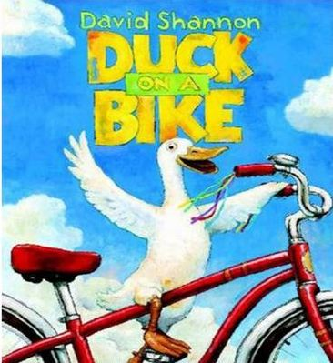Anyone can ride a bike - even a duck!
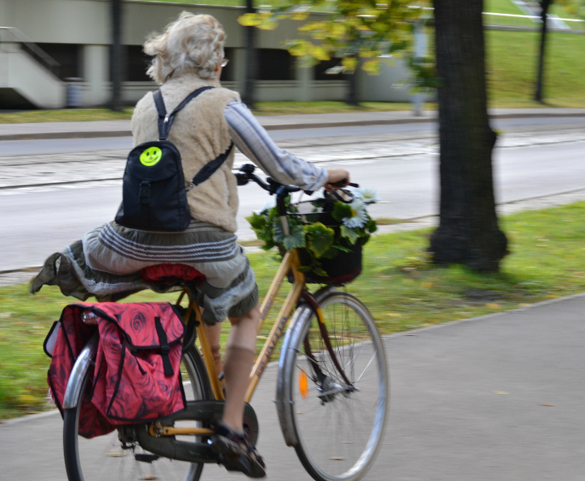Older...
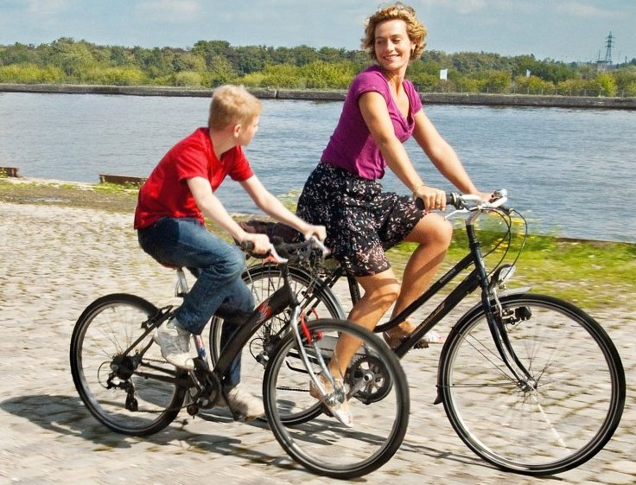Younger...
St. Martins Centre, 232 Dalry Road, Edinburgh EH11 2JG 0131.313.2114 [answerphone] competition@spokes.org.uk www.spokes.org.uk Twitter @SpokesLothian Facebook Spokes
This competition info/entry form is on the Spokes website in documents > odds and ends
My Cycling Inspiration
SPOKES SUMMER 2019 COMPETITION – OPEN TO ALL
For our 2019 summer competition we'd like to know what inspired you to start getting around by bike – or how you inspired someone else to start
It might be thanks to a friend, or due to the unhealthy sedentariness of driving to work, seeing a new cycle route, persuasion by your children, or maybe your parents showed you from the earliest age that this is the best way to get around; perhaps even it was something you saw or heard from Spokes!
Your entry must fit an A4 sheet, but apart from that it's up to you. Words alone are fine, even just one superb sentence, but pictures, diagrams etc often add value.
We'll publicise prizewinning ideas - your experience may inspire others!
Please read these rules carefully ...
- Each person can submit 1 or 2 entries (not more) .
- The competition is open to all, but members of Spokes Resources Group can't win prizes.
- If your entry has pictures of a place, it must be in Edinburgh or Lothian. Copenhagen or Amsterdam, may have inspired you a great deal, but those pictures wouldn't count for our competition.
- The competition closes at midnight on Saturday 31 August - entries will be judged soon after.
- Send your entry in any common electronic format (a text email, doc, rtf, pdf, etc) or on paper. We will not return anything sent by post.
- If your entry includes photos, diagrams etc, you can either make up your own final document; or you can send your text and up to 2 photos separately and we will put them together - photos should if possible be sent as jpg files not exceeding 1MB size.
- Your entry must answer one of the two questions overleaf and give your contact details, as overleaf.
- Email the completed entry form and any attachments to competition@spokes.org.uk. For printed entries and/or photos, post to our office address.
- Spokes may use your entry on our website, in our Bulletin or in other ways. By entering the competition you give Spokes permission to use your entry material in our ongoing campaigning and promotional work in any way. We may credit your name, unless you specifically ask us not to.
Great prizes ... See overleaf for a full list.
PRIZES | Top prizewinner gets first choice of prizes, and so on till all prizes allocate.  Well-placed entries which don't win a prize get to choose a free Spokes map.

www.edinburghbicycle.com Edinburgh Bicycle voucher £50
ScotRail www.scotrail.co.uk Return ticket for 2 adults + 4 kids between any 2 Scottish stations
Sustrans www.sustrans.org.uk Choice of any 5 Sustrans 'Pocket Cycle Map' series
Filmhouse www.filmhousecinema.com Tickets for 2
Camera Obscura/World of Illusions www.camera-obscura.co.uk Family ticket [2 prizes]
Kalpna Indian Veg Restaurant www.kalpnarestaurant.com £20 lunch-for-2 voucher
Laidback Bikes www.laid-back-bikes.scot Recumbent tour for up to 2 people
Edinburgh Festival of Cycling edfoc.org.uk/cargo-bike-hire Urban Arrow cargo bike, day hire
Harts Cyclery www.harts-cyclery.co.uk One week e-bike hire
Boardwalk Foreshore cafe twitter.com/BoardwalkBeach £25 voucher
Lanterne Rouge Cafe (Gifford) facebook £10 voucher
Cafe Milk (Sculpture Workshop) edinburghsculpture.org/cafemilknewhaven Lunch voucher for 2
Spokes (from a kind donation) www.spokes.org.uk/documents/advice/cargo-bikes £500 cargo-bike voucher*
*This voucher may only be used towards a cargo bike purchase. It may only be used by the winner and is not transferable. It must be used at an Edinburgh or Lothians bike shop (e.g. Laidback, Harts, Edinburgh Bicycle, above). We will pay the shop direct.
ENTRY FORM
Either use this form or attach your entry separately. Be sure to follow the rules overleaf.

Your Name

Address Postcode

Email Phone number
------------------------------------------------------------------------------------------------------------------
What inspired you to start using a bike to get around ?
Or … How did you inspire someone else to start ? (please cross out whichever does not apply)

Thanks for entering – Encourage your friends to enter too!

