Edinburgh World Heritage

Our comments on the North-South tram extension
Home » Our comments on the North-South tram extension
Edinburgh World Heritage (EWH) has serious and significant concerns about the impacts of the proposed tram project on major heritage structures within the World Heritage Site. In particular, given the evidence that is available at this time, we do not support the use of South Bridge as a route option due to the potentially serious implications and damage to this Category A-listed Georgian “megastructure”, which is one of the most important attributes of the World Heritage Site. This and other concerns on impacts to the Site’s Outstanding Universal Value (the characteristics, receptors and qualities underpinning Edinburgh’s inscription as a World Heritage Site) are explored in more detail in our full statement here.
South Bridge’s heritage value
South Bridge is a marvel of Georgian engineering. Built over a four-year period, it is one of the largest structures in the World Heritage Site, forming a continuous roadway and street over the steep valley. It was designed as a single entity and is a physical manifestation of the urban ambitions of the City at the time. Its importance as a contributor to the Outstanding Universal Value of the World Heritage Site cannot be overstated.
EWH’s specific concerns
Engineering consultancy firm Jacobs was commissioned to write a report on South Bridge’s suitability as a tram route as part of the North-South tram project’s strategic business assessment. The report provides no assurance or technical assessment of South Bridge’s capability to take the dynamic loads of a modern tram, and no details of any reinforcement works to address these were provided. Until such time as suitable evidence that any impact can be mitigated, we advise that South Bridge should not be considered capable of accommodating a modern tram.
EWH accepts that while it may be possible to mitigate these concerns, the Georgian structure would make this process complicated and expensive. South Bridge is a tertiary retail street, but what is not appreciated is the varied use of the highly complex, vaulted structures that comprise it. Several of the larger, lower vaults are used as nightclub/hospitality spaces, while others are used as storage for retail businesses. Some are used as formal fire escape routes for businesses and run transversely from one side to another. Ownership is mixed, with most spaces assumed to be under private control, which might necessitate expensive and lengthy Compulsory Purchase Orders. The intricacy of the structures and the multiple ownerships of them will make any mitigating structural works more complex and therefore more expensive.
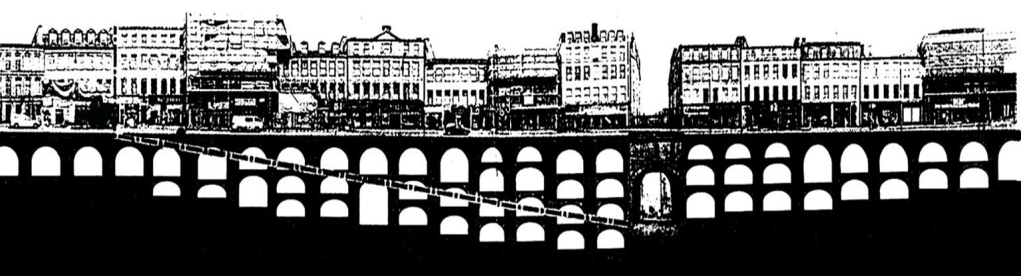
Conclusion
EWH continues to support trams in principle. However, we do not support the use of South Bridge as part of the tram corridor due to its impact on the Outstanding Universal Value and impact on this key heritage asset. We note the engineering consultant’s comments that the current structure may not be suitable to carry tram loading without unspecified additional works and strengthening, which if possible, would be a complex and expensive process. Until such time as suitable evidence of mitigating measures that are consistent with its importance as a heritage asset, we advise that the position taken should be that South Bridge is not capable of accommodating a modern tram.
EWH continues to support the expansion of the tram network in Edinburgh. As such, EWH suggests that other route options, such as Morrison Street or Lothian Road should be kept open. Further, the Council’s current intention to use battery hybrid trams, which could be lighter and would require less intrusive overhead cabling, might also mitigate some concerns.
Notes to editors
About Edinburgh World Heritage
Edinburgh World Heritage protects, preserves and promotes the Old and New Towns of Edinburgh UNESCO World Heritage Site. Working in partnership with the City of Edinburgh Council and Historic Environment Scotland, EWH looks after the city’s historic environment through conservation, engagement and advocacy, ensuring Edinburgh’s unique character remains something for all to enjoy.
Edinburgh World Heritage is registered in Scotland No. SC195077 Scottish Charity No. SC037183
Acheson House, 5 Bakehouse Close, 146 Canongate, Edinburgh, EH8 8DD
ewh.org.uk/about-us
Images are available on our Dropbox.
Contact jen.macneill@ewht.org.uk for further information.
If you would like to know more about the topic above, please contact us directly.
Press Centre
Contact

Edinburgh World Heritage
Acheson House
5 Bakehouse Close
146 Canongate
Edinburgh
EH8 8DD

About us

↪ Support us

↪ Events

↪ Careers

Our People

Our Impact

Resources

Press Centre

Contact

The UNESCO World Heritage Site

↪ The Management Plan

↪ Grants

Help us to protect Edinburgh's beautiful built environment
We are the only charity dedicated to the protection of Edinburgh’s historic environment. Your donations help us continue our work for current and future generations.
Donate now
Support us
Events

Supported by






Edinburgh World Heritage gratefully acknowledges the support of



© Edinburgh World Heritage. Registered in Scotland No. SC195077. Scottish Charity No. SC037183.

Website design by LBD Studio.

